STATE OF CALIFORNIA
APPLICATION
FOR
DOMESTIC WATER SUPPLY PERMIT
FROM

Applicant:
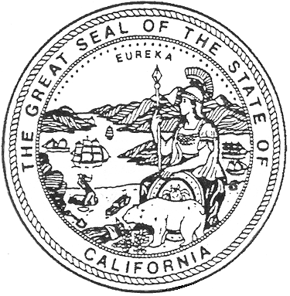
(Enter the name of legal owner, person(s) or organization)

Address:

System Name:

System Number:

TO: State Water Resources Control Board
Division of Drinking Water
Southern California Drinking Water Field Operations Branch
Tehachapi District Office
4925 Commerce Drive, Suite 120
Bakersfield, California, 93309

Pursuant and subject to the requirements of the California Health and Safety Code, Division 104, Part 12, Chapter 4 (California Safe Drinking Water Act), Article 7, Section 116525, relating to domestic water supply permits, application is hereby made for a

domestic water supply permit to operate

(Applicant should state the type of system, e.g., community,

transient-noncommunity, or nontransient-noncommunity, and the proposed area of services. This application will also be used

for a change in ownership application.

I (We) declare under penalty of perjury that the statements on this application and on the accompanying attachments are correct to my (our) knowledge and that I (we) are acting under authority and direction of the responsible legal entity under whose name this application is made.

By:
Title:
Address:

Telephone:

Dated: DDW 07/2014

