IV. GROUNDWATER QUALITY ASSESSMENT

This portion of the 305(b) report summarizes an assessment of groundwater quality in California. Although the Clean Water Act does not require that states conduct a groundwater quality assessment for 305(b) reporting, significant efforts are being made to comprehensively monitor and assess California’s groundwater. These efforts and available data are summarized herein.

A. EXISTING GROUNDWATER QUALITY MONITORING AND ASSESSMENT PROGRAMS IN CALIFORNIA

The quality of California's groundwater resources is the concern of more than one agency. Each of these agencies, at the state and federal levels, approaches groundwater issues from a unique perspective, based on its individual mandate. As a result, different types of groundwater quality data and information are collected. The functions of these agencies and the data that they generate are complementary but not overlapping. The state agencies that implement groundwater-related monitoring and assessment programs are the State Water Resources Control Board (SWRCB) and Regional Water Quality Control Boards (RWQCBs), Department of Water Resources (DWR), Department of Health Services (DHS), Department of Toxic Substances Control (DTSC), and Department of Pesticide Regulation (DPR). Federal agencies that implement groundwater-related monitoring and assessment programs include the United States Environmental Protection Agency (USEPA) and the United States Geological Survey (USGS). The following table (Table 15) describes the various groundwater monitoring and assessment programs currently implemented through the various state agencies.

TABLE 15: Groundwater Monitoring and Assessment Programs

Agency | Groundwater Programs | Groundwater Monitoring/  Assessment Objectives
Dept. of Health Services  (DHS) | California Safe Drinking Water Act | - Ascertain quality of all public water supply sources for compliance with MCLs;  - Complete source water assessments of all sources by May 2003;  A source water assessment is required for all new sources before receiving a DHS permit
Dept. of Pesticide Regulation  (DPR) | Groundwater Contaminant Identification | - Determine potential for movement of pesticide residues to groundwater based on their physical/chemical properties  - Conduct well sampling to identify new pesticide active ingredients in groundwater  - Provide monitoring data to determine trends in pesticide concentrations in contaminated basins
Dept. of Pesticide Regulation  (DPR) | Vulnerable Area Identification | - Determine the spatial extent of contamination for residues already detected in groundwater  - Use monitoring, soil, depth to groundwater, climate and other geographic or agronomic factors to identify areas vulnerable to pesticide contamination of groundwater
Dept. of Pesticide Regulation  (DPR) | Mitigation Measure Development and Implementation | - Identify and test mitigation measures to prevent movement of residues to groundwater  - Implement mitigation measures to prevent continued movement of pesticides to groundwater
Dept. of Pesticide Regulation  (DPR) | Backflow and Chemigation Education and Training Program | Prevent the backflow of residues into groundwater when they are applied through injection into irrigation water
Dept.  of Toxic Substances Control  (DTSC) | Hazardous Waste Management Program - Facility Permitting Division | Evaluation of groundwater contamination at Resource Conservation and Recovery Act storage, treatment, and disposal facilities
Dept.  of Toxic Substances Control  (DTSC) | Site Mitigation Program - Statewide Cleanup Operations Division | Evaluation of groundwater contamination at Superfund, brownfield, and voluntary cleanup sites
Dept.  of Toxic Substances Control  (DTSC) | Site Mitigation Program - Emergency Response and Statewide Operations Division | Evaluation of groundwater contamination at Superfund, brownfield, and voluntary cleanup sites (technical support)
Dept.  of Toxic Substances Control  (DTSC) | Site Mitigation Program - Office of Military Facilities | Evaluation of groundwater contamination at military sites
Dept. of Water Resources  (DWR) | Bulletin 118 | Update of groundwater basin boundaries and basin characteristics
Dept. of Water Resources  (DWR) | Water Quality & Quantity (Water & Environmental Monitoring) | Long-term water quality and well level data
Dept. of Water Resources  (DWR) | Local and Regional Studies | Miscellaneous groundwater studies addressing local groundwater issues
Dept. of Water Resources  (DWR) | Groundwater Quantity for Updating the State Water Plan | State's water supply and demand budget
Dept. of Water Resources  (DWR) | State Water Project Conjunctive use program | Basin monitoring associated with State Water Project conjunctive use projects
Dept. of Water Resources  (DWR) | Integrated Storage Investigations Conjunctive Use Program, and Grants and Loans | Data collection, monitoring, & evaluation, feasibility studies for Groundwater recharge and storage
Dept. of Water Resources  (DWR) | Water Data Management Systems | Water Data Library: on-line access to hydrologic data
Dept. of Water Resources  (DWR) | Subsidence Monitoring | Monitoring along California Aqueduct; special studies as needed

TABLE 15: Groundwater Monitoring and Assessment Programs (continued)

Agency | Groundwater Programs | Groundwater Monitoring/  Assessment Objectives
State Water Board  (SWRCB) | Groundwater Ambient Monitoring and Assessment (GAMA) Program | Assesses statewide groundwater quality and aquifer susceptibility.
State and Regional Water Boards  (SWRCB/  RWQCBs) | Underground Storage Tank (UST) Program | Regulates USTs and provides cleanup oversight.
State and Regional Water Boards  (SWRCB/  RWQCBs) | Land Disposal Program | Imposes statewide requirements for siting, operation, and closure of waste disposal sites through issuance of waste discharge requirements and compliance and enforcement efforts to ensure adequate protection of water quality.
State and Regional Water Boards  (SWRCB/  RWQCBs) | Spills, Leaks, Investigations, and Cleanup (SLIC) Program (reimbursed cleanup program) | Oversees the investigation and remediation of sites associated with unauthorized releases that may impact water quality.
State and Regional Water Boards  (SWRCB/  RWQCBs) | Department of Defense Program (DOD) | Partners with the US Dept. of Defense (DoD) through the Defense and State Memorandum of Agreement (DSMOA) to oversee the investigation and remediation of water quality issues at over 200 military facilities.
Regional Water Boards  (RWQCBs) | Regional Board specific efforts | Conduct special projects to address groundwater monitoring outside the regulatory programs described above.  San Francisco Bay Regional Water Quality Control Board – Groundwater Basin Evaluations, Electronic Reporting of Solvent Plume Maps

B. EXISTING GROUNDWATER MONITORING/ASSESSMENT DATA

Through the various groundwater monitoring and assessment programs, a significant amount of groundwater-related data is collected in various formats. Table 16 specifies information on the state agencies’ groundwater-related monitoring and assessment data; the type of sampling used to collect the data (Survey – one time effort; Monitoring – ongoing data collection but limited analysis; Assessment – ongoing data collection and detailed analysis); the data format (hard copy or electronic); and whether or not spatial location Geographic Information System (GIS) data are available. The information presented in this table is based on the information available at the time this report was written.

TABLE 16: Groundwater Monitoring/Assessment Data

Types of Groundwater  Data Collected | Spatial Coverage (Statewide/Regional/ Local) | Type of Sampling  (Survey – one time effort, Monitoring – ongoing data collection but limited analysis, or Assessment – ongoing data collection and detailed analysis) | Data Format  (Hard copy or Electronic; Application - Oracle, Access, Dbase, Excel, etc.) | Spatial Data (GIS) Availability
Dept. of Health Services (DHS)
Public Water Well Locations and Water Quality | Statewide | Monitoring, Assessment | Electronic (Access); Hardcopy | Yes
Source Water Assessment Program Data | Statewide | Survey,  Assessment | Electronic (Access) | Yes
Well Data | Statewide | Monitoring | Electronic (Access); Hardcopy | Yes
Water System Water Quality Monitoring Plan | Statewide | Monitoring,  Assessment | Hardcopy | No
Groundwater Recharge with Recycled Water Monitoring Programs | Local | Survey, Monitoring | Hardcopy | No
Dept. of Pesticide Regulation (DPR)
Well Inventory Database – Mandated by law that other state agencies report their pesticide well monitoring results to DPR. Other federal and local agencies are contacted for submission of data | Statewide | Collects survey and monitoring data | Electronic - Oracle | Yes. All databases are indexed according to the USGS Public Land Survey Coordinate System - Township/Range/Section (TRS)
Well Sampling Investigations - Well sampling conducted to comply with Pesticide Contamination Prevention Act. Study objectives are to: 1. Identify pesticide active ingredients in groundwater; 2. Identify vulnerable areas; 3. Determine relationship of detections with agronomic and geographic variables; 4. Determine trends in concentration to measure effective of regulations | Local to Statewide | Surveys and monitoring | Electronic - Oracle (captured in the Well Inventory Database) | Yes. Indexed to TRS
Pesticide Use Report Database – Beginning in 1990, all agricultural uses of pesticides are reported to DPR by Township, Range, and Section via the County Agricultural Commissioner | Statewide | Assessment (used to identify potential sampling sites) | Electronic - Oracle | Yes. Indexed to TRS
California Vulnerability Model (CALVUL) – Identify soil, climatic, depth to groundwater and other geographic properties of vulnerable areas | Statewide | Assessment (used to identify potential sampling sites) | Electronic - Oracle or Access | Yes. Indexed to TRS
Pesticide Chemistry Database – Registrants of pesticide active ingredients are required to submit data on the physical and chemical properties of pesticides including water solubility, soil adsorption coefficient (KOC), hydrolysis half-life, aerobic and anaerobic soil metabolism and dissipation of pesticides | Not Applicable | Assessment (used to identify potential sampling sites) | Electronic - Oracle or Access | Not Applicable
Dept. of Toxic Substances Control (DTSC)
Hazardous Waste Management Program - Facility Permitting Division | Statewide  (mostly urbanized areas) | Survey, Monitoring | Hard copy only | No. Spatial well information is not available
Site Mitigation Program - Statewide Cleanup Operations Division | Statewide  (mostly urbanized areas) | Survey, Monitoring | Hard copy only | No. Spatial well information is not available
Site Mitigation Program - Emergency Response and Statewide Operations Division | Statewide  (mostly urbanized areas) | Survey, Monitoring | Hard copy only except for Stringfellow site (data are currently in Access and will be moved to Equis in the near future) | Yes. for Stringfellow site. Otherwise, spatial well information is not available
Site Mitigation Program - Office of Military Facilities | Statewide (military bases) | Survey, Monitoring | Hard copy only | No. Spatial well information is not available
Dept. of Water Resources (DWR)
Bulletin 118 groundwater basin and subbasin boundaries and associated numbers based on basin and subbasin data (some data in GIS) | Statewide | NA | ArcView | limited
Groundwater levels, available in hydrograph and tabular format on DWR’s web page | Statewide | Monitoring | Hardcopy, electronic, Oracle, Access | limited
Groundwater quality analyses, available in tabular format on DWR’s web page | Regional, Local | Monitoring, Assessment | Oracle, Access | limited
Inelastic and elastic subsidence | Regional, Local | Monitoring | Access | none
AB 303 Data (WC §10750)—The statute requires that any data collected as a result of the grant must be submitted to DWR. | Local | Survey, Monitoring, Assessment | Hardcopy, Electronic: (various applications) | Yes, varies with project
Well Completion Reports, commonly called Well Logs (DWR 188) | Statewide | NA | Electronic: Access | Yes, limited
Watermaster data for Central and West Coast Basins (Southern District) | Local, Regional | Monitoring | Electronic: Excel | No
Prop 13 Groundwater Storage and conjunctive management project specific data | Local, Regional | Survey, Monitoring,  Assessment | Hardcopy, Electronic: (various applications) | Yes, varies with project
State and Regional Water Boards (SWRCB/RWQCBs)
Groundwater Ambient Monitoring and Assessment (GAMA) Program, California Aquifer Susceptibility (CAS) Assessment - Low-level VOCs, groundwater age data | Statewide | Survey, Assessment | Oracle | Yes
GAMA Program, Voluntary Domestic Well Assessment Project - Private domestic drinking water well location and water quality data | Local | Assessment | Access | Yes
Location, release, water quality, and water level data for Leaking UST sites (Geotracker) | Leaking UST sites located statewide | Monitoring | Hard copy and Electronic: Oracle | Yes
Location, water quality, and water level data for Land Disposal Program sites | Land Disposal sites located statewide | Monitoring | Location (hard copy, limited electronic: Excel);  Water quality (hard copy, limited electronic: Excel);  Water level data (hard copy, limited electronic Excel) | Yes (Land Disposal site locations)
Location, water quality, and water level data for Dept. of Defense (DOD), Leaking Landfills, and Spills Leaks, Investigations, and Cleanup (SLIC) sites | DOD, landfills, and SLIC sites located statewide. | Monitoring | Electronic UST data in Geotracker. In general, site location (hard copy, limited electronic: Excel);  Water quality (hard copy, limited electronic: Excel);  Water level data (hard copy, limited electronic: Excel) | In progress
Hydrogeologic Vulnerability Areas (GIS) delineated based on published hydrogeologic data and information | Statewide | NA | Electronic: GIS | Yes
RWQCBs specific efforts:  San Francisco Bay Regional Water Quality Control Board – Electronic Solvent Plume Reporting Project.  Others – To be determined | Regional | Survey, Monitoring, Assessment | (San Francisco Bay Regional Water Quality Control Board, Electronic Solvent Plume Reporting Project - Excel) | Yes (San Francisco Bay Regional Water Quality Control Board, Electronic Solvent Plume Reporting Project)

C. DEVELOPMENT OF A COMPREHENSIVE MONITORING PROGRAM IN CALIFORNIA

State Water Resources Control Board Groundwater Programs

The scope of the SWRCB groundwater programs ranges from pollution prevention to formal monitoring, assessment, and water quality cleanups. Pollution prevention includes regulation of wastes associated with operation of underground fuel storage tanks, landfills, and surface impoundments. Cleanup programs include oversight of assessment and remediation of discharges of wastes associated with the same types of facilities represented in the pollution prevention programs, with the addition of a general category of groundwater cleanup sites that were never formally regulated, such as dry cleaners. Recent significant efforts in groundwater monitoring and assessment are described below.

Groundwater Ambient Monitoring Assessment (GAMA) Program

As a result of an increased awareness toward groundwater quality, the Supplemental Report of the 1999 Budget Act required the SWRCB to develop a comprehensive ambient groundwater monitoring plan. To meet this mandate, the SWRCB created the Groundwater Ambient Monitoring and Assessment (GAMA) Program.

One objective of the GAMA Program is an effort to identify and centralize the many sources of groundwater data and information available in the state. As part of this effort, the SWRCB has joined with other state and federal agencies to form a Groundwater Resources Information Sharing Team (GRIST). Agencies currently participating in GRIST include the SWRCB, Department of Health Services (DHS), Department of Pesticide Regulation (DPR), Department of Water Resources (DWR), Lawrence Livermore National Laboratory (LLNL), and U.S. Geological Survey (USGS).

The various groundwater data sets will be made accessible to the public and interested agencies within a Groundwater Resources Information Database (GRID). A listing of the data, along with the appropriate agency contacts and Internet links, are maintained by the SWRCB on the GRID. In addition, to facilitate effective information sharing and communication among stakeholders, groundwater data are being made available on the SWRCB Geotracker system. Geotracker is a database with a Geographic Information System (GIS) that provides Internet access to environmental data. The centralization of environmental data through Geotracker is enabling more in-depth geospatial and statistical analyses of groundwater data. This expansion in capabilities should greatly assist public agencies in planning and resource management.

Another objective of the GAMA Program is to assess the water quality and relative susceptibility of groundwater resources. In addition to ongoing assessments of groundwater based on existing water quality data, the GAMA Program has two sampling components: the California Aquifer Susceptibility (CAS) Assessment which addresses public supply drinking water wells, and the Voluntary Domestic Well Assessment Project which addresses private drinking water wells.

California Aquifer Susceptibility (CAS) Assessment

The California Aquifer Susceptibility (CAS) Assessment is a study of the water quality and relative susceptibility of groundwater that serves as a source for public drinking water supplies. The SWRCB, with assistance from the USGS and LLNL, is collecting data to evaluate the use of groundwater age (using tritium-helium analysis) and low-level volatile organic compound (VOC) concentrations as indicators of the susceptibility of groundwater to contamination. Age-dating provides information on the presence of young groundwater, i.e., groundwater that has been in contact with the earth’s surface within the last 50 years. Young groundwater or groundwater with trace amounts of VOCs can be considered indicators of vulnerability to pollution from surface contaminants from land use activities. In addition, analysis for trace amounts of recently introduced compounds such as methyl tert-butyl ether (MTBE) will allow water managers to identify trends in groundwater quality in their region and respond before concentrations reach action levels.

The CAS assessment is designed to sample approximately 15,000 public supply wells in California, through voluntary cooperation of water suppliers. Sampling began in 2000 and will continue for the next several years depending on the availability of funding. Sampling and analysis are being conducted by scientists from the USGS and LLNL. Quality-control samples are collected to assure that bias has not been introduced as a result of sampling procedures. As of the Fall of 2002, more than 800 public drinking water wells have been sampled in this way.

The SWRCB is implementing the CAS Assessment, in consultation with the DHS, DWR, and other entities. More detailed information about the GAMA Program and the CAS Assessment is available at the GAMA Program website:

http://www.swrcb.ca.gov/gama

- Voluntary Domestic Well Assessment Project

Currently, the quality of domestic well water in California is largely unknown. Other states with domestic well sampling programs have occasionally found constituents such as MTBE and bacteria in domestic wells. The Voluntary Domestic Well Assessment Project samples domestic wells for various constituents commonly found in domestic well water and provides that information to the domestic well owners. In addition, the Voluntary Domestic Well Assessment Project includes a public education component to aid the public in understanding water quality data and water quality issues affecting domestic water wells. The Voluntary Domestic Well Assessment Project focuses on specific areas, as resources permit. The focus areas are chosen based upon existing knowledge of water quality and land use, in coordination with local environmental health agencies. The SWRCB incurs the costs of sampling and analysis. As of the summer of 2002, over 100 domestic wells have been sampled in a focused area.

AB 599 – Groundwater Quality Management Act

In October 2001, the Governor approved Assembly Bill 599 (AB 599), establishing the Groundwater Quality Monitoring Act of 2001. Introduced by Assemblymember Carol Liu, the goal of AB 599 (WC§10780) is to improve comprehensive groundwater monitoring and increase the availability of information about groundwater quality to the public.

AB 599 requires that the SWRCB, in coordination with an Interagency Task Force (ITF) and Public Advisory Committee (PAC), integrate existing monitoring programs and design new program elements, as necessary, to establish a comprehensive statewide groundwater quality monitoring program. AB 599 also requires that on or before March 1, 2003, the SWRCB submit a report to the Governor and Legislature, detailing the efforts of the joint activities with the ITF and PAC, and including the following elements:

- A detailed description of a comprehensive groundwater quality monitoring program;
- A description of how the program takes maximum advantage of existing information;
- An assessment of additional monitoring necessary;
- A specific set of recommendations for coordinating existing monitoring programs;
- An estimate of funding necessary to implement the program;
- Recommendations for an ongoing source of funds; and
- A prioritized list of actions to increase effectiveness of monitoring efforts

The ITF is composed of representatives of the following member state agencies: SWRCB, DWR, DHS, DPR, DTSC, and the California Department of Food and Agriculture. The ITF has the following responsibilities:

- Identify actions necessary to establish a comprehensive groundwater quality monitoring program;
- Identify measures to increase coordination among agencies that collect groundwater quality information;
- Design a database capable of supporting the groundwater monitoring program;
- Determine constituents to be included in the monitoring program;
- Assess the scope and nature of necessary monitoring enhancements;
- Identify the cost of any recommended measures; and
- Identify how to make monitoring information available to the public.

The SWRCB convened the required PAC to the ITF, including members from two representatives of federal agencies, two representatives of public water systems, one representative of a local water agency, two representatives from groundwater management entities, two representatives of environmental organizations, two representatives of the business, and two representatives of agriculture.

As of the Fall of 2002, the ITF and PAC had met several times and the development of the report to the Legislature, including the description of a comprehensive groundwater monitoring program, was well underway.

- Groundwater Quality in California:

Currently, the best available and readily usable source of groundwater data, for widespread groundwater quality assessment in the State of California, is the DHS public water supply well database. The database contains results of regular water quality monitoring, required by federal and state laws and regulations, for numerous chemical, radiological, and bacteriological contaminants. The laws and regulations applicable to the public supply wells establish numerical water quality criteria for these contaminants, called Maximum Contaminant Levels (MCLs), to protect public health. The DHS database contains water quality data and locational data for over 15,000 public water supply wells within the state. While these data are not evenly spatially distributed throughout the state or the aquifers within the state, they do provide a good inventory of the quality of groundwater that is being used for public consumption.

Nearly 10,000 public supply wells are within the DWR-defined alluvial groundwater basins of the state. In working with staff from DWR, the SWRCB queried the DHS database to identify general water quality patterns in the alluvial groundwater basins. The list of Contaminants of Concern (COC’s) categories used in the queries is listed in Table 17. The results of the water quality queries are summarized by Hydrologic Region in Table 18, with most frequent constituent exceedences summarized in Table 19. The tables show the total number of DHS-regulated public supply wells within each hydrologic region, and the number of those wells within the most recently available sampling cycle (1994-2000) that had a MCL exceedence for at least one of the COCs in a COC group. These data show that in general, the groundwater used for public supply in the state is of reasonably good quality. When an occasional problem occurs, DHS’s regulatory programs are in place to limit the public’s potential exposure to contaminants. Following the summary tables, in Appendix A, expanded lists of water quality data, at the basin and sub-basin levels for each hydrologic region, are provided.

It should be noted that the DHS data only measure the quality of groundwater at the point of resource consumption, the supply well intake. This does not allow for a comprehensive evaluation of the status of the entire groundwater resource (used and currently unused portions of all aquifers). Previously discussed efforts such as the SWRCB’s GAMA Program, and the multi-agency effort to address the AB 599 requirements, build on existing data to create more comprehensive groundwater assessments.

Table 17: Constituents of Contaminant Groups Used in General Queries

Inorganics (Primary MCL) | Inorganics (Secondary MCL) | Radiological | Nitrates | Pesticides | VOCs
Aluminum  Antimony  Arsenic  Asbestos  Barium  Beryllium  Cadmium  Chromium (Total)  Cyanide  Fluoride  Mercury  Nickel  Selenium  Thallium | Chloride  Copper  Iron  Manganese  Silver  Specific Conductance  Sulfate  Total Dissolved Solids  Zinc | Combined Ra (226 + Ra 228)  Gross Alpha  Radium 226  Radium 228  Strontium-90  Uranium | Nitrate  (As No3)  Nitrate + Nitrite  (As N)  Nitrate Nitrogen (No3-N)  Nitrite  (As N) | 1,3-Dichloropropene (Total)  2,4-D  Bentazon  Carbofuran  Chlordane  Di(2-Ethylhexyl)Phthalate  DBCP  Dinoseb  EDB  Heptachlor  Heptachlor Epoxide  Lindane  Methoxychlor  Pentachlorophenol  Polychlorinated Biphenyls  (Total PCB's)  Toxaphene | 1,1,2,2-Tetrachloroethane  1,1,2-Trichloroethane  1,1-Dichloroethane  1,1-Dichloroethylene  1,2-Dichloroethane  1,2-Dichloropropane  1,4-Dichlorobenzene  1,1,2,2-Tetrachloroethane  Benzene  Benzo (A) Pyrene  Bromodichlormethane (Thm)  Carbon Tetrachloride  Chloroform (Thm)  Cis-1,2-Dichloroethylene  Dichloromethane  Methyl-Tert-Butyl-Ether (MtBE)  Tetrachloroethylene  Total Trihalomethanes  Trans-1,2-Dichloroethylene  Trichloroethylene  Trichlorofluoromethane  Vinyl Chloride
Other consituents not categorized: color, foaming agents (MBAS), odor threshold @ 60 C, turbidity (laboratory and field)

Table 18: Summary of MCL Exceedences Per Number of Public Supply Wells Sampled By Hydrologic Region: DHS Database, 1994-2000*

Hydrologic Region (Inclusive Regional Board No. follows in parentheses) | Inorganics  Primary MCL # Exceedence /  (# Sampled) | Radiological | Nitrates | Pesticides | VOCs
North Coast (R1) | 12 (515) | 7 (307) | 8 (573) | 0 (356) | 5 (348)
S.F. Bay (R2) | 27 ( 444) | 3 (363) | 28 (458) | 5 (419) | 13 (415)
Central Coast (R3) | 21 (608) | 18 (540) | 69 (627) | 6 (570) | 11 (586)
South Coast  (R4, R8, and R9) | 115 (2,151) | 119 (2,093) | 374 (2,237) | 71 (2,130) | 315 (2,169)
Sacramento River  (R5) | 19 (1,131) | 4 (943) | 24 (1,273) | 3 (907) | 25 (895)
San Joaquin River  (R5) | 17 (607) | 49 (486) | 27 (630) | 55 (625) | 18 (609)
Tulare Lake (R5) | 68 (1,319) | 81 (1,223) | 87 (1,371) | 148 (1,336) | 49 (1,275)
North Lahontan (R6) | 7 (121) | 7 (77) | 0 (129) | 0 (72) | 8 (73)
South Lahontan (R6) | 52 (518) | 21 (469) | 15 (567) | 2 (497) | 6 (499)
Colorado River (R7) | 17 (286) | 21 (279) | 6 (293) | 0 (274) | 0 (272)
Totals | 355 (7,700) | 330 (6,780) | 638 (8,158) | 290 (7,186) | 450 (7,141)
* Does not include over 4,000 public supply wells located outside DWR-defined alluvial groundwater
basins.

Table 19: Overview of Individual Constituent Exceedences By Hydrologic Region (See Appendix A for Expanded Regional Information)

Hydrologic Region  (Inclusive Regional Board No. follows in parentheses) | Individual Constituents Most Frequently Exceeding MCLs  (Number of Exceedences)
North Coast (R1) | *Nitrates (8), Aluminum (4), Arsenic (4), Radium 228 (3), TCE (2)
S.F. Bay (R2) | Iron (57), Manganese (57), *Nitrates (28), Fluoride (7), TCE (4)
Central Coast (R3) | *Nitrates (69), Gross Alpha (15)
South Coast  (R4, R8, and R9) | *Nitrates (374), TCE (196), PCE (152), Gross Alpha (104)
Sacramento River  (R5) | *Nitrates (24), PCE (11), TCE (7), Benzene (4), Gross Alpha (4)
San Joaquin River (R5) | DBCP (44), Uranium (33), *Nitrates (27), Gross Alpha (26)
Tulare Lake (R5) | DBCP (130), *Nitrates (87), Gross Alpha (74), Fluoride (32)
North Lahontan (R6) | 1,2-DCA (8), Gross Alpha (7), Uranium (5), Fluoride (3)
South Lahontan (R6) | Fluoride (30), *Nitrates (15), Arsenic (19), Gross Alpha (18)
Colorado River (R9) | Fluoride (17), *Nitrates (6), Radium (3)

*The nitrate numbers represent total public supply wells with one or more exceedences of nitrate quantities in at least one of three ways: Nitrate as (NO₃), Nitrate + Nitrite, or Nitrate Nitrogen (NO₃ –N).

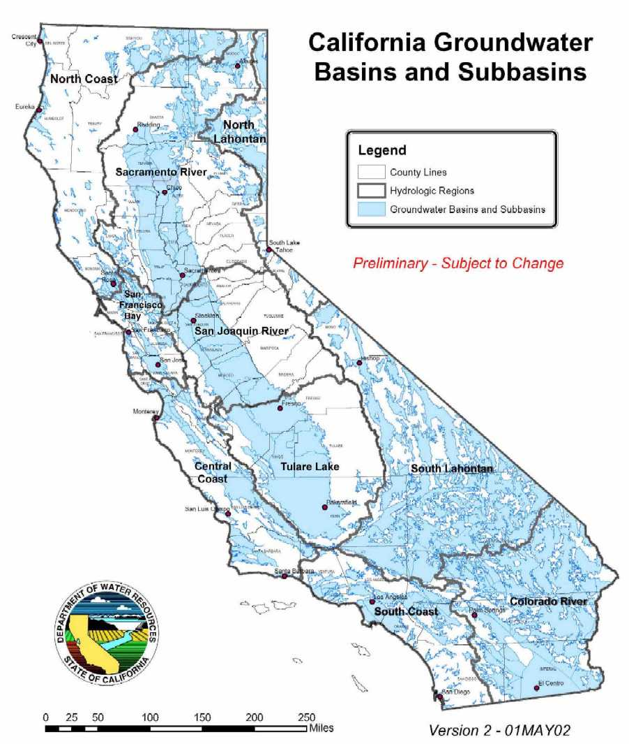

Figure 13: Hydrologic Regions, and Groundwater Basins and Sub-basins
From: California’s Groundwater – Bulletin 118, Version 2 (Draft)

D. CHAPTER REFERENCES

California’s Groundwater – Bulletin 118, Version 2 (Draft) – Department of Water Resources - http://www.waterplan.water.ca.gov/groundwater/118index.htm

EPIC – Drinking Water Quality Indicators – http://www.oehha.ca.gov/multimedia/epic/2002reptpdf/Chapter3-3of8Water.pdf

Personal Communication with Mr. Robert J. Swartz, Senior Engineering Geologist, California Department of Water Resources, 8 October 2002.

Plan For Implementing A Comprehensive Program For Monitoring Surface and Groundwater Quality, State Water Resources Control Board, January 2000.

SWRCB GAMA Program Web Site - http://www.swrcb.ca.gov/gama

SWRCB Geotracker Web Site - http://geotracker.swrcb.ca.gov/

E. Groundwater Quality Data for Individual Hydrologic Regions

North Coast Hydrologic Region
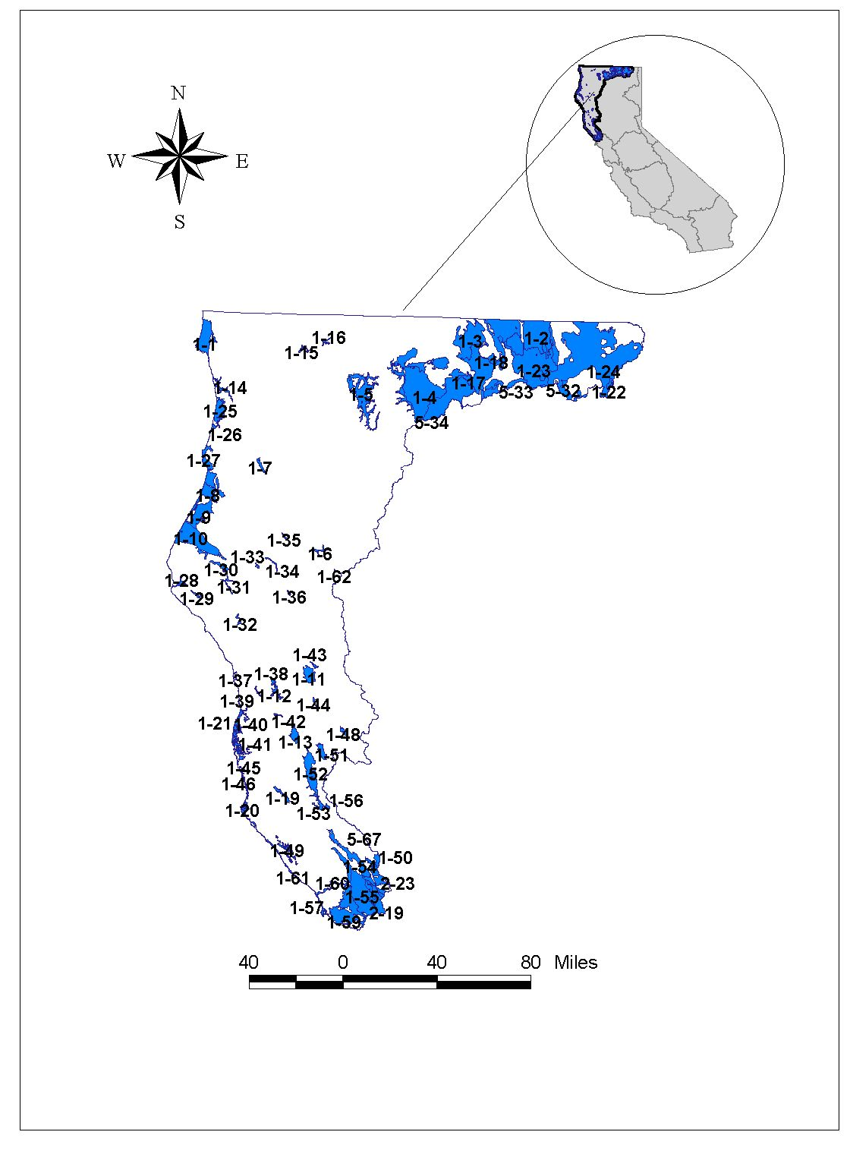

Figure 14: North Coast Hydrologic Region
Modified From DWR, 2002. Note: Not all sub-basins labeled on map.

Table 20: Basins and Subbasins of the North Coast Hydrologic Region

Basin/subbasin | Basin Name | Basin/subbasin | Basin Name
1-1 | Smith River Plain | 1-34 | Dinsmores Town Area
1-2 | Klamath River Valley | 1-35 | Hyampom Valley
1-3 | Butte Valley | 1-36 | Hettenshaw Valley
1-4 | Shasta Valley | 1-37 | Cottoneva Creek Valley
1-5 | Scott River Valley | 1-38 | Lower Laytonville Valley
1-6 | Hayfork Valley | 1-39 | Branscomb Town Area
1-7 | Hoopa Valley | 1-40 | Ten Mile River Valley
1-8 | Mad River Valley | 1-41 | Little Valley
1-8.01 | Mad River Valley Lowland | 1-42 | Sherwood Valley
1-8.02 | Dows Prairie School Area | 1-43 | Williams Valley
1-9 | Eureka Plain | 1-44 | Eden Valley
1-10 | Eel River Valley | 1-45 | Big River Valley
1-11 | Covelo Round Valley | 1-46 | Navarro River Valley
1-12 | Laytonville Valley | 1-48 | Gravelley Valley
1-13 | Little Lake Valley | 1-49 | Anapolis Ohlson Ranch For Highlands
1-14 | Lower Klamath River Valley | 1-50 | Knights Valley
1-15 | Happy Camp Town Area | 1-51 | Potter Valley
1-16 | Seiad Valley | 1-52 | Ukiah Valley
1-17 | Bray Town Area | 1-53 | Sanel Valley
1-18 | Red Rock Valley | 1-54 | Alexander Valley
1-19 | Anderson Valley | 1-54.01 | Alexander Area
1-20 | Garcia River Valley | 1-54.02 | Cloverdale Area
1-21 | Fort Bragg Terrace Area | 1-55 | Santa Rosa Valley
1-22 | Fairchild Swamp Valley | 1-55.01 | Santa Rosa Plain
1-25 | Prairie Creek Area | 1-55.02 | Healdsburg Area
1-26 | Redwood Creek Area | 1-55.03 | Rincon Valley
1-27 | Big Lagoon Area | 1-56 | McDowell Valley
1-28 | Mattole River Valley | 1-57 | Bodega Bay Area
1-29 | Honeydew Town Area | 1-59 | Wilson Grove Formation Highlands
1-30 | Pepperwood Town Area | 1-60 | Lower Russian River Valley
1-31 | Weott Town Area | 1-61 | Fort Ross Terrace Deposits
1-32 | Garberville Town Area | 1-62 | Wilson Point Area
1-33 | Larabee Valley
From: California's Groundwater – Bulletin 118 (2002), Version 2 (Draft) (water quality data provided by California DHS)

Table 21: Three most frequently occurring contaminants by contaminant group in the North Coast Hydrologic Region

Contaminant Group | Contaminant –  # of wells | Contaminant –  # of wells | Contaminant –  # of wells
Inorganics – Primary | Aluminum – 4 | Arsenic – 4 | 4 tied at 1 exceedance
Inorganics – Secondary | Manganese – 150 | Iron – 108 | Copper – 2
Radiological | Radium 228 – 3 | Combined RA226 + RA228 – 3 | Radium 226 – 1
Nitrates | Nitrate(as NO3) – 7 | Nitrite(as N) – 1
Pesticides
VOCs | TCE – 2 | 3 tied at 1 exceedance
From: California's Groundwater – Bulletin 118 (2002), Version 2 (Draft) (water quality data provided by California DHS)

Table 22: Groundwater Quality in North Coast Hydrologic Region
Public Supply Wells  Wells Exceeding MCL (Wells Sampled) |  |  |  |  |  |  |  |  |  |  |  |  | Groundwater Quality  (TDS in mg/L)
Basin/  Subbasin | Inorganics  Primary |  | Inorganics  Secondary |  |  | Radiological | Nitrates |  | Pesticides | VOCs |  |  | Avg | Range
1-1 |  | 1(23) |  | 1(23) |  | 0(12) | 0(26) | 0(8) |  | 1(15) |  | 164 |  | 32 - 496
1-2 |  | () |  |  | () | () | () | () |  | () |  | 721 |  | 140 - 2,200
1-3 |  | 0(1) |  | 0(1) |  | 0(2) | 0(1) | 0(0) |  | 0(0) |  | 310 |  | 55 - 1,110
1-4 |  | 0(5) |  | 0(5) |  | 0(4) | 2(15) | 0(2) |  | 0(2)
1-5 |  | 1(4) |  | 1(4) |  | 0(0) | 0(4) | 0(1) |  | 0(1) |  | 258 |  | 47 - 1,510
1-6 |  | () |  |  | () | () | () | () |  | ()
1-7 |  | () |  |  | () | () | () | () |  | () |  | 125 |  | 95 - 159
1-8
1-8.01 |  | 0(2) |  | 1(2) |  | 0(2) | 0(2) | 0(0) |  | 0(1) |  | 184 |  | 55 - 280
1-8.02 |  | 0(2) |  | 2(2) |  | 0(2) | 0(3) | 0(1) |  | 0(1)
1-9 |  | 0(14) |  | 4(14) |  | 0(8) | 0(20) | 0(8) |  | 0(6) |  | 177 |  | 97 - 460
1-10 |  | 0(24) |  | 8(24) |  | 0(14) | 0(27) | 0(8) |  | 0(12) |  | 237 |  | 110 - 340
1-11 |  | 0(4) |  | 2(4) |  | 0(0) | 0(6) | 0(1) |  | 0(2) |  | 239 |  | 116 - 381
1-12 |  | 2(3) |  | 2(3) |  | 0(2) | 0(3) | 0(2) |  | 0(2) |  | 149 |  | 53 - 251
1-13 |  | () |  |  | () | () | () | () |  | () |  | 340 |  | 97 - 1,710
1-14 |  | 0(10) |  | 2(10) |  | 0(6) | 0(17) | 0(5) |  | 0(6) |  |  |  | 43 - 150
1-15 |  | () |  |  | () | () | () | () |  | ()
1-16 |  | 0(1) |  | 1(1) |  | 0(0) | 0(2) | 0(0) |  | 0(0)
1-17 |  | () |  |  | () | () | () | () |  | ()
1-18 |  | () |  |  | () | () | () | () |  | ()
1-19 |  | 0(6) |  | 2(6) |  | 0(4) | 0(6) | 0(4) |  | 0(3) |  |  |  | 80 - 400
1-20 |  | () |  |  | () | () | () | () |  | ()
1-21 |  | 0(46) |  | 10(46) |  | 0(15) | 0(46) | 0(25) |  | 0(24) |  | 185 |  | 26 - 650
1-22 |  | () |  |  | () | () | () | () |  | ()
1-25 |  | () |  |  | () | () | () | () |  | () |  | 106
1-26 |  | 0(4) |  | 1(4) |  | 0(0) | 0(4) | 0(2) |  | 0(2) |  |  |  | 102 - 332
1-27 |  | 1(7) |  | 1(7) |  | 0(2) | 0(13) | 0(0) |  | 0(0) |  | 174
1-28 |  | () |  |  | () | () | () | () |  | ()
1-29 |  | () |  |  | () | () | () | () |  | ()
1-30 |  | () |  |  | () | () | () | () |  | ()
1-31 |  | 0(2) |  | 0(2) |  | 0(1) | 0(3) | 0(0) |  | 0(0)
1-32 |  | 0(2) |  | 0(2) |  | 0(1) | 0(4) | 0(0) |  | 0(1)
1-33 |  | () |  |  | () | () | () | () |  | ()
1-34 |  | () |  |  | () | () | () | () |  | ()
1-35 |  | 0(0) |  | 0(0) |  | 0(0) | 0(1) | 0(0) |  | 0(0)
1-36 |  | () |  |  | () | () | () | () |  | ()
1-37 |  | () |  |  | () | () | () | () |  | ()
1-38 |  | () |  |  | () | () | () | () |  | () |  | NA |  | NA
1-39 |  | () |  |  | () | () | () | () |  | ()
1-40 |  | () |  |  | () | () | () | () |  | ()
1-41 |  | () |  |  | () | () | () | () |  | ()
1-42 |  | () |  |  | () | () | () | () |  | ()
1-43 |  | () |  |  | () | () | () | () |  | ()
1-44 |  | () |  |  | () | () | () | () |  | ()
1-45 |  | () |  |  | () | () | () | () |  | ()
1-46 |  | () |  |  | () | () | () | () |  | ()
1-48 |  | () |  |  | () | () | () | () |  | ()
1-49 |  | 0(1) |  | 0(1) |  | 0(0) | 0(1) | 0(1) |  | 0(1)
1-50 |  | () |  |  | () | () | () | () |  | ()
1-51 |  | 0(1) |  | 0(1) |  | 0(0) | 0(1) | 0(1) |  | 0(1) |  |  |  | 140 - 395
1-52 |  | 0(23) |  | 6(23) |  | 0(21) | 0(28) | 0(23) |  | 0(22) |  | 224 |  | 108 - 401
1-53 |  | 1(5) |  | 1(5) |  | 0(2) | 0(5) | 0(5) |  | 0(5) |  |  |  | 174-306
1-54
1-54.01 |  | 0(19) |  | 6(19) |  | 0(9) | 0(21) | 0(16) |  | 0(16) |  |  |  | 130 - 444
1-54.02 |  | 0(10) |  | 0(10) |  | 0(7) | 0(10) | 0(9) |  | 0(8) |  |  |  | 130 - 304
1-55
1-55.01 |  | 3(150) |  | 86(150) |  | 5(120) | 1(155) | 0(139) |  | 2(126)
1-55.02 |  | 0(25) |  | 11(25) |  | 0(11) | 0(26) | 0(13) |  | 0(14) |  |  |  | 90 - 500
1-55.03 |  | 0(12) |  | 5(12) |  | 0(9) | 0(14) | 0(11) |  | 0(10)
1-56 |  | () |  |  | () | () | () | () |  | ()
1-57 |  | 0(4) |  | 2(4) |  | 0(3) | 1(4) | 0(3) |  | 0(2)
1-59 |  | 2(61) |  | 31(61) |  | 0(27) | 4(59) | 0(45) |  | 2(43)
1-60 |  | 1(29) |  | 14(29) |  | 2(19) | 0(29) | 0(19) |  | 0(18) |  |  |  | 120-210
1-61 |  | 0(5) |  | 3(5) |  | 0(4) | 0(7) | 0(4) |  | 0(4)
1-62 |  | () |  |  | () | () | () | () |  | ()
From: California's Groundwater – Bulletin 118 (2002), Version 2 (Draft) (water quality data provided by California DHS)

San Francisco Hydrologic Region
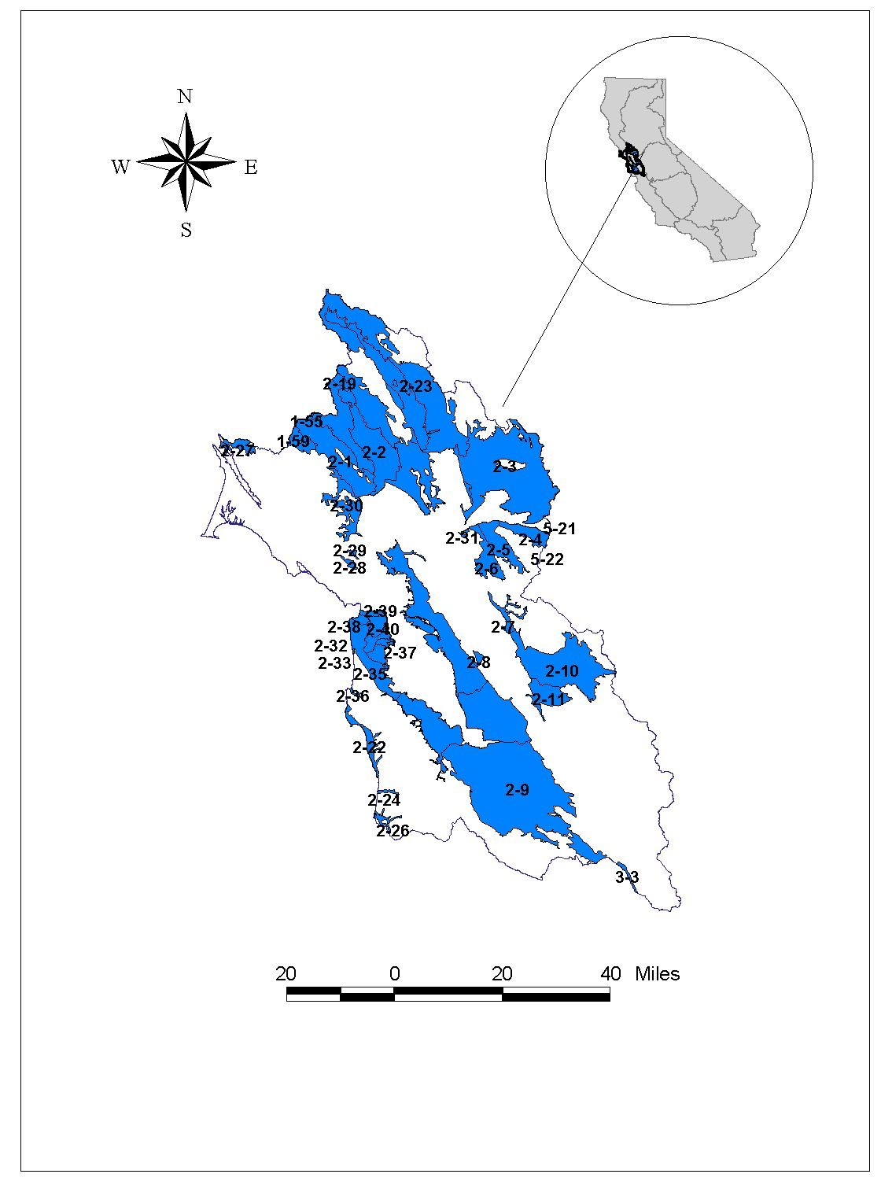

Figure 15: San Francisco Hydrologic Region
Modified From DWR, 2002. Note: Not all sub-basins labeled on map.

Table 23: Basins and Subbasins of the San Francisco Bay Hydrologic Region

Basin/subbasin | Basin Name | Basin/subbasin | Basin Name
2-1 | Petaluma Valley | 2-10 | Livermore Valley
2-2 | Napa-Sonoma Valley | 2-11 | Sunol Valley
2-2.01 | Napa Valley | 2-19 | Kenwood Valley
2-2.02 | Sonoma Valley | 2-22 | Half Moon Bay Terrace
2-2.03 | Napa-Sonoma Lowlands
2-3 | Suisun-Fairfield Valley | 2-24 | San Gregorio Valley
2-4 | Pittsburg Plain | 2-26 | Pescadero Valley
2-5 | Clayton Valley | 2-27 | Sand Point Area
2-6 | Ygnacio Valley | 2-28 | Ross Valley
2-7 | San Ramon Valley | 2-29 | San Rafael Valley
2-8 | Castro Valley | 2-30 | Novato Valley
2-9 | Santa Clara Valley | 2-31 | Arroyo Del Hambre Valley
2-9.01 | Niles Cone | 2-32 | Visitation Valley
2-9.02 | Santa Clara | 2-33 | Islais Valley
2-9.03 | San Mateo Plain | 2-34 | San Francisco Sand Dune Area
2-9.04 | East Bay Plain | 2-35 | Merced Valley
 |  | 2-36 | San Pedro Valley
From: California's Groundwater – Bulletin 118 (2002), Version 2 (Draft) (water quality data provided by California DHS)

Table 24: Three most frequently occurring contaminants by contaminant group in the
San Francisco Bay Hydrologic Region

Contaminant Group | Contaminant –  # of wells | Contaminant –  # of wells | Contaminant –  # of wells
Inorganics | Iron – 57 | Manganese – 57 | Fluoride – 7
Radiological | Gross Alpha – 2 | Radium 226 – 1
Nitrates | Nitrate (as NO3) – 27 | Nitrate + Nitrite – 3 | Nitrite (as N) – 1
Pesticides | Di(2-Ethylhexyl)phthalate – 4 | Heptachlor – 1
VOCs | Tetrachloroethylene – 4 | Dichloromethane – 3 | Trichloroethylene – 2  Vinyl Chloride – 2
From: California's Groundwater – Bulletin 118 (2002), Version 2 (Draft) (water quality data provided by California DHS)
Table 25: Groundwater Quality in San Francisco Bay Hydrologic Region

Public Supply Wells  Wells Exceeding MCL (Wells Sampled) |  |  |  |  |  |  |  |  |  |  |  | Groundwater Quality  (TDS in mg/L)
Basin/  Subbasin | Inorganics  Primary |  | Inorganics  Secondary |  | Radiological |  | Nitrates |  | Pesticides | VOCs |  | Avg |  | Range
2-1 |  | 1(25) |  | 9(25) | 0(16) | 1(27) |  | 0(16) |  |  | 0(16) |  | 347 | 58-650
2-2
2-2.01 |  | 1(5) |  | 3(5) | 0(2) | 0(4) |  | 0(9) |  |  | 0(6) |  | 272 | 150-370
2-2.02 |  | 3(26) |  | 5(26) | 0(7) | 0(27) |  | 0(15) |  |  | 0(16) |  | 321 | 100-550
2-2.03 |  | 0(1) |  | 0(1) | 0(2) | 0(1) |  | 0(2) |  |  | 1(2) |  | 185 | 50-300
2-3 |  | 1(15) |  | 3(15) | 0(6) | 2(16) |  | 0(12) |  |  | 0(13) |  | 410 | 160-740
2-4 |  | 0(3) |  | 3(3) | 1(4) | 1(3) |  | 0(6) |  |  | 0(6)
2-5 |  | 0(5) |  | 2(5) | 0(5) | 0(5) |  | 0(5) |  |  | 0(5)
2-6 |  | 0(0) |  | 0(0) | 0(1) | 0(1) |  | 0(0) |  |  | 0(0)
2-7 |  | () |  | () | () | () |  | () |  |  | ()
2-8 |  | () |  | () | () | () |  | () |  |  | ()
2-9
2-9.01 |  | 4(16) |  | 7(16) | 1(14) | 1(16) |  | 0(16) |  |  | 0(16)
2-9.02 |  | 9(257) |  | 29(257) | 1(234) | 10(268) |  | 3(253) |  |  | 4(252) |  | 408 | 200-931
2-9.03 |  | 0(10) |  | 2(10) | 0(11) | 0(10) |  | 0(11) |  |  | 0(9) |  | 407 | 300-480
2-9.04 |  | 0(5) |  | 2(5) | 0(4) | 0(5) |  | 0(3) |  |  | 0(3) |  | 638 | 364-1,420
2-10 |  | 0(33) |  | 5(33) | 0(24) | 5(33) |  | 1(31) |  |  | 2(31)
2-11 |  | () |  | () | () | () |  | () |  |  | ()
2-19 |  | 2(10) |  | 4(10) | 0(4) | 0(10) |  | 0(6) |  |  | 0(6)
2-22 |  | 3(12) |  | 10(12) | 0(13) | 0(12) |  | 1(13) |  |  | 4(13)
2-24 |  | () |  | () | () | () |  | () |  |  | ()
2-26 |  | () |  | () | () | () |  | () |  |  | ()
2-27 |  | 0(3) |  | 0(3) | 0(3) | 0(3) |  | 0(3) |  |  | 0(3)
2-28 |  | () |  | () | () | () |  | () |  |  | ()
2-29 |  | () |  | () | () | () |  | () |  |  | ()
2-30 |  | 0(2) |  | 0(2) | 0(1) | 0(2) |  | 0(1) |  |  | 0(1)
2-31 |  | () |  | () | () | () |  | () |  |  | ()
2-32 |  | () |  | () | () | () |  | () |  |  | ()
2-33 |  | () |  | () | () | () |  | () |  |  | ()
2-35 |  | 3(16) |  | 5(16) | 0(12) | 8(15) |  | 0(17) |  |  | 2(17)
2-36 |  | () |  | () | () | () |  | () |  |  | ()
2-37 |  | () |  | () | () | () |  | () |  |  | ()
2-38 |  | () |  | () | () | () |  | () |  |  | ()
2-39 |  | () |  | () | () | () |  | () |  |  | ()
2-40 |  | () |  | () | () | () |  | () |  |  | ()
From: California's Groundwater – Bulletin 118 (2002), Version 2 (Draft) (water quality data provided by California DHS)

Central Coast Hydrologic Region

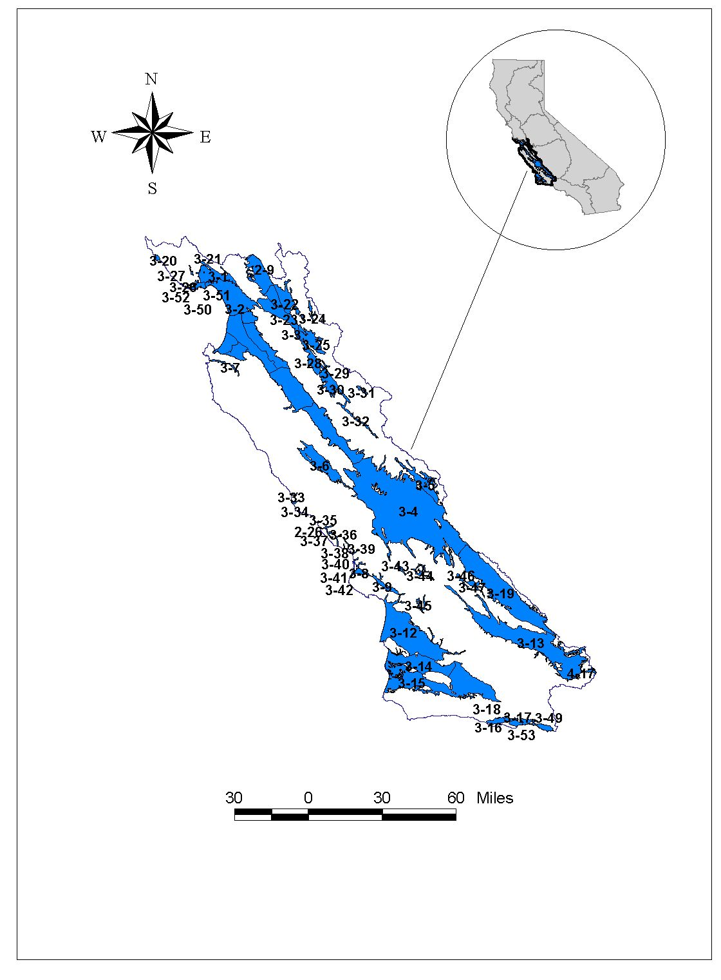

Figure 16: Central Coast Hydrologic Region
Modified From DWR, 2002. Note: Not all sub-basins labeled on map.

Table 26: Basins and Subbasins of Central Coast Hydrologic Region

Basin/subbasin | Basin Name | Basin/subbasin | Basin Name
3-1 | Soquel Valley | 3-24 | Quien Sabe Valley
3-2 | Pajaro Valley | 3-25 | Tres Pinos Valley
3-3 | Gilroy-Hollister Valley | 3-26 | West Santa Cruz Terrace
3-3.01 | Llagas Area | 3-27 | Scotts Valley
3-3.02 | Bolsa Area | 3-28 | San Benito River Valley
3-3.03 | Hollister Area | 3-29 | Dry Lake Valley
3-3.04 | San Juan Bautista Area | 3-30 | Bitter Water Valley
3-4 | Salinas Valley | 3-31 | Hernandez Valley
3-4.01 | 180/400 Foot Aquifer | 3-32 | Peach Tree Valley
3-4.02 | East Side Aquifer | 3-33 | San Carpoforo Valley
3-4.04 | Forebay Aquifer | 3-34 | Arroyo de la Cruz Valley
3-4.05 | Upper Valley Aquifer | 3-35 | San Simeon Valley
3-4.06 | Paso Robles Area | 3-36 | Santa Rosa Valley
3-4.08 | Seaside Area | 3-37 | Villa Valley
3-4.09 | Langley Area | 3-38 | Cayucos Valley
3-4.10 | Corral de Tierra Area | 3-39 | Old Valley
3-5 | Cholame Valley | 3-40 | Toro Valley
3-6 | Lockwood Valley | 3-41 | Morro Valley
3-7 | Carmel Valley | 3-42 | Chorro Valley
3-8 | Los Osos Valley | 3-43 | Rinconada Valley
3-9 | San Luis Obispo Valley | 3-44 | Pozo Valley
3-12 | Santa Maria River Valley | 3-45 | Huasna Valley
3-13 | Cuyama Valley | 3-46 | Rafael Valley
3-14 | San Antonio Creek Valley | 3-47 | Big Spring Area
3-15 | Santa Ynez River Valley | 3-49 | Montecito
3-16 | Goleta | 3-50 | Felton Area
3-17 | Santa Barbara | 3-51 | Majors Creek
3-18 | Carpinteria | 3-52 | Needle Rock Point
3-19 | Carrizo Plain | 3-53 | Foothill
3-20 | Ano Nuevo Area
3-21 | Santa Cruz Purisima Formation
3-22 | Santa Ana Valley
3-23 | Upper Santa Ana Valley
From: California's Groundwater – Bulletin 118 (2002), Version 2 (Draft) (water quality data provided by California DHS)

Table 27: Three most frequently occurring contaminants by contaminant group in the Central Coast Hydrologic Region

Contaminant Group | Contaminant –  # of wells | Contaminant –  # of wells | Contaminant –  # of wells
Inorganics – Primary | Antimony – 6 | Aluminum – 4 | Chromium (Total) – 4
Inorganics – Secondary | Iron – 145 | Manganese – 135 | TDS – 11
Radiological | Gross Alpha – 15 | Radium 226 – 3 | Uranium – 3
Nitrates | Nitrate (as NO3) – 69 | Nitrate + Nitrite – 24
Pesticides | Heptachlor – 4 | Di (2-Ethylhexyl) phthalate – 2
VOCs | TCE – 3 | 3 are tied at 2 exceedances
From: California's Groundwater – Bulletin 118 (2002), Version 2 (Draft) (water quality data provided by California DHS)
Table 28: Groundwater Quality in the Central Coast Hydrologic Region

Public Supply Wells  Wells Exceeding MCL (Wells Sampled) |  |  |  |  |  |  | Groundwater Quality  (TDS in mg/L)
Basin/  Subbasin | Inorganics  Primary | Inorganics  Secondary | Radiological | Nitrates | Pesticides | VOCs | Avg | Range
3-1 | 0(14) | 8(14) | 0(10) | 0(10) | 0(8) | 0(8) | 482 | 270-990
3-2 | 0(37) | 9(37) | 0(34) | 0(37) | 1(41) | 0(42) | 580-910 | 300-30,000
3-3
3-3.01 | 3(65) | 11(65) | 0(35) | 13(72) | 5(51) | 0(51)
3-3.02 | 0(1) | 0(1) | 0(1) | 1(3) | 0(1) | 0(1)
3-3.03 | 0(24) | 9(24) | 0(10) | 3(24) | 0(16) | 0(16)
3-3.04 | 5(33) | 16(33) | 4(23) | 8(37) | 0(29) | 0(30)
3-4
3-4.01 | 0(33) | 7(33) | 3(36) | 2(33) | 0(41) | 4(41) | 478 | 223-1,013
3-4.02 | 0(28) | 4(28) | 0(30) | 2(28) | 0(30) | 0(30) | 450 | 168-977
3-4.04 | 2(15) | 6(15) | 0(17) | 3(14) | 0(14) | 0(15) | 624 | 300-1,100
3-4.05 | 4(12) | 0(12) | 0(11) | 6(12) | 0(13) | 0(13) | 443 | 140-3,700
3-4.06 | 1(56) | 13(56) | 5(52) | 4(58) | 0(51) | 1(51) | 614 | 165-3,868
3-4.08 | 1(19) | 6(19) | 3(21) | 0(21) | 0(20) | 0(20) | 600 | 200-900
3-4.09 | 0(6) | 0(6) | 0(4) | 0(2) | 0(11) | 0(11) | Unknown | 52-348
3-4.10 | 0(9) | 5(9) | 0(11) | 0(9) | 0(10) | 0(10)
3-5 | () | () | () | () | () | () |  | Unknown
3-6 | 0(5) | 0(5) | 0(4) | 0(5) | 0(5) | 0(5)
3-7 | 0(18) | 14(18) | 0(17) | 0(18) | 0(18) | 0(18) | 260-670 | 220-1,200
3-8 | 0(11) | 5(11) | 0(10) | 2(11) | 0(10) | 0(10) | 354 | 78-33,700
3-9 | 0(5) | 2(5) | 0(5) | 0(6) | 0(5) | 0(5) | 583 | 278-1,949
3-12 | 2(81) | 19(81) | 1(79) | 15(81) | 0(79) | 1(79) | 598 | 139-1,200
3-13 | 1(4) | 3(4) | 0(3) | 0(4) | 0(2) | 0(2) |  | 206-3,905
3-14 | 0(7) | 5(7) | 0(7) | 0(7) | 0(6) | 0(6) | 415 | 129-8,040
3-15 | 0(49) | 25(49) | 0(51) | 4(58) | 0(52) | 0(51) | 507 | 400-700
3-16 | 0(12) | 5(12) | 1(12) | 0(12) | 0(5) | 0(11) | 755 | 617-929
3-17 | 0(4) | 3(4) | 0(3) | 0(4) | 0(3) | 0(3) |  | 217-385
3-18 | 0(4) | 3(4) | 0(4) | 0(4) | 0(4) | 0(4) | 557 | 317-1,780
3-19 | () | () | () | () | () | ()
3-20 | () | () | () | () | () | ()
3-21 | 1(7) | 6(7) | 0(3) | 0(6) | 0(10) | 1(10) | 440 | 380-560
3-22 | () | () | () | () | () | () |  | Unknown
3-23 | () | () | () | () | () | () |  | Unknown
3-24 | () | () | () | () | () | () |  | Unknown
3-25 | 0(3) | 1(3) | 0(2) | 0(2) | 0(1) | 0(1) |  | Unknown
3-26 | 0(6) | 4(6) | 0(6) | 0(5) | 0(5) | 1(5)
3-27 | 0(4) | 2(4) | 0(4) | 0(4) | 0(4) | 2(4) | 360 | 100-980
3-28 | () | () | () | () | () | () |  | Unknown
3-29 | 0(0) | 0(0) | 0(0) | 0(2) | 0(0) | 0(0) |  | Unknown
3-30 | () | () | () | () | () | () |  | Unknown
3-31 | () | () | () | () | () | () |  | Unknown
3-32 | () | () | () | () | () | () |  | Unknown
3-33 | () | () | () | () | () | () |  | 217-385
3-34 | () | () | () | () | () | () |  | 211-381
3-35 | 0(3) | 0(3) | 0(3) | 0(3) | 0(3) | 0(3) | 413 | 46-2,210
3-36 | 0(1) | 1(1) | 0(1) | 0(1) | 0(1) | 0(1) |  | 298-2,637
3-37 | () | () | () | () | () | () |  | 260-1,635
3-38 | () | () | () | () | () | () |  | 815-916
3-39 | 0(1) | 0(1) | 0(0) | 0(1) | 0(1) | 0(0) |  | 346-2,462
3-40 | () | () | () | () | () | () |  | 458-732
3-41 | 1(4) | 2(4) | 0(4) | 0(4) | 0(4) | 0(4) | 1150 | 469-5,100
3-42 | 0(6) | 2(6) | 0(4) | 4(6) | 0(4) | 0(4) | 656 | 60-3,606
3-43 | () | () | () | () | () | ()
3-44 | () | () | () | () | () | () |  | 287-676
3-45 | () | () | () | () | () | ()
3-46 | () | () | () | () | () | ()
3-47 | () | () | () | () | () | ()
3-49 | 0(14) | 8(14) | 0(15) | 2(16) | 0(5) | 0(5) | 700 | 600-1,100
3-50 | () | () | () | () | () | ()
3-51 | () | () | () | () | () | ()
3-52 | () | () | () | () | () | ()
3-53 | 0(7) | 1(7) | 1(8) | 0(7) | 0(7) | 1(7) | 828 | 554-1,118
From: California's Groundwater – Bulletin 118 (2002), Version 2 (Draft) (water quality data provided by California DHS)

South Coast Hydrologic Region
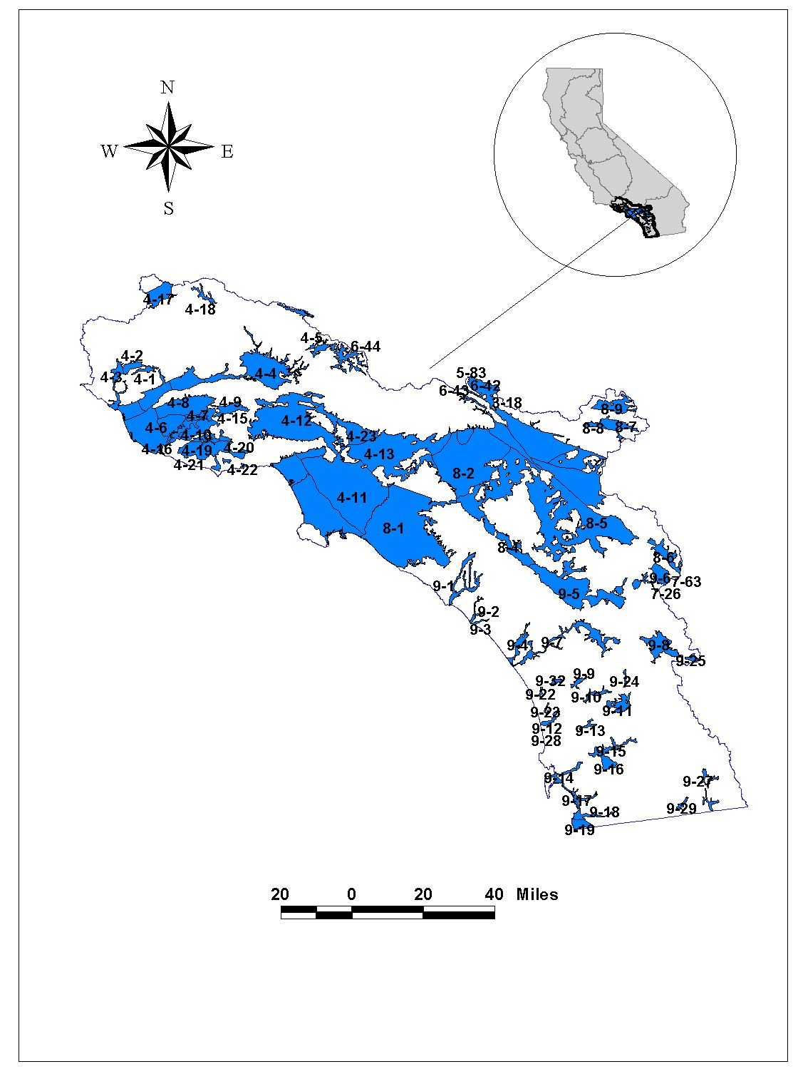

Figure 17: South Coast Hydrologic Region
Modified From DWR, 2002. Note: Not all sub-basins labeled on map.

Table 29: Basins and Subbasins of the South Coast Hydrologic Region

Basin/subbasin | Basin Name | Basin/subbasin | Basin Name
4-1 | Upper Ojai Valley | 8-2.04 | Rialto-Colton
4-2 | Ojai Valley | 8-2.05 | Cajon
4-3 | Ventura River Valley | 8-2.06 | Bunker Hill
4-3.01 | Upper Ventura River | 8-2.07 | Yucaipa
4-3.02 | Lower Ventura River | 8-2.08 | San Timoteo
4-4 | Santa Clara River Valley | 8-2.09 | Temescal
4-4.02 | Oxnard | 8-4 | Elsinore
4-4.03 | Mound | 8-5 | San Jacinto
4-4.04 | Santa Paula | 8-6 | Hemet Lake Valley
4-4.05 | Fillmore | 8-7 | Big Meadows Valley
4-4.06 | Piru | 8-8 | Seven Oaks Valley
4-4.07 | Santa Clara River Valley East | 8-9 | Bear Valley
4-5 | Acton Valley | 9-1 | San Juan Valley
4-6 | Pleasant Valley | 9-2 | San Mateo Valley
4-7 | Arroyo Santa Rosa Valley | 9-3 | San Onofre Valley
4-8 | Las Posas Valley | 9-4 | Santa Margarita Valley
4-9 | Simi Valley | 9-5 | Temecula Valley
4-10 | Conejo Valley | 9-6 | Coahuila Valley
4-11 | Coastal Plain of Los Angeles | 9-7 | San Luis Rey Valley
4-11.01 | Santa Monica | 9-8 | Warner Valley
4-11.02 | Hollywood | 9-9 | Escondido Valley
4-11.03 | West Coast | 9-10 | San Pasqual Valley
4-11.04 | Central | 9-11 | Santa Maria Valley
4-12 | San Fernando Valley | 9-12 | San Dieguito Creek
4-13 | San Gabriel Valley | 9-13 | Poway Valley
4-15 | Tierre Rejada | 9-14 | Mission Valley
4-16 | Hidden Valley | 9-15 | San Diego River Valley
4-17 | Lockwood Valley | 9-16 | El Cajon Valley
4-18 | Hungry Valley | 9-17 | Sweetwater Valley
4-19 | Thousand Oaks Area | 9-18 | Otay Valley
4-20 | Russell VAlley | 9-19 | Tijuana Basin
4-21X | Conejo-Tierra Rejada Volcanic | 9-22 | Batiquitos Lagoon Valley
4-22 | Malibu Valley | 9-23 | San Elijo Valley
4-23 | Raymond | 9-24 | Pamo Valley
8-1 | Coastal Plain of Orange County | 9-25 | Ranchita Town Area
8-2 | Upper Santa Ana Valley | 9-27 | Cottonwood Valley
8-2.01 | Chino | 9-28 | Campo Valley
8-2.02 | Cucamonga | 9-29 | Potrero Valley
8-2.03 | Riverside-Arlington | 9-32 | San Marcos Area
From: California's Groundwater – Bulletin 118 (2002), Version 2 (Draft) (water quality data provided by California DHS)

Table 30: Three most frequently occurring contaminants by contaminant group in the South Coast Hydrologic Region

Contaminant Group | Contaminant –  # of wells | Contaminant –  # of wells | Contaminant –  # of wells
Inorganics – Primary | Fluoride – 56 | Thallium – 13 | Aluminum – 12
Inorganics – Secondary | Iron – 337 | Manganese – 335 | TDS – 36
Radiological | Gross Alpha – 104 | Uranium – 40 | Radium 226 – 9  Radium 228 – 9
Nitrates | Nitrate (as NO3) – 364 | Nitrate + Nitrite – 179 | Nitrate Nitrogen (NO3-N) – 14
Pesticides | DBCP – 61 | Di(2-Ethylhexyl)phthalate –5 | Heptchlor – 2  EDB – 2
VOCs | Trichloroethylene – 196 | Tetrachloroethylene – 152 | 1,2 Dichloroethane – 89
From: California's Groundwater – Bulletin 118 (2002), Version 2 (Draft) (water quality data provided by California DHS)
Table 31: Groundwater Quality in the South Coast Hydrologic Region

Public Supply Wells  Wells Exceeding MCL (Wells Sampled) |  |  |  |  |  |  |  |  |  |  | Groundwater Quality  (TDS in mg/L)
Basin/  Subbasin | Inorganics  Primary |  | Inorganics  Secondary |  | Radiological | Nitrates | Pesticides | VOCs |  |  | Avg | Range
4-1 |  | 0(1) |  | 1(1) | 0(1) | 0(1) | 0(1) | 0(1) |  | 707 |  | 438-1,249
4-2 |  | 0(8) |  | 8(8) | 1(8) | 1(8) | 0(8) | 0(6) |  | 640 |  | 450-1,140
4-3
4-3.01 |  | 4(17) |  | 4(17) | 0(17) | 2(18) | 0(16) | 0(16) |  | 706 |  | 500-1,240
4-3.02 |  | () |  | () | () | () | () | () |  |  |  | 760-3,000
4-4
4-4.02 |  | 6(73) |  | 49(73) | 8(69) | 14(80) | 1(63) | 2(68) |  | 1,102 |  | 160-1,800
4-4.03 |  | 1(2) |  | 2(2) | 0(2) | 0(2) | 0(2) | 0(2) |  | 1,644 |  | 1,498-1,908
4-4.04 |  | 3(16) |  | 15(16) | 1(12) | 2(16) | 0(9) | 0(9) |  | 1,198 |  | 470-3,010
4-4.05 |  | 0(13) |  | 3(13) | 1(10) | 1(14) | 0(10) | 1(10) |  | 1,100 |  | 800-2,400
4-4.06 |  | 0(3) |  | 1(3) | 0(3) | 0(3) | 0(3) | 0(3) |  | 1,300 |  | 608-2,400
4-4.07 |  | 4(67) |  | 7(67) | 2(56) | 2(74) | 4(66) | 0(66)
4-5 |  | 0(7) |  | 0(7) | 0(0) | 1(14) | 0(4) | 0(4)
4-6 |  | 0(10) |  | 10(10) | 1(10) | 0(10) | 0(10) | 0(10) |  | 1,110 |  | 597-3,490
4-7 |  | 1(8) |  | 2(8) | 0(8) | 5(8) | 0(8) | 0(8) |  | 1,006 |  | 670-1,200
4-8 |  | 1(22) |  | 16(22) | 2(22) | 0(24) | 1(22) | 0(22) |  | 742 |  | 338-1,700
4-9 |  | 0(4) |  | 3(4) | 3(4) | 1(4) | 0(4) | 0(1) |  |  |  | 1,580
4-10 |  | 0(3) |  | 0(3) | 0(2) | 1(3) | 0(1) | 0(2) |  | 631 |  | 335-2,064
4-11
4-11.01 |  | 0(13) |  | 8(13) | 1(12) | 0(13) | 0(12) | 9(12) |  | 916 |  | 729-1,156
4-11.02 |  | () |  | () | () | () | () | () |  |  |  | 526
4-11.03 |  | 0(45) |  | 30(45) | 1(45) | 0(46) | 0(46) | 0(44) |  | 456
4-11.04 |  | 15(316) |  | 113(316) | 1(315) | 2(315) | 0(322) | 43(344) |  | 453 |  | 200-2,500
4-12 |  | 6(129) |  | 17(129) | 13(122) | 44(129) | 3(134) | 90(134) |  | 499 |  | 176-1,160
4-13 |  | 3(287) |  | 20(287) | 4(278) | 73(300) | 1(292) | 85(301) |  | 367 |  | 90-4,288
4-15 |  | () |  | () | () | () | () | () |  |  |  | 619-930
4-16 |  | () |  | () | () | () | () | () |  | 453 |  | 289-743
4-17 |  | 0(1) |  | 1(1) | 0(0) | 0(1) | 0(1) | 0(1)
4-18 |  | () |  | () | () | () | () | () <350
4-19 |  | () |  | () | () | () | () | () |  | 1,410 |  | 1,200-2,300
4-20 |  | () |  | () | () | () | () | ()
4-21X |  | () |  | () | () | () | () | ()
4-22 |  | () |  | () | () | () | () | ()
4-23 |  | 9(66) |  | 9(66) | 8(55) | 23(78) | 0(57) | 19(60) |  | 346 |  | 138-780
8-1 |  | 1(249) |  | 21(249) | 5(253) | 15(267) | 0(268) | 7(268) |  | 475 |  | 232-661
8-2
8-2.01 |  | 17(153) |  | 31(153) | 5(149) | 73(164) | 6(153) | 10(151) |  | 484 |  | 200-600
8-2.02 |  | 0(24) |  | 4(24) | 0(23) | 14(24) | 10(24) | 0(24)
8-2.03 |  | 2(48) |  | 11(48) | 11(48) | 21(51) | 19(50) | 8(50) |  |  |  | 370-756
8-2.04 |  | 0(38) |  | 3(38) | 0(40) | 2(38) | 0(40) | 3(40) |  | 337
8-2.05 |  | 0(2) |  | 1(2) | 0(2) | 0(2) | 0(2) | 0(2)
8-2.06 |  | 13(212) |  | 25(212) | 34(207) | 34(214) | 20(211) | 32(211) |  |  |  | 150-550
8-2.07 |  | 1(43) |  | 4(43) | 1(44) | 12(46) | 4(43) | 1(44) |  | 334
8-2.08 |  | 0(27) |  | 1(27) | 0(26) | 0(28) | 0(27) | 0(27)
8-2.09 |  | 2(20) |  | 2(20) | 1(17) | 13(20) | 0(17) | 0(17) |  | 753 |  | 373-950
8-4 |  | 1(18) |  | 4(18) | 0(20) | 0(18) | 0(20) | 1(20)
8-5 |  | 3(56) |  | 15(56) | 2(56) | 12(58) | 1(55) | 0(54) |  | 463 |  | 160-12,000
8-6 |  | 0(5) |  | 2(5) | 0(5) | 0(5) | 0(5) | 0(5)
8-7 |  | 0(4) |  | 0(4) | 0(3) | 0(4) | 0(3) | 0(3)
8-8 |  | () |  | () | () | () | () | ()
8-9 |  | 7(33) |  | 5(33) | 0(37) | 0(32) | 0(20) | 0(31)
9-1 |  | 0(3) |  | 3(3) | 0(3) | 0(3) | 1(3) | 0(3) |  | 760 |  | 430-12,880
9-2 |  | 1(5) |  | 3(5) | 0(4) | 2(5) | 0(5) | 0(5) |  | 586 |  | 490-770
9-3 |  | () |  | () | () | () | () | () |  |  |  | 600-1,500
9-4 |  | () |  | () | () | () | () | () |  |  |  | 337-9,030
9-5 |  | 4(56) |  | 16(56) | 1(57) | 2(56) | 0(58) | 2(56) |  | 476 |  | 220-1,500
9-6 |  | () |  | () | () | () | () | () |  |  |  | 304-969
9-7 |  | 10(27) |  | 17(27) | 3(23) | 2(24) | 0(19) | 1(19) |  | 1,258 |  | 530-7,060
9-8 |  | 0(2) |  | 1(2) | 1(1) | 0(2) | 0(1) | 0(1) |  |  |  | 263
9-9 |  | () |  | () | () | () | () | () |  |  |  | 250-5,000
9-10 |  | () |  | () | () | () | () | () |  |  |  | 500-1,550
9-11 |  | 0(3) |  | 0(3) | 3(3) | 0(3) | 0(3) | 0(2) |  | 1,000 |  | 324-1,680
9-12 |  | () |  | () | () | () | () | () |  |  |  | 2,000
9-13 |  | 0(1) |  | 0(1) | 0(0) | 0(1) | 0(1) | 0(1) |  |  |  | 610-1,500
9-14 |  | () |  | () | () | () | () | ()
9-15 |  | 0(1) |  | 1(1) | 0(1) | 0(1) | 0(1) | 0(1) |  |  |  | 260-2,870
9-16 |  | 0(1) |  | 1(1) | 1(1) | 0(1) | 0(1) | 1(1) |  |  |  | 2,340
9-17 |  | 0(9) |  | 9(9) | 3(9) | 0(9) | 0(9) | 0(9) |  | 2,114 |  | 300-50,000
9-18 |  | () |  | () | () | () | () | () |  |  |  | 500->2,000
9-19 |  | () |  | () | () | () | () | () |  |  |  | 380-3,620
9-22 |  | () |  | () | () | () | () | () | 1,280 |  |  | 788-2,362
9-23 |  | () |  | () | () | () | () | () |  |  |  | 1,170-5,090
9-24 |  | () |  | () | () | () | () | () | 369 |  |  | 279-455
9-25 |  | () |  | () | () | () | () | () |  |  |  | 283-305
9-27 |  | () |  | () | () | () | () | ()
9-28 |  | () |  | () | () | () | () | () |  |  |  | 800
9-29 |  | () |  | () | () | () | () | ()
9-32 |  | () |  | () | () | () | () | () |  |  |  | 500-700
From: California's Groundwater – Bulletin 118 (2002), Version 2 (Draft) (water quality data provided by California DHS)
Sacramento River Hydrologic Region
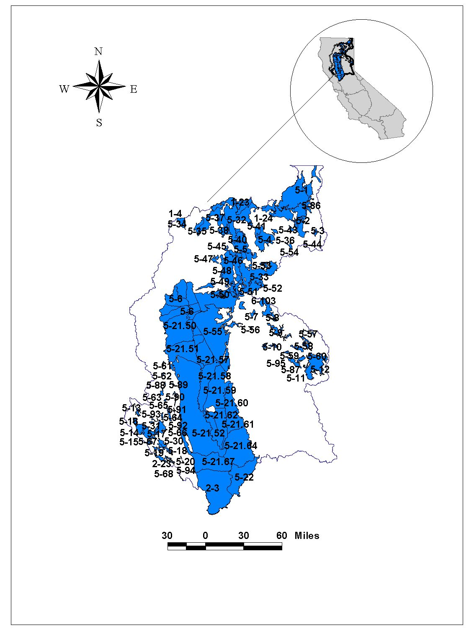

Figure 18: Sacramento River Hydrologic Region
Modified From DWR, 2002. Note: Not all sub-basins labeled on map.

Table 32: Basins and Subbasins of Sacramento River Hydrologic Region

Basin/subbasins | Basin Name | Basin/subbasins | Basin Name
5-1 | Goose Lake Valley | 5-21.64 | North American
5-1.01 | Lower Goose Lake Valley | 5-21.65 | South American
5-1.02 | Fandango Valley | 5-21.66 | Solano
5-2 | Alturas Area | 5-21.67 | Yolo
5-2.01 | South Fork Pitt River | 5-21.68 | Capay Valley
5-2.02 | Warm Springs Valley | 5-30 | Lower Lake Valley
5-3 | Jess Valley | 5-31 | Long Valley
5-4 | Big Valley | 5-35 | Mccloud Area
5-5 | Fall River Valley | 5-36 | Round Valley
5-6 | Redding Area | 5-37 | Toad Well Area
5-6.01 | Bowman | 5-38 | Pondosa Town Area
5-6.02 | Rosewood | 5-40 | Hot Springs Valley
5-6.03 | Anderson | 5-41 | Egg Lake Valley
5-6.04 | Enterprise | 5-43 | Rock Prairie Valley
5-6.05 | Millville | 5-44 | Long Valley
5-6.06 | South Battle Creek | 5-45 | Cayton Valley
5-7 | Lake Almanor Valley | 5-46 | Lake Britton Area
5-8 | Mountain Meadows Valley | 5-47 | Goose Valley
5-9 | Indian Valley | 5-48 | Burney Creek Valley
5-10 | American Valley | 5-49 | Dry Burney Creek Valley
5-11 | Mohawk Valley | 5-50 | North Fork Battle Creek
5-12 | Sierra Valley | 5-51 | Butte Creek Valley
5-12.01 | Sierra Valley | 5-52 | Gray Valley
5-12.02 | Chilcoot | 5-53 | Dixie Valley
5-13 | Upper Lake Valley | 5-54 | Ash Valley
5-14 | Scotts Valley | 5-56 | Yellow Creek Valley
5-15 | Big Valley | 5-57 | Last Chance Creek Valley
5-16 | High Valley | 5-58 | Clover Valley
5-17 | Burns Valley | 5-59 | Grizzly Valley
5-18 | Coyote Valley | 5-60 | Humbug Valley
5-19 | Collayomi Valley | 5-61 | Chrome Town Area
5-20 | Berryessa Valley | 5-62 | Elk Creek Area
5-21 | Sacramento Valley | 5-63 | Stonyford Town Area
5-21.50 | Red Bluff | 5-64 | Bear Valley
5-21.51 | Corning | 5-65 | Little Indian Valley
5-21.52 | Colusa | 5-66 | Clear Lake Cache Formation
5-21.53 | Bend | 5-68 | Pope Valley
5-21.54 | Antelope | 5-86 | Joseph Creek
5-21.55 | Dye Creek | 5-87 | Middle Fork Feather River
5-21.56 | Los Molinos | 5-88 | Stony Gorge Reservoir
5-21.57 | Vina | 5-89 | Squaw Flat
5-21.58 | West Butte | 5-90 | Funks Creek
5-21.59 | East Butte | 5-91 | Antelope Creek
5-21.60 | North Yuba | 5-92 | Blanchard Valley
5-21.61 | South Yuba | 5-93 | North Fork Cache Creek
5-21.62 | East Sutter | 5-94 | Middle Creek
5-21.63 | West Sutter | 5-95 | Meadow Valley
From: California's Groundwater – Bulletin 118 (2002), Version 2 (Draft) (water quality data provided by California DHS)

Table 33: Three most frequently occurring contaminants by contaminant group in the Sacramento River Hydrologic Region

Contaminant Group | Contaminant –  # of wells | Contaminant –  # of wells | Contaminant –  # of wells
Inorganics – Primary | Cadmium – 4 | Chromium (Total) – 3 | 3 tied at 2
Inorganics – Secondary | Manganese – 221 | Iron – 166 | Specific Conductance – 3
Radiological | Gross Alpha – 4
Nitrates | Nitrate (as NO3) – 22 | Nitrate + Nitrite – 5 | Nitrate Nitrogen (NO3-N) – 2
Pesticides | Di(2-Ethylhexyl)phthalate–4
VOCs | Tetrachloroethylene–11 | Trichloroethylene – 7 | Benzene – 4
From: California's Groundwater – Bulletin 118 (2002), Version 2 (Draft) (water quality data provided by California DHS)

Table 34: Groundwater Quality in the Sacramento River Hydrologic Region

Public Supply Wells  Wells Exceeding MCL (Wells Sampled) |  |  |  |  |  |  |  |  | Groundwater Quality  (TDS in mg/L)
Basin/  Subbasin | Inorganics  Primary |  | Inorganics  Secondary |  | Radiological | Nitrates | Pesticides | VOCs | Avg | Range
5-1
5-1.01 |  | () |  | () | () | () | () | () | 183 | 68 - 528
5-1.02 |  | () |  | () | () | () | () | ()
5-2 |  |  |  |  |  |  |  |  | 357 | 180 - 800
5-2.01 |  | () |  | () | () | () | () | ()
5-2.02 |  | () |  | () | () | () | () | ()
5-3 |  | () |  | () | () | () | () | ()
5-4 |  | 0(7) |  | 4(7) | 0(5) | 0(9) | 0(3) | 0(3) | 260 | 141 - 633
5-5 |  | 0(1) |  | 0(1) | 0(2) | 0(2) | 0(1) | 0(1) | 174 | 115 - 232
5-6
5-6.01 |  | 0(6) |  | 1(6) | 0(5) | 0(6) | 0(5) | 0(5) |  | 70 - 247
5-6.02 |  | () |  | () | () | () | () | () |  | 118 - 218
5-6.03 |  | 0(19) |  | 1(19) | 0(31) | 0(20) | 0(13) | 0(17) | 194 | 109-320
5-6.04 |  | 0(18) |  | 7(18) | 0(19) | 0(17) | 0(7) | 0(14) |  | 160 - 210
5-6.05 |  | 0(1) |  | 0(1) | 0(1) | 0(1) | 0(1) | 0(1) | 140
5-6.06 |  | () |  | () | () | () | () | () | 360
5-7 |  | 0(3) |  | 0(3) | 0(3) | 0(3) | 0(3) | 0(3) | 105 | 53 - 260
5-8 |  | () |  | () | () | () | () | ()
5-9 |  | 0(14) |  | 1(14) | 0(5) | 0(17) | 0(1) | 0(1)
5-10 |  | 0(29) |  | 7(29) | 0(14) | 0(34) | 0(12) | 1(13)
5-11 |  | 0(11) |  | 5(11) | 0(3) | 0(15) | 0(4) | 0(4) | 248 | 210 - 285
5-12
5-12.01 |  | 0(9) |  | 1(9) | 0(3) | 0(10) | 0(9) | 0(9) | 312 | 110 - 1,620
5-12.02 |  | 0(5) |  | 1(5) | 0(4) | 0(5) | 0(4) | 0(4)
5-13 |  | 0(6) |  | 3(6) | 0(4) | 0(7) | 0(4) | 0(4)
5-14 |  | 1(7) |  | 1(7) | 0(6) | 1(9) | 0(4) | 0(5) | 158 | 140 - 175
5-15 |  | 0(8) |  | 6(8) | 0(6) | 0(8) | 0(6) | 0(5) | 535 | 270 - 790
5-16 |  | 0(1) |  | 1(1) | 0(0) | 0(1) | 0(0) | 0(0) | 598 | 480 - 745
5-17 |  | () |  | () | () | () | () | () | 335 | 280 - 455
5-18 |  | 0(5) |  | 0(5) | 0(3) | 0(5) | 0(2) | 0(2) | 288 | 175 - 390
5-19 |  | 0(2) |  | 0(2) | 0(2) | 0(2) | 0(2) | 0(2) | 202 | 150 - 255
5-20 |  | () |  | () | () | () | () | ()
5-21
5-21.50 |  | 2(41) |  | 4(41) | 0(33) | 0(41) | 0(23) | 0(16) | 207 | 120 - 500
5-21.51 |  | 0(20) |  | 0(20) | 0(19) | 0(20) | 0(18) | 0(16) | 286 | 130 - 490
5-21.52 |  | 0(103) |  | 18(103) | 0(57) | 2(109) | 0(64) | 0(58) | 391 | 120 - 1,220
5-21.53 |  | 0(1) |  | 0(1) | 0(1) | 0(1) | 0(0) | 0(0) |  | 334-360
5-21.54 |  | 0(17) |  | 3(17) | 0(10) | 0(17) | 0(6) | 0(3) | 296
5-21.55 |  | 0(2) |  | 0(2) | 0(2) | 0(2) | 0(1) | 0(0) | 240 | 159 - 396
5-21.56 |  | 0(6) |  | 0(6) | 0(6) | 0(6) | 0(4) | 0(3) | 217
5-21.57 |  | 0(52) |  | 1(52) | 0(49) | 4(56) | 0(49) | 4(48) | 285 | 48 - 543
5-21.58 |  | 0(29) |  | 2(29) | 0(25) | 0(30) | 0(26) | 1(26) | 293 | 130 - 676
5-21.59 |  | 1(30) |  | 3(30) | 0(25) | 2(32) | 0(16) | 0(19) | 235 | 122 - 570
5-21.60 |  | 0(27) |  | 7(27) | 1(23) | 1(35) | 0(23) | 2(24)
5-21.61 |  | 2(38) |  | 32(38) | 0(31) | 0(43) | 0(33) | 1(33)
5-21.62 |  | 0(37) |  | 12(37) | 0(34) | 4(41) | 0(19) | 0(20)
5-21.63 |  | 0(4) |  | 4(4) | 0(3) | 0(4) | 0(3) | 0(0)
5-21.64 |  | 7(265) |  | 75(265) | 2(254) | 0(276) | 0(268) | 6(267) | 300 | 150 - 1,000
5-21.65 |  | 2(144) |  | 46(144) | 1(147) | 1(170) | 0(148) | 8(144) | 221 | 24-581
5-21.66 |  | 1(71) |  | 17(71) | 0(41) | 8(96) | 3(56) | 1(57) | 427 | 150 - 880
5-21.67 |  | 3(61) |  | 11(61) | 0(53) | 1(67) | 0(59) | 1(59) | 880 | 480 - 2,060
5-21.68 |  | () |  | () | () | () | () | ()
5-30 |  | 0(3) |  | 2(3) | 0(1) | 0(5) | 0(1) | 0(0) | 568 | 290 - 1,230
5-31 |  | () |  | () | () | () | () | ()
5-35 |  | 0(0) |  | 0(0) | 0(0) | 0(1) | 0(0) | 0(0)
5-36 |  | () |  | () | () | () | () | () |  | 148 - 633
5-37 |  | () |  | () | () | () | () | ()
5-38 |  | () |  | () | () | () | () | ()
5-39 |  | 0(1) |  | 0(1) | 0(0) | 0(1) | 0(0) | 0(0)
5-40 |  | () |  | () | () | () | () | ()
5-41 |  | 0(6) |  | 0(6) | 0(0) | 0(7) | 0(2) | 0(2)
5-43 |  | () |  | () | () | () | () | ()
5-44 |  | () |  | () | () | () | () | ()
5-45 |  | () |  | () | () | () | () | ()
5-46 |  | () |  | () | () | () | () | ()
5-47 |  | () |  | () | () | () | () | ()
5-48 |  | 0(0) |  | 0(0) | 0(0) | 0(1) | 0(0) | 0(0)
From: California's Groundwater – Bulletin 118 (2002), Version 2 (Draft) (water quality data provided by California DHS)

San Joaquin River Hydrologic Region
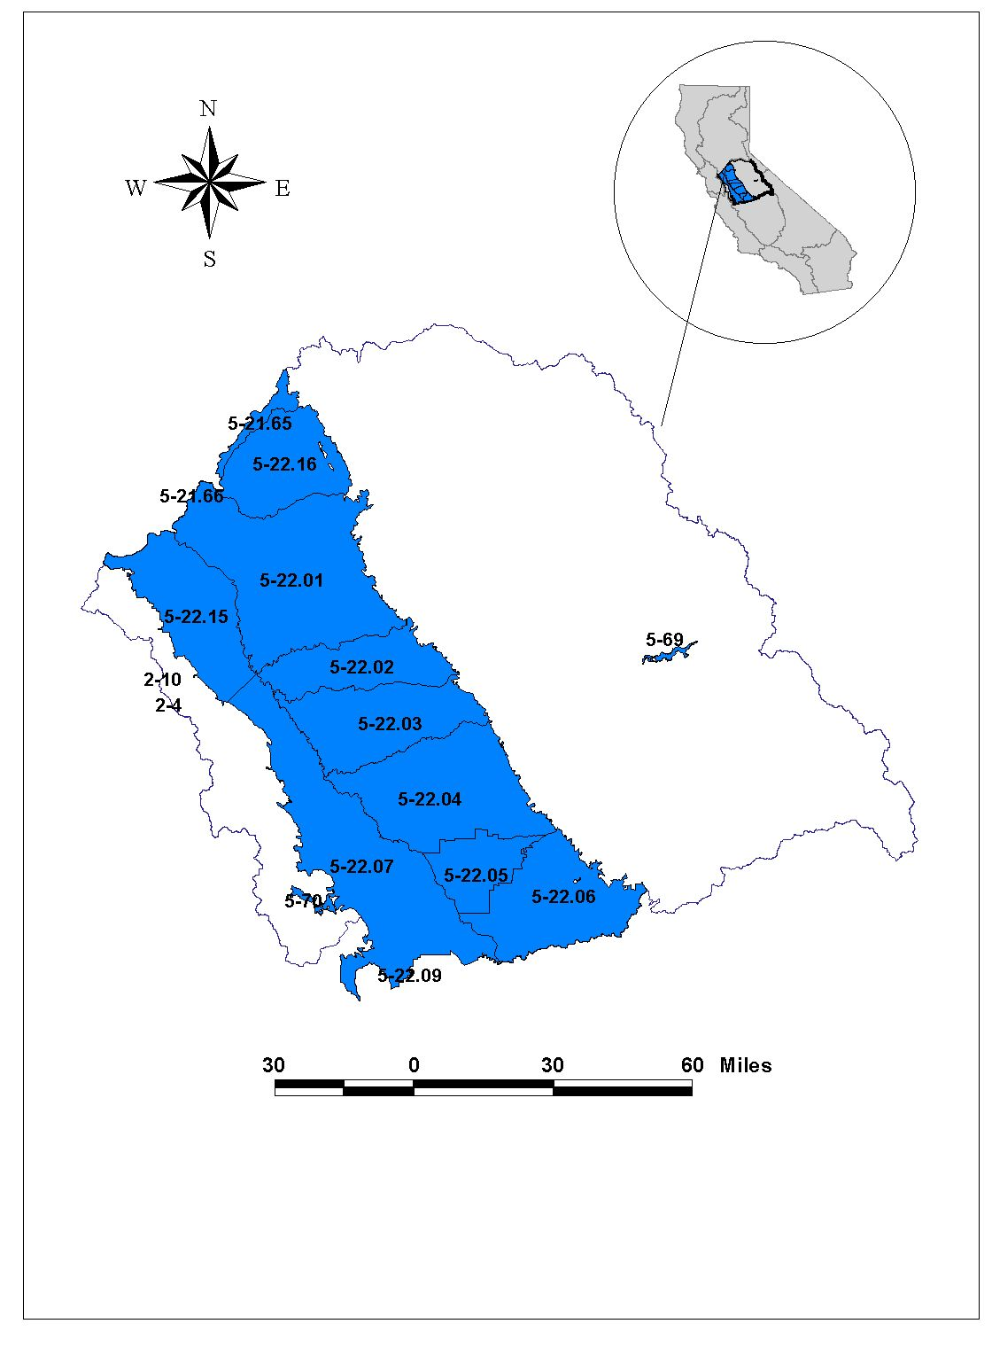

Figure 19: San Joaquin River Hydrologic Region
Modified From DWR, 2002. Note: Not all sub-basins labeled on map.

Table 35: Basins and Subbasins for the San Joaquin River Hydrologic Region

Basin/subbasin | Basin Name
5-22 | San Joaquin Valley
5-22.01 | Eastern San Joaquin
5-22.02 | Modesto
5-22.03 | Turlock
5-22.04 | Merced
5-22.05 | Chowchilla
5-22.06 | Madera
5-22.07 | Delta-Mendota
5-22.15 | Tracy
5-22.16 | Cosumnes
5-69 | Yosemite Valley
5-70 | Los Banos Creek Valley
From: California's Groundwater – Bulletin 118 (2002), Version 2 (Draft)
(water quality data provided by California DHS)

Table 36: Three most frequently occurring contaminants by contaminant group in the
San Joaquin River Hydrologic Region

Contaminant Group | Contaminant –  # of wells | Contaminant –  # of wells | Contaminant –  # of wells
Inorganics – Primary | Aluminum – 4 | Arsenic – 4 | 4 tied at 2 exceedances
Inorganics – Secondary | Manganese – 123 | Iron – 102 | TDS – 9
Radiological | Uranium – 33 | Gross Alpha – 26 | Radium 228 – 6
Nitrates | Nitrate (as NO3) – 23 | Nitrate + Nitrite – 6 | Nitrate Nitrogen (NO3-N) – 3
Pesticides | DBCP – 44 | Di(2-Ethylhexyl)phthalate – 11 | EDB – 6
VOCs | Tetrachloroethylene–8 | Dichloromethane – 3 | Trichloroethylene – 3
From: California's Groundwater – Bulletin 118 (2002), Version 2 (Draft) (water quality data provided by California DHS)

Table 37: Groundwater Quality in the San Joaquin River Hydrologic Region

Public Supply Wells  Wells Exceeding MCL (Wells Sampled) |  |  |  |  |  |  |  |  |  | Groundwater Quality  (TDS in mg/L)
Basin/  Subbasin | Inorganics  Primary |  | Inorganics  Secondary |  | Radiological | Nitrates | Pesticides | VOCs |  | Avg | Range
5-22
5-22.01 |  | 8(182) |  | 71(182) | 8(179) | 7(189) | 21(191) | 6(185) | 310 |  |  | 30 - 1,632
5-22.02 |  | 3(110) |  | 8(110) | 25(109) | 3(114) | 14(117) | 8(117) | 60-500 |  |  | 200-8300
5-22.03 |  | 0(84) |  | 11(84) | 12(80) | 8(90) | 5(89) | 3(86) | 200-500 |  |  | 100-8300
5-22.04 |  | 0(65) |  | 8(65) | 1(58) | 2(64) | 8(62) | 1(59) | 200-400 |  |  | 100-3600
5-22.05 |  | 0(12) |  | 0(12) | 0(10) | 0(10) | 0(12) | 0(12) | 200-500 |  |  | 120-6400
5-22.06 |  | 0(44) |  | 7(44) | 0(44) | 1(43) | 3(46) | 0(45) | 200-400 |  |  | 100-6400
5-22.07 |  | 2(47) |  | 18(47) | 1(47) | 4(51) | 1(47) | 0(45) | 770 |  |  | 210-86,000
5-22.15 |  | 4(34) |  | 18(34) | 2(39) | 2(36) | 2(36) | 0(37) | 1,190 |  |  | 210-7,800
5-22.16 |  | 0(26) |  | 21(26) | 0(17) | 0(30) | 1(22) | 0(22) | 218 |  |  | 140-438
5-69 |  | 0(3) |  | 1(3) | 0(3) | 0(3) | 0(3) | 0(3) | 54 |  |  | 43-73
5-70 |  | () |  | () | () | () | () | () | Unknown |  |  | Unknown
From: California's Groundwater – Bulletin 118 (2002), Version 2 (Draft) (water quality data provided by California DHS)

Tulare Lake Hydrologic Region
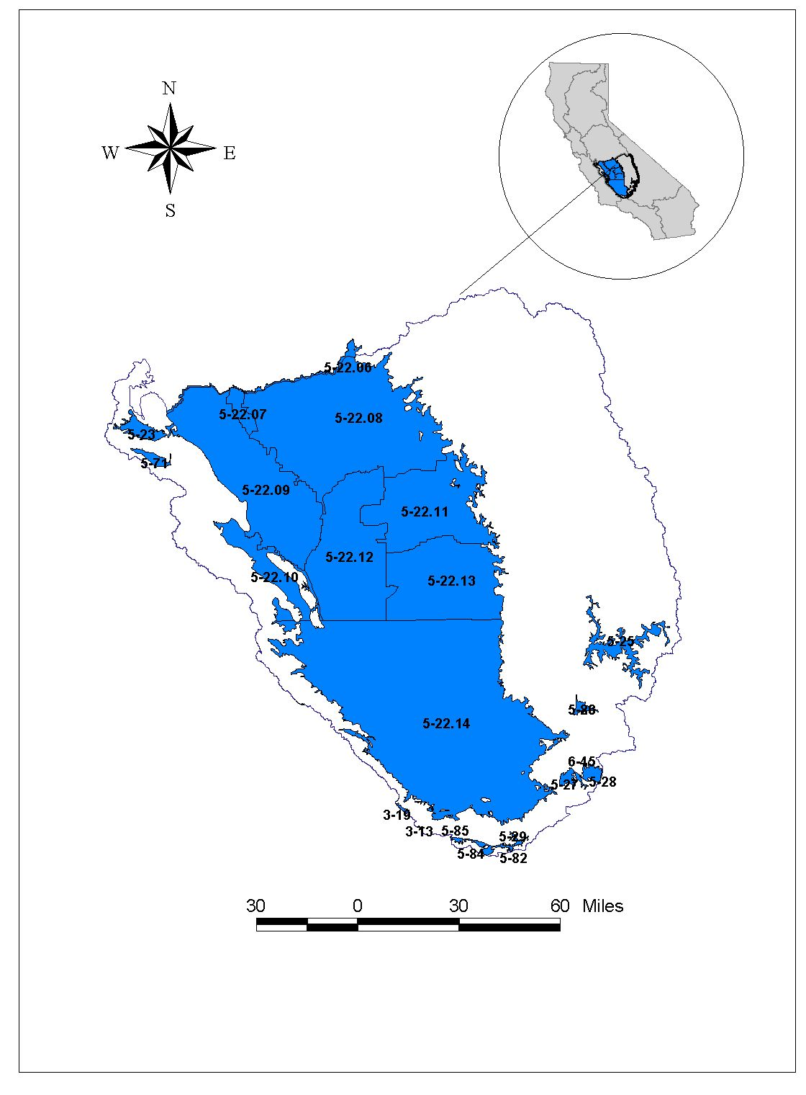

Figure 20: Tulare Lake Hydrologic Region
Modified From DWR, 2002. Note: Not all sub-basins labeled on map

Table 38: Basins and Subbasins of Tulare Lake Hydrologic Regions

Basin/subbasin | Basin Name | Basin/subbasin | Basin Name
5-22 | San Joaquin Valley | 5-26 | Walker Basin Creek Valley
5-22.08 | Kings | 5-27 | Cummings Valley
5-22.09 | Westside | 5-28 | Tehachapi Valley West
5-22.10 | Pleasant Valley | 5-29 | Castac Lake Valley
5-22.11 | Kaweah | 5-71 | Vallecitos Creek Valley
5-22.12 | Tulare Lake | 5-82 | Cuddy Canyon Valley
5-22.13 | Tule | 5-83 | Cuddy Ranch Area
5-22.14 | Kern County | 5-84 | Cuddy Valley
5-23 | Panoche Valley | 5-85 | Mil Potrero Area
5-25 | Kern River Valley
From: California's Groundwater – Bulletin 118 (2002), Version 2 (Draft) (water quality data provided by California DHS)

Table 39: Three most frequently occurring contaminants by contaminant group in the
Tulare Lake Hydrologic Region

Contaminant Group | Contaminant –  # of wells | Contaminant –  # of wells | Contaminant –  # of wells
Inorganics - Primary | Fluoride – 32 | Arsenic – 16 | Aluminum – 13
Inorganics - Secondary | Iron – 155 | Manganese – 82 | TDS – 9
Radiological | Gross Alpha – 74 | Uranium – 24 | Radium 228 – 8
Nitrates | Nitrate(as NO3) – 83 | Nitrate + Nitrite – 14 | Nitrite(as N) – 3
Pesticides | DBCP – 130 | EDB – 24 | Di(2-Ethylhexyl)phthalate – 7
VOCs | Trichloroethylene – 17 | Tetrachloroethylene – 16 | Benzene – 6  MTBE – 6
From: California's Groundwater – Bulletin 118 (2002), Version 2 (Draft) (water quality data provided by California DHS)

Table 40: Groundwater Quality in the Tulare Lake Hydrologic Region

Public Supply Wells  Wells Exceeding MCL (Wells Sampled) |  |  |  |  |  |  |  |  |  | Groundwater Quality  (TDS in mg/L)
Basin/  Subbasin | Inorganics  Primary |  | Inorganics  Secondary |  | Radiological | Nitrates | Pesticides | VOCs |  | Avg | Range
5-22
5-22.08 |  | 8(457) |  | 41(457) | 24(443) | 23(463) | 105(495) | 17(468) | 200-700 |  | 40-2000
5-22.09 |  | 0(2) |  | 2(2) | 0(1) | 0(2) | 0(2) | 0(2) | 520 |  | 220-35,000
5-22.10 |  | () |  | () | () | () | () | () | 1,500 |  | 1000-3000
5-22.11 |  | 1(157) |  | 25(157) | 8(158) | 13(165) | 16(167) | 5(165) | 189 |  | 35-580
5-22.12 |  | 11(39) |  | 10(39) | 7(39) | 0(38) | 2(40) | 2(39) | 200-600 |  | 200-40,000
5-22.13 |  | 0(73) |  | 10(73) | 3(71) | 6(71) | 1(73) | 5(71) | 256 |  | 200-30,000
5-22.14 |  | 18(444) |  | 60(444) | 15(372) | 38(475) | 23(436) | 19(409) | 400-450 |  | 150-5000
5-23 |  | () |  | () | () | () | () | () | 1,300 |  | 394-3530
5-25 |  | 14(73) |  | 21(73) | 19(78) | 5(76) | 0(58) | 1(58) | 378 |  | 253-480
5-26 |  | () |  | () | () | () | () | () | Unknown |  | Unknown
5-27 |  | 2(15) |  | 5(15) | 1(11) | 0(15) | 1(15) | 0(14) | 344 |  | Unknown
5-28 |  | 3(28) |  | 2(28) | 0(23) | 2(30) | 0(23) | 0(22) | 315 |  | 280-365
5-29 |  | 3(7) |  | 1(7) | 1(5) | 0(8) | 0(6) | 0(6) | 583 |  | 570-605
5-71 |  | () |  | () | () | () | () | () | Unknown |  | Unknown
5-82 |  | 4(5) |  | 2(5) | 2(5) | 0(5) | 0(5) | 0(5) | 693 |  | 695
5-83 |  | 1(6) |  | 3(6) | 0(5) | 0(6) | 0(5) | 0(5) | 550 |  | 480-645
5-84 |  | 2(6) |  | 4(6) | 1(6) | 0(10) | 0(5) | 0(5) | 407 |  | 325-645
5-85 |  | 1(7) |  | 5(7) | 0(6) | 0(7) | 0(6) | 0(6) | 460 |  | 372-657
From: California's Groundwater – Bulletin 118 (2002), Version 2 (Draft) (water quality data provided by California DHS)
North Lahontan Hydrologic Region
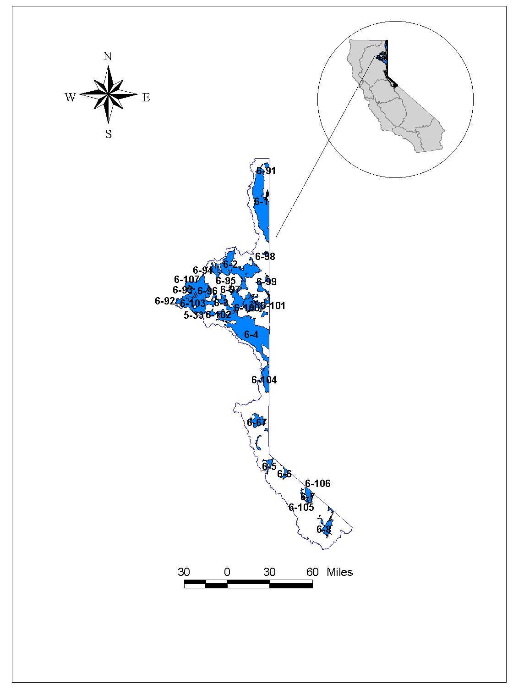

Figure 21: North Lahontan Hydrologic Region
Modified From DWR, 2002. Note: Not all sub-basins labeled on map

Table 41: Basins and Subbasins of North Lahontan Hydrologic Region
Basin/subbasin | Basin Name | Basin/subbasin | Basin Name
6-1 | Surprise Valley | 6-93 | Harvey Valley
6-2 | Madeline Plains | 6-94 | Grasshopper Valley
6-3 | Willow Creek Valley | 6-95 | Dry Valley
6-4 | Honey Lake Valley | 6-96 | Eagle Lake Area
6-5 | Tahoe Valley | 6-97 | Horse Lake Valley
6-5.01 | Tahoe Valley South | 6-98 | Tuledad Canyon
6-5.02 | Tahoe Valley West | 6-99 | Painters Flat
6-5.03 | Tahoe Valley North | 6-100 | Secret Valley
6-6 | Carson Valley | 6-101 | Bull Flat
6-7 | Antelope Valley | 6-104 | Long Valley
6-8 | Bridgeport Valley | 6-105 | Slinkard Valley
6-67 | Martis (Truckee) Valley | 6-106 | Little Antelope Valley
6-91 | Cow Head Lake Valley | 6-107 | Sweetwater Flat
6-92 | Pine Creek Valley
From: California's Groundwater – Bulletin 118 (2002), Version 2 (Draft) (water quality data provided by California DHS)

Table 42: Three most frequently occurring contaminants by contaminant group in the North Lahontan Hydrologic Region
Contaminant Group | Contaminant –  # of wells | Contaminant –  # of wells | Contaminant –  # of wells
Inorganics – Primary | Fluoride – 3 | Thallium – 3 | 3 tied at 1 exceedance
Inorganics – Secondary | Iron – 14 | Manganese – 13 | TDS – 1
Radiological | Gross Alpha – 7 | Uranium – 5 | Radium 226 – 1
Nitrates
Pesticides
VOCs | 1,2 Dichloroethane – 8 | TCE – 2 | MTBE – 1
From: California's Groundwater – Bulletin 118 (2002), Version 2 (Draft) (water quality data provided by California DHS)

Table 43: Groundwater Quality in the North Lahontan Hydrologic Region
Public Supply Wells  Wells Exceeding MCL (Wells Sampled) |  |  |  |  |  |  |  |  | Groundwater Quality  (TDS in mg/L)
Basin/  Subbasin | Inorganics  Primary |  | Inorganics  Secondary |  | Radiological | Nitrates | Pesticides | VOCs | Avg | Range
6-1 |  | 0(2) |  | 0(2) | 0(1) | 0(4) | 0(0) | 0(1) | 224 | 87 - 1,800
6-2 |  | 0(1) |  | 0(1) | 0(0) | 0(1) | 0(0) | 0(0) | 402 | 81 - 1,790
6-3 |  | () |  | () | () | () | () | () | 401 | 90 - 1,200
6-4 |  | 4(54) |  | 11(54) | 1(17) | 0(60) | 0(12) | 0(12) | 518 | 89 - 2,500
6-5
6-5.01 |  | 2(44) |  | 12(44) | 4(47) | 0(46) | 0(44) | 8(44) |  | 59 - 206
6-5.02 |  | 0(8) |  | 1(8) | 0(5) | 0(8) | 0(7) | 0(7) | 103 | 68 - 128
6-5.03 |  | () |  | () | () | () | () | () | 141
6-6 |  | () |  | () | () | () | () | ()
6-7 |  | 1(5) |  | 0(5) | 2(5) | 0(4) | 0(5) | 0(5)
6-8 |  | 0(3) |  | 1(3) | 0(2) | 0(2) | 0(2) | 0(2)
6-67 |  | () |  | () | () | () | () | ()
6-91 |  | () |  | () | () | () | () | ()
6-92 |  | () |  | () | () | () | () | ()
6-93 |  | () |  | () | () | () | () | ()
6-94 |  | () |  | () | () | () | () | ()
6-95 |  | () |  | () | () | () | () | ()
6-96 |  | 0(4) |  | 0(4) | 0(0) | 0(4) | 0(2) | 0(2)
6-97 |  | () |  | () | () | () | () | ()
6-98 |  | () |  | () | () | () | () | ()
6-99 |  | () |  | () | () | () | () | ()
6-100 |  | () |  | () | () | () | () | () |  | 125 - 3,200
6-101 |  | () |  | () | () | () | () | ()
6-104 |  | () |  | () | () | () | () | () | 302 | 127 - 570
6-105 |  | () |  | () | () | () | () | ()
6-106 |  | () |  | () | () | () | () | ()
6-107 |  | () |  | () | () | () | () | ()
From: California's Groundwater – Bulletin 118 (2002), Version 2 (Draft) (water quality data provided by California DHS)
South Lahontan Hydrologic Region
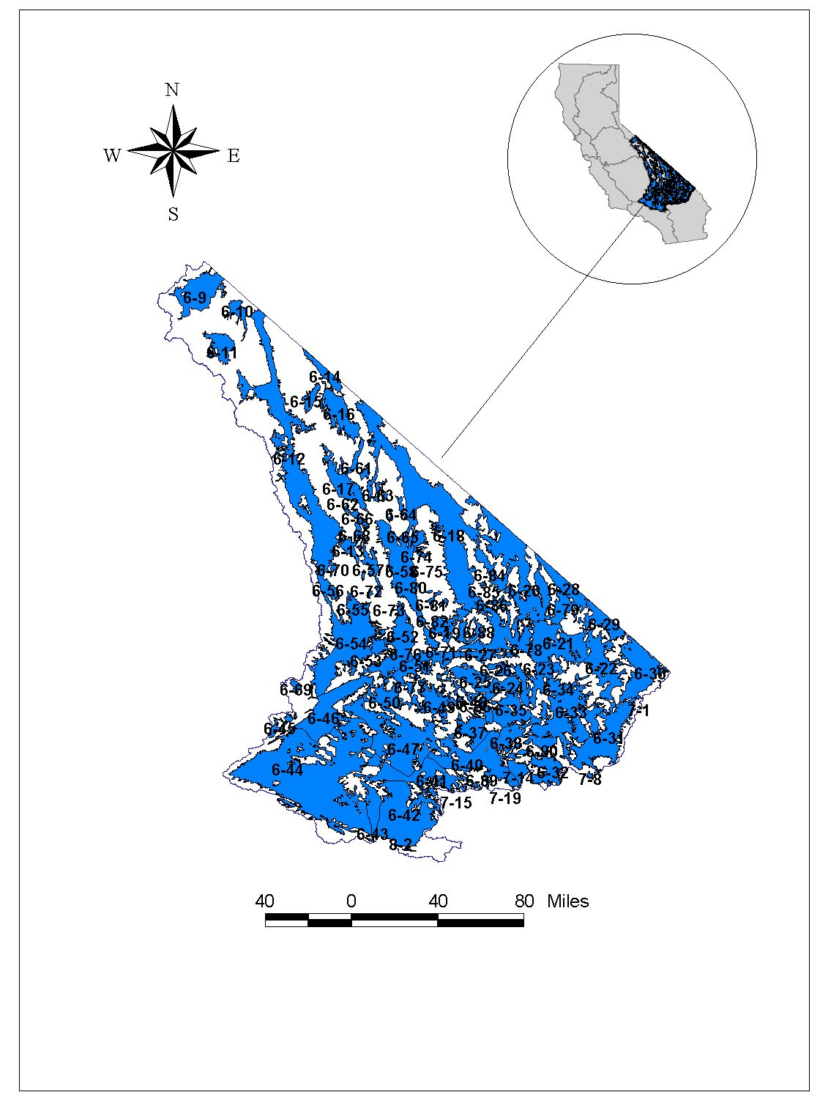

Figure 22: South Lahontan Hydrologic Region
Modified From DWR, 2002. Note: Not all sub-basins labeled on map.

Table 44: Basins and Subbasins of South Lahontan Hydrologic Region

Basin/subbasins | Basin Name | Basin/subbasins | Basin Name
6-09 | Mono Valley | 6-47 | Harper Valley
6-10 | Adobe Lake Valley | 6-48 | Goldstone Valley
6-11 | Long Valley | 6-49 | Superior Valley
6-12 | Owens Valley | 6-50 | Cuddeback Valley
6-13 | Black Springs Valley | 6-51 | Pilot Knob Valley
6-14 | Fish Lake Valley | 6-52 | Searles Valley
6-15 | Deep Springs Valley | 6-53 | Salt Wells Valley
6-16 | Eureka Valley | 6-54 | Indian Wells Valley
6-17 | Saline Valley | 6-55 | Coso Valley
6-18 | Death Valley | 6-56 | Rose Valley
6-19 | Wingate Valley | 6-57 | Darwin Valley
6-20 | Middle Amargosa Valley | 6-58 | Panamint Valley
6-21 | Lower Kingston Valley | 6-61 | Cameo Area
6-22 | Upper Kingston Valley | 6-62 | Race Track Valley
6-23 | Riggs Valley | 6-63 | Hidden Valley
6-24 | Red Pass Valley | 6-64 | Marble Canyon Area
6-25 | Bicycle Valley | 6-65 | Cottonwood Spring Area
6-26 | Avawatz Valley | 6-66 | Lee Flat
6-27 | Leach Valley | 6-68 | Santa Rosa Flat
6-28 | Pahrump Valley | 6-69 | Kelso Lander Valley
6-29 | Mesquite Valley | 6-70 | Cactus Flat
6-30 | Ivanpah Valley | 6-71 | Lost Lake Valley
6-31 | Kelso Valley | 6-72 | Coles Flat
6-32 | Broadwell Valley | 6-73 | Wild Horse Mesa Area
6-33 | Soda Lake Valley | 6-74 | Harrisburg Flats
6-34 | Silver Lake Valley | 6-75 | Wildrose Canyon
6-35 | Cronise Valley | 6-76 | Brown Mountain Valley
6-36 | Langford Valley | 6-77 | Grass Valley
6-36.01 | Langford Valley East | 6-78 | Denning Spring Valley
6-36.02 | Langford Well Lake | 6-79 | California Valley
6-36.03 | Irwin | 6-80 | Middle Park Canyon
6-37 | Coyote Lake Valley | 6-81 | Butte Valley
6-38 | Caves Canyon Valley | 6-82 | Spring Canyon Valley
6-40 | Lower Mojave River Valley | 6-84 | Greenwater Valley
6-41 | Middle Mojave River Valley | 6-85 | Gold Valley
6-42 | Upper Mojave River Valley | 6-86 | Rhodes Hill Area
6-43 | El Mirage Valley | 6-88 | Owl Lake Valley
6-44 | Antelope Valley | 6-89 | Kane Wash Area
6-45 | Tehachapi Valley East | 6-90 | Cady Fault Area
6-46 | Fremont Valley
From: California's Groundwater – Bulletin 118 (2002), Version 2 (Draft) (water quality data provided by California DHS)

Table 45: Three most frequently occurring contaminants by contaminant group in the
South Lahontan Hydrologic Region

Contaminant Group | Contaminant –  # of wells | Contaminant –  # of wells | Contaminant –  # of wells
Inorganics – Primary | Fluoride – 30 | Arsenic – 19 | Antimony – 5
Inorganics – Secondary | Iron – 82 | Manganese – 36 | Specific Conductance–5  TDS – 5
Radiological | Gross Alpha – 18 | Uranium – 7 | Radium 228 – 2
Dissolved Nitrogen | Nitrate (as NO3) – 12 | Nitrate + Nitrite–6 | Nitrite (as N) – 4
Pesticides | Di(2-Ethylhexyl)phthalate)–2
VOCs | MTBE – 2 | Trichloroethylene–2 | Carbon Tetrachloride–2
From: California's Groundwater – Bulletin 118 (2002), Version 2 (Draft) (water quality data provided by California DHS)

Table 46: Groundwater Quality in the South Lahontan Hydrologic Region

Public Supply Wells  Wells Exceeding MCL (Wells Sampled) |  |  |  |  |  |  |  |  |  |  | Groundwater Quality  (TDS in mg/L)
Basin/  Subbasin |  | Inorganics  Primary | Inorganics  Secondary |  | Radiological |  | Nitrates | Pesticides |  | VOCs | Avg | Range
6-09 | 0(1) |  |  | 0(1) | 0(1) | 0(1) |  |  | 0(1) | 0(1) |  |  | 2060
6-10 | () |  |  | () | () | () |  |  | () | ()
6-11 | 0(4) |  |  | 4(4) | 2(6) | 0(4) |  |  | 0(4) | 0(4)
6-12 | 1(25) |  |  | 2(25) | 0(26) | 0(25) |  |  | 0(24) | 0(22) |  |  | 300-450,000
6-13 | () |  |  | () | () | () |  |  | () | ()
6-14 | () |  |  | () | () | () |  |  | () | ()
6-15 | () |  |  | () | () | () |  |  | () | ()
6-16 | () |  |  | () | () | () |  |  | () | ()
6-17 | () |  |  | () | () | () |  |  | () | ()
6-18 | () |  |  | () | () | () |  |  | () | ()
6-19 | () |  |  | () | () | () |  |  | () | ()
6-20 | () |  |  | () | () | () |  |  | () | ()
6-21 | () |  |  | () | () | () |  |  | () | ()
6-22 | () |  |  | () | () | () |  |  | () | ()
6-23 | () |  |  | () | () | () |  |  | () | ()
6-24 | () |  |  | () | () | () |  |  | () | ()
6-25 | 5(6) |  |  | 5(6) | 1(6) | 0(6) |  |  | 0(5) | 0(5) | 618 |  | 508-810
6-26 | () |  |  | () | () | () |  |  | () | ()
6-27 | () |  |  | () | () | () |  |  | () | ()
6-28 | () |  |  | () | () | () |  |  | () | ()
6-29 | () |  |  | () | () | () |  |  | () | ()
6-30 | () |  |  | () | () | () |  |  | () | ()
6-31 | () |  |  | () | () | () |  |  | () | ()
6-32 | 1(1) |  |  | 0(1) | 0(0) | 0(1) |  |  | 0(1) | 0(1)
6-33 | 0(0) |  |  | 0(0) | 1(1) | 0(0) |  |  | 0(0) | 0(0)
6-34 | () |  |  | () | () | () |  |  | () | ()
6-35 | () |  |  | () | () | () |  |  | () | ()
6-36
6-36.01 | 3(3) |  |  | 2(3) | 1(3) | 0(3) |  |  | 0(3) | 0(3) | 498 |  | 440-568
6-36.02 | 0(5) |  |  | 0(5) | 0(5) | 0(5) |  |  | 0(4) | 0(4) | 528 |  | 496-598
6-37 | () |  |  | () | () | () |  |  | () | () |  |  | 300-1000
6-38 | 1(1) |  |  | 0(1) | 0(0) | 0(1) |  |  | 0(0) | 0(0) |  |  | 300-1000
6-40 | 2(41) |  |  | 9(41) | 6(38) | 4(41) |  |  | 0(36) | 0(36) | 300
6-41 | 1(4) |  |  | 1(4) | 0(3) | 0(5) |  |  | 0(4) | 0(4) | 500
6-42 | 9(122) |  |  | 11(122) | 2(115) | 2(125) |  |  | 0(117) | 0(120) | 500 |  | 1105
6-43 | 0(19) |  |  | 2(19) | 0(18) | 0(20) |  |  | 0(18) | 2(17)
6-44 | 25(214) |  |  | 39(214) | 6(183) | 8(243) |  |  | 2(207) | 4(207) | 300 |  | 200-800
6-45 | 1(7) |  |  | 0(7) | 0(2) | 0(10) |  |  | 0(7) | 0(8) | 361 |  | 298-405
6-46 | 0(14) |  |  | 5(14) | 0(11) | 0(15) |  |  | 0(13) | 0(12) | 596 |  | 350-100,000
6-47 | 0(2) |  |  | 0(2) | 0(2) | 0(2) |  |  | 0(4) | 0(4) |  |  | 179-2391
6-48 | () |  |  | () | () | () |  |  | () | ()
6-49 | () |  |  | () | () | () |  |  | () | ()
6-50 | () |  |  | () | () | () |  |  | () | ()
6-51 | 0(2) |  |  | 0(2) | 0(2) | 0(2) |  |  | 0(2) | 0(2)
6-52 | () |  |  | () | () | () |  |  | () | ()
6-53 | () |  |  | () | () | () |  |  | () | ()
6-54 | 3(47) |  |  | 15(47) | 2(46) | 1(58) |  |  | 0(47) | 0(49) | 312 |  | 110-1620
6-55 | () |  |  | () | () | () |  |  | () | ()
6-56 | 0(0) |  |  | 0(0) | 0(1) | 0(0) |  |  | 0(0) | 0(0)
6-57 | () |  |  | () | () | () |  |  | () | ()
6-58 | () |  |  | () | () | () |  |  | () | ()
6-61 | () |  |  | () | () | () |  |  | () | ()
6-62 | () |  |  | () | () | () |  |  | () | ()
6-63 | () |  |  | () | () | () |  |  | () | ()
6-64 | () |  |  | () | () | () |  |  | () | ()
6-65 | () |  |  | () | () | () |  |  | () | ()
6-66 | () |  |  | () | () | () |  |  | () | ()
6-68 | () |  |  | () | () | () |  |  | () | ()
6-69 | () |  |  | () | () | () |  |  | () | ()
6-70 | () |  |  | () | () | () |  |  | () | ()
6-71 | () |  |  | () | () | () |  |  | () | ()
6-72 | () |  |  | () | () | () |  |  | () | ()
6-73 | () |  |  | () | () | () |  |  | () | ()
6-74 | () |  |  | () | () | () |  |  | () | ()
6-75 | () |  |  | () | () | () |  |  | () | ()
6-76 | () |  |  | () | () | () |  |  | () | ()
6-77 | 0 |  |  | 0 | 0 | 0 |  |  | 0 | 0
6-78 | 0 |  |  | 0 | 0 | 0 |  |  | 0 | 0
6-79 | 0 |  |  | 0 | 0 | 0 |  |  | 0 | 0
6-80 | 0 |  |  | 0 | 0 | 0 |  |  | 0 | 0
6-81 | 0 |  |  | 0 | 0 | 0 |  |  | 0 | 0
6-82 | 0 |  |  | 0 | 0 | 0 |  |  | 0 | 0
6-84 | 0 |  |  | 0 | 0 | 0 |  |  | 0 | 0
6-85 | 0 |  |  | 0 | 0 | 0 |  |  | 0 | 0
6-86 | 0 |  |  | 0 | 0 | 0 |  |  | 0 | 0
6-88 | 0 |  |  | 0 | 0 | 0 |  |  | 0 | 0
6-89 | 0 |  |  | 0 | 0 | 0 |  |  | 0 | 0
6-90 | () |  |  | () | () | () |  |  | () | ()
From: California's Groundwater – Bulletin 118 (2002), Version 2 (Draft) (water quality data provided by California DHS)

Colorado River Hydrologic Region
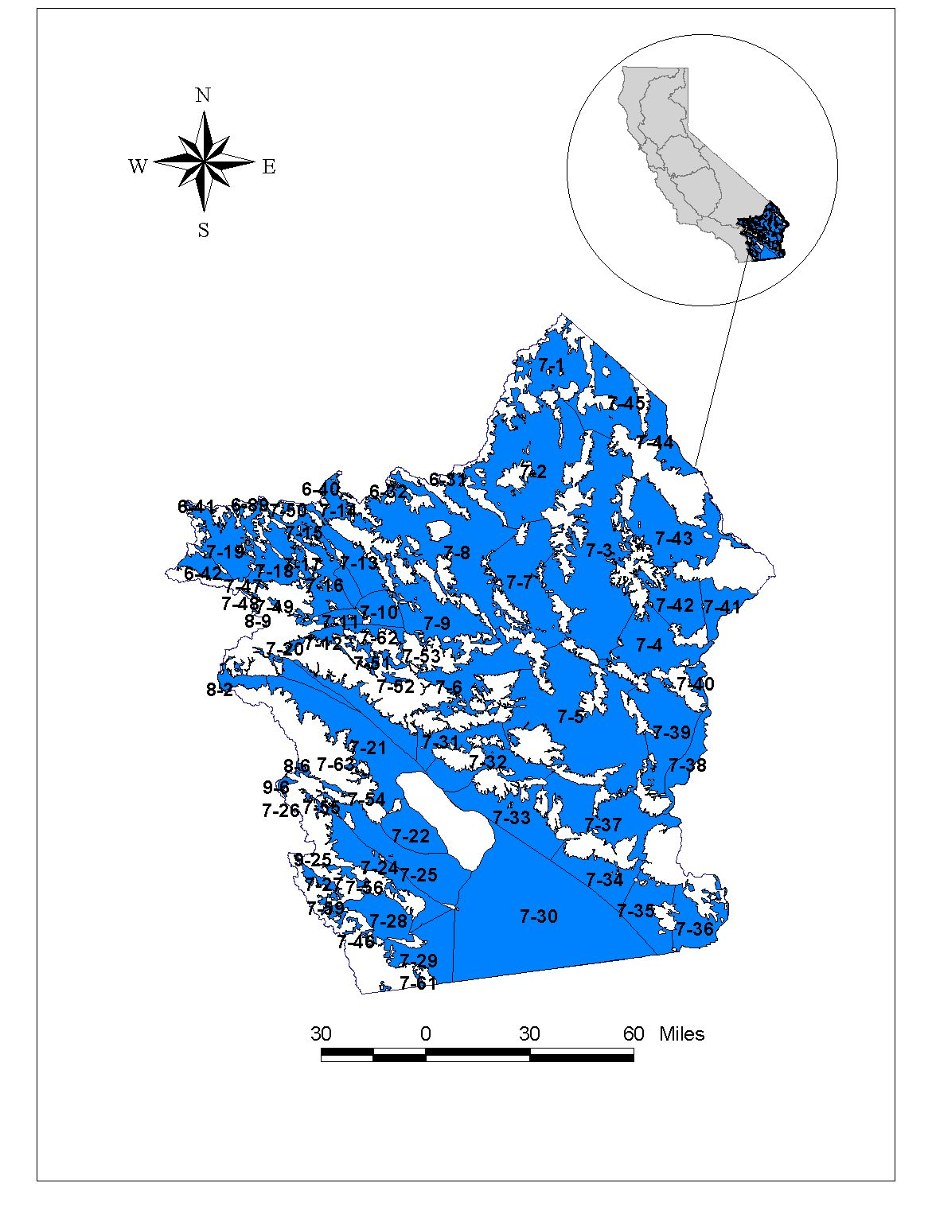

Figure 23: Colorado River Hydrologic Region
Modified From DWR, 2002. Note: Not all sub-basins labeled on map.

Table 47: Basins and Subbasins of Colorado River Hydrologic Region

Basin/subbasin | Basin Name | Basin/subbasin | Basin Name
7-1 | Lanfair Valley | 7-28 | Vallecito-Carrizo Valley
7-2 | Fenner Valley | 7-29 | Coyote Wells Valley
7-3 | Ward Valley | 7-30 | Imperial Valley
7-4 | Rice Valley | 7-31 | Orocopia Valley
7-5 | Chuckwalla Valley | 7-32 | Chocolate Valley
7-6 | Pinto Valley | 7-33 | East Salton Sea
7-7 | Cadiz Valley | 7-34 | Amos Valley
7-8 | Bristol Valley | 7-35 | Ogilby Valley
7-9 | Dale Valley | 7-36 | Yuma Valley
7-10 | Twentynine Palms Valley | 7-37 | Arroyo Seco Valley
7-11 | Copper Mountain Valley | 7-38 | Palo Verde Valley
7-12 | Warren Valley | 7-39 | Palo Verde Mesa
7-13 | Deadman Valley | 7-40 | Quien Sabe Point Valley
7-13.01 | Deadman Lake | 7-41 | Calzona Valley
7-13.02 | Surprise Spring | 7-42 | Vidal Valley
7-14 | Lavic Valley | 7-43 | Chemehuevi Valley
7-15 | Bessemer Valley | 7-44 | Needles Valley
7-16 | Ames Valley | 7-45 | Piute Valley
7-17 | Means Valley | 7-46 | Canebrake Valley
7-18 | Johnson Valley Area | 7-47 | Jacumba Valley
7-18.01 | Soggy Lake | 7-48 | Helendale Fault Valley
7-18.02 | Upper Johnson Valley | 7-49 | Pipes Canyon Fault Valley
7-19 | Lucerne Valley | 7-50 | Iron Ridge Area
7-20 | Morongo Valley | 7-51 | Lost Horse Valley
7-21 | Coachella Valley | 7-52 | Pleasant Valley
7-21.01 | Indio | 7-53 | Hexie Mountain Area
7-21.02 | Mission Creek | 7-54 | Buck Ridge Fault Valley
7-21.03 | Desert Hot Springs | 7-55 | Collins Valley
7-21.04 | San Gorgonio Pass | 7-56 | Yaqui Well Area
7-22 | West Salton Sea | 7-59 | Mason Valley
7-24 | Borrego Valley | 7-61 | Davies Valley
7-25 | Ocotillo-Clark Valley | 7-62 | Joshua Tree
7-26 | Terwilliger Valley | 7-63 | Vandeventer Flat
7-27 | San Felipe Valley
From: California's Groundwater – Bulletin 118 (2002), Version 2 (Draft) (water quality data provided by California DHS)

Table 48: Three most frequently occurring contaminants by contaminant group in the Colorado River Hydrologic Region

Contaminant Group | Contaminant –  # of wells | Contaminant –  # of wells | Contaminant  # of wells
Inorganics – Primary | Fluoride – 17
Inorganics – Secondary | Iron – 38 | Manganese – 26 | TDS – 5
Radiological | Radium 228 – 3 | Combined RA226 + RA228 – 3 | Radium 226 – 1
Nitrates | Nitrate (as NO3) – 6 | Nitrate + Nitrite – 1
Pesticides
VOCs
From: California's Groundwater – Bulletin 118 (2002), Version 2 (Draft) (water quality data provided by California DHS)

Table 49: Groundwater Quality in the Colorado River Hydrologic Region

Public Supply Wells  Wells Exceeding MCL (Wells Sampled) |  |  |  |  |  |  |  |  |  |  |  |  |  |  |  | Groundwater Quality  (TDS in mg/L)
Basin/  Subbasin | Inorganics  Primary |  |  |  | Inorganics  Secondary |  | Radiological |  | Nitrates |  |  | Pesticides |  |  | VOCs | Avg | Range
7-1 |  |  | () |  |  | () |  | () |  | () |  |  | () | () |  | 515 | 173-2,260
7-2 |  |  | () |  |  | () |  | () |  | () |  |  | () | () |  | 515 | 173- 2,260
7-3 |  |  | () |  |  | () |  | () |  | () |  |  | () | () |  |  | 327-589
7-4 |  |  | () |  |  | () |  | () |  | () |  |  | () | ()
7-5 |  | 1(1) |  | 0(1) |  |  | 0(1) |  |  | 0(1) | 0(1) |  |  | 0(1) |  |  | 424
7-6 |  | 1(1) |  | 0(1) |  |  | 0(0) |  |  | 0(1) | 0(1) |  |  | 0(1)
7-7 |  |  | () |  |  | () |  | () |  | () |  |  | () | () |  | 400 | 300-3000
7-8 |  |  | () |  |  | () |  | () |  | () |  |  | () | () |  |  | 300-298,000
7-9 |  |  | () |  |  | () |  | () |  | () |  |  | () | ()
7-10 |  | 0(1) |  | 0(1) |  |  | 0(1) |  |  | 0(1) | 0(1) |  |  | 0(1) |  | 640
7-11 |  | 0(2) |  | 0(2) |  |  | 0(2) |  |  | 0(2) | 0(2) |  |  | 0(2) |  |  | 180-214
7-12 |  | 1(18) |  | 3(18) |  |  | 1(18) |  | 5(18) |  | 0(16) |  |  | 0(16) |  | 196 | 129-269
7-13
7-13.01 |  | 0(1) |  | 0(1) |  |  | 0(1) |  |  | 0(1) | 0(1) |  |  | 0(1) |  |  | 311-985
7-13.02 |  | 0(9) |  | 5(9) |  |  | 1(9) |  |  | 0(9) | 0(9) |  |  | 0(9) |  | 177 | 141-1,050
7-14 |  |  | () |  |  | () |  | () |  | () |  |  | () | ()
7-15 |  |  | () |  |  | () |  | () |  | () |  |  | () | ()
7-16 |  | 0(10) |  | 0(10) |  |  | 3(10) |  | 0(10) |  | 0(10) |  |  | 0(10) |  | 459
7-17 |  |  | () |  |  | () |  | () |  | () |  |  | () | ()
7-18
7-18.01 |  | 0(1) |  | 1(1) |  |  | 0(1) |  |  | 0(1) | 0(1) |  |  | 0(1) |  |  | 300-2,000
7-18.02 |  |  | () |  |  | () |  | () |  | () |  |  | () | () |  |  | 3,000
7-19 |  | 0(5) |  | 0(5) |  |  | 0(4) |  |  | 0(6) | 0(4) |  |  | 0(4) |  | 301 | 200-5,000
7-20 |  | 0(4) |  | 2(4) |  |  | 5(5) |  |  | 0(4) | 0(4) |  |  | 0(4)
7-21
7-21.01 |  | 2(161) |  | 13(161) |  |  | 7(162) |  | 0(164) |  | 0(163) |  |  | 0(161) |  | 300
7-21.02 |  | 0(14) |  | 0(14) |  |  | 2(15) |  | 1(15) |  | 0(14) |  |  | 0(14) |  | <500
7-21.03 |  | 0(0) |  | 0(0) |  |  | 0(1) |  |  | 0(1) | 0(1) |  |  | 0(1) |  |  | 800-1,000
7-21.04 |  |  | () |  |  | () |  | () |  | () |  |  | () | () |  |  | 106-205
7-22 |  |  | () |  |  | () |  | () |  | () |  |  | () | ()
7-24 |  | 1(11) |  | 0(11) |  |  | 0(9) |  | 0(12) |  | 0(6) |  |  | 0(6) |  |  | 300-2,440
7-25 |  |  | () |  |  | () |  | () |  | () |  |  | () | ()
7-26 |  |  | () |  |  | () |  | () |  | () |  |  | () | () |  |  | 500
7-27 |  |  | () |  |  | () |  | () |  | () |  |  | () | ()
7-28 |  |  | () |  |  | () |  | () |  | () |  |  | () | ()
7-29 |  |  | () |  |  | () |  | () |  | () |  |  | () | ()
7-30 |  | 0(1) |  | 0(1) |  |  | 0(0) |  |  | 0(0) | 0(0) |  |  | 0(0) |  | 1088 | 498-7,280
7-31 |  |  | () |  |  | () |  | () |  | () |  |  | () | ()
7-32 |  |  | () |  |  | () |  | () |  | () |  |  | () | ()
7-33 |  |  | () |  |  | () |  | () |  | () |  |  | () | ()
7-34 |  |  | () |  |  | () |  | () |  | () |  |  | () | ()
7-35 |  |  | () |  |  | () |  | () |  | () |  |  | () | ()
7-36 |  |  | () |  |  | () |  | () |  | () |  |  | () | ()
7-37 |  |  | () |  |  | () |  | () |  | () |  |  | () | ()
7-38 |  | 0(11) |  | 10(11) |  |  | 0(12) |  | 0(11) |  | 0(11) |  |  | 0(11) |  | 840 | 658-1,030
7-39 |  | 1(11) |  | 9(11) |  |  | 0(10) |  | 0(11) |  | 0(11) |  |  | 0(11)
7-40 |  |  | () |  |  | () |  | () |  | () |  |  | () | ()
7-41 |  | 0(2) |  | 1(2) |  |  | 0(0) |  |  | 0(2) | 0(1) |  |  | 0(1)
7-42 |  | 0(1) |  | 0(1) |  |  | 0(0) |  |  | 0(1) | 0(0) |  |  | 0(0)
7-43 |  |  | () |  |  | () |  | () |  | () |  |  | () | ()
7-44 |  | 0(4) |  | 3(4) |  |  | 0(3) |  |  | 0(5) | 0(4) |  |  | 0(4)
7-45 |  |  | () |  |  | () |  | () |  | () |  |  | () | ()
7-46 |  |  | () |  |  | () |  | () |  | () |  |  | () | ()
7-47 |  | 0(1) |  | 0(1) |  |  | 0(0) |  |  | 0(1) | 0(0) |  |  | 0(0) |  |  | 296-6,100
7-48 |  |  | () |  |  | () |  | () |  | () |  |  | () | ()
7-49 |  |  | () |  |  | () |  | () |  | () |  |  | () | ()
7-50 |  |  | () |  |  | () |  | () |  | () |  |  | () | ()
7-51 |  |  | () |  |  | () |  | () |  | () |  |  | () | ()
7-52 |  |  | () |  |  | () |  | () |  | () |  |  | () | ()
7-53 |  |  | () |  |  | () |  | () |  | () |  |  | () | ()
7-54 |  |  | () |  |  | () |  | () |  | () |  |  | () | ()
7-55 |  |  | () |  |  | () |  | () |  | () |  |  | () | ()
7-56 |  |  | () |  |  | () |  | () |  | () |  |  | () | ()
7-59 |  |  | () |  |  | () |  | () |  | () |  |  | () | ()
7-61 |  |  | () |  |  | () |  | () |  | () |  |  | () | ()
7-62 |  | 10(16) |  | 2(16) |  |  | 2(15) |  | 0(16) |  | 0(13) |  |  | 0(13) |  | 180 | 117-185
7-63 |  |  | () |  |  | () |  | () |  | () |  |  | () | ()
From: California's Groundwater – Bulletin 118 (2002), Version 2 (Draft) (water quality data provided by California DHS)

