III. SURFACE WATER ASSESSMENT

A. Surface Water Ambient Monitoring Program (SWAMP)

The following summary is taken from the SWRCB Report to the Legislature, Pursuant to AB982 of 1999, Structure and Effectiveness of the State’s Water Quality Programs: Section 303(d) of the Federal Clean Water Act and Total Maximum Daily Loads (TMDLs).

A strong monitoring program that can produce extensive monitoring data is essential to the success of assessing the quality of California’s waters. SWAMP is a relatively new program at the SWRCB and RWQCBs. Initiated in 1999, SWRCB is responsible for statewide ambient monitoring efforts and oversees RWQCB monitoring activities, while each RWQCB establishes monitoring priorities for the water bodies within its jurisdiction for site-specific monitoring. To ensure statewide consistency, SWAMP also specifies the protocols and methodologies to be used for sampling, data analysis and data reporting

SWAMP is intended to meet four goals as follows:
- Identify specific problems preventing the SWRCB, RWQCBs, and the public from realizing beneficial uses in targeted watersheds.
- Create an ambient monitoring program that addresses all watersheds of the State using consistent and objective monitoring, sampling and analysis methods; consistent data quality assurance protocols; and centralized data management.
- Document ambient water quality conditions in potentially clean and polluted areas.
- Provide the data to evaluate the effectiveness of water quality regulatory programs in protecting beneficial uses of waters of the State.

Initial field monitoring activities began in Fiscal Year (FY) 2001-02 and focused on site-specific, targeted monitoring. Because of budget constraints, SWAMP continues to focus primarily on site-specific monitoring to better characterize problem sites to meet each RWQCB’s needs for 303(d) listing and TMDL development. In the future if additional funds are made available further development of statewide monitoring will be under taken in SWAMP.

SWAMP Progress

- It is important to recognize that SWAMP is still in its infancy. Extensive planning and preliminary research activities were conducted during 1999, 2000, and 2001 to provide the guidance and framework to create an effective surface water quality ambient monitoring program for all of California's surface waters.

- SWAMP field monitoring activities began in FY 2001-02 and focused on site-specific target monitoring. Guidance documents were prepared by SWRCB to provide a framework within which the RWQCBs could develop region-specific SWAMP projects.

- A Water Quality Monitoring Coordinating Committee (WQMCC) was established, consisting of SWRCB and RWQCB SWAMP staff and representatives from other state agencies. WQMCC meets regularly to discuss SWAMP activities and address existing and potential issues. One of the primary focuses of WQMCC’s 2002 meetings has been the development of a Quality Assurance Project Plan (QAPP), which is critical to ensure high quality of data. SWAMP sponsored a number of scientific workshops on quality assurance in 2002. Topics for these workshops included sample collection and field data measurement, laboratory analytical methodology and quality assurance/quality control issues, biological assessment and toxicity testing issues, and data management issues. Resolutions of many of these issues are evolving from the discussions held at these workshops and WQMCC meetings.

- SWAMP has organized an external scientific panel, the Scientific Planning and Review Committee (SPARC), to review study design, approaches, indicators, and other relevant topics. SPARC members are representatives from federal and state agencies and academics with expertise in the fields that include monitoring program management, fish habitat, invertebrates, sediment, organic chemistry, metals chemistry, quality assurance, pathogens, toxicology, and statistics, etc.

- SPARC held a two-day meeting in May 2002, at which staff from the nine RWQCBs gave presentations on past and future SWAMP activities within each region. One major comment from SPARC members at the meeting was that statewide data comparability needs to be the first step towards statewide consistency for SWAMP. Statewide data comparability means that ambient water quality measurements taken in one part of the state can be directly compared with like measurements taken in other parts of the state. Data comparability in SWAMP is being achieved through requirements in SWAMP QAPP. Statewide data comparability issues and other comments and recommendations in SPRAC report will be the subject of future WQMCC meetings.

Current Monitoring Activities

Because of the budget constraints, SWAMP has primarily focusing on site-specific monitoring to better characterize problem sites or clean locations (reference sites) to meet each RWQCB’s needs for 303(d) listing, TMDL development, and other core regulatory programs. Some of the monitoring activities under SWAMP for FY 2002-03 are conducted through contracts and interagency agreements with a number of organizations.

Another major component of SWAMP– the overall status and trends of the state’s surface water quality–will be implemented in the future, if additional funds are made available. Until then, RWQCBs will continue to use SWAMP resources to address high priority water quality issues in each region, while following SWAMP protocols to ensure statewide data comparability.

The following describes the surface water monitoring program currently being implemented at each RWQCB under the umbrella of SWAMP, with maps that identify the watersheds where monitoring activities have occurred or have been scheduled between FY 2001-02 and FY 2002-03. At the end of FY 2002-03, samples will have been collected and analyzed for 480 water bodies located in 76 of the state’s 172 watersheds (hydrological units).

Region 1: North Coast Region

The North Coast region has thousands of stream miles most of which have little or no assessment information. Much of the water quality data are confined to the Russian River basin or to a limited number of specific sites, collected as a result of discharger self-monitoring requirements, cleanup activities, or enforcement actions. With the exception of the Russian River and a few of its tributaries, there are no long-term data on any water body in the region.

Data collected through SWAMP in this region will be used to identify temporal trends in water quality in water bodies for which there currently exists little or no data. This effort is coordinated with RWQCB’s core regulatory program, north coast watershed assessment program, nonpoint source program, and TMDL program. The core regulatory program is currently using the draft monitoring data collected by SWAMP to implement the California Toxics Rule. Information collected by SWAMP is also being used to establish receiving water data for NPDES discharges.

The North Coast RWQCB is on a very tight time schedule to establish a number of TMDLs as a result of a court-ordered consent decree. SWAMP is used to collect data in support of these efforts. Draft nutrient data are currently being used to assist U.S. EPA in establishing TMDLs for the Eel River. RWQCB also plans to fund an infrared thermal imaging study of the Scott and Shasta river basins with SWAMP funds to support the watershed assessment program and TMDL efforts in these watersheds. SWAMP has also provided resources for the installation and maintenance of three new stream gages in the Eel River watershed where information on stream flow and sediment load is urgently needed as development of TMDLs is currently underway.
Figure 1

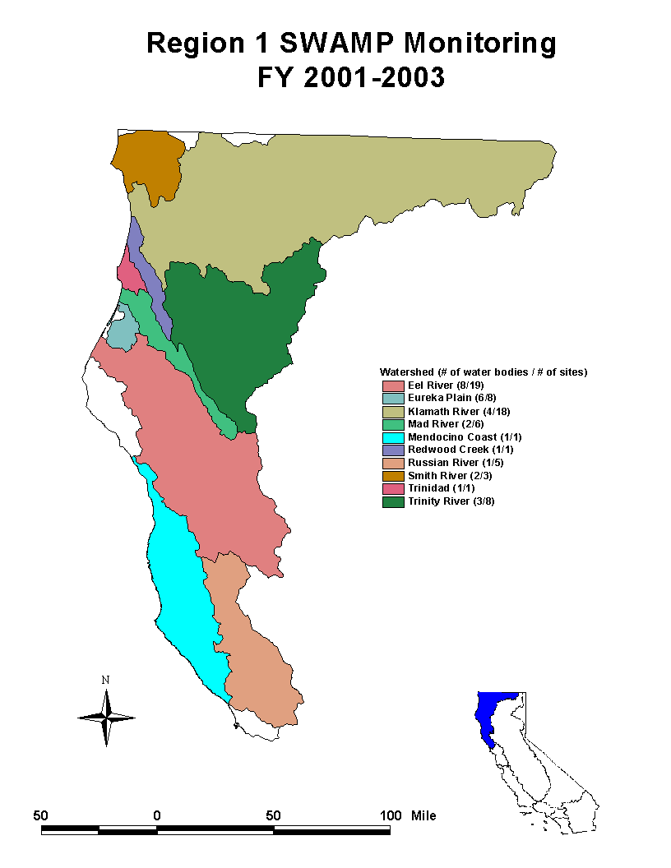
Region 2: San Francisco Bay Region

The goal of SWAMP in the San Francisco Bay region is to monitor and assess all water bodies of the region in order to identify reference sites (clean sites) and water bodies or sites that are impaired, based on data and information that provide a weight-of-evidence assessment of water quality. The San Francisco Bay RWQCB has developed a Regional Monitoring and Assessment Strategy (RMAS) in order to develop information for all water bodies in the region for the report required by CWA section 305(b) [305(b) report] and the 303(d) list. SWAMP resources are used to implement the RMAS. The selection and schedule of watersheds to be monitored are based on a number of factors. Overall, RWQCB is seeking geographic balance in the region in committing its monitoring resources. Watersheds monitored in the beginning years of the program tended to involve time-sensitive issues such as endangered species habitat (e.g., salmonids) or imminent development plans. In some instances, paired watersheds, which are close geographically and have similar land use and geology, are chosen for monitoring.

SWAMP funds are used to concentrate on monitoring watersheds, lakes/reservoirs, and bays and estuaries in this region other than the San Francisco Bay, which is currently monitored through the San Francisco Estuary Regional Monitoring Program. SWAMP monitoring will be used to evaluate beneficial uses in this region, through the use of water quality indicators.

The data collected as a result of SWAMP monitoring will be used to identify impaired water bodies and the cause of impairment for the 303(d) list, identify reference conditions, and establish baseline conditions to evaluate future land use changes. SWAMP data will also be used to determine if there is an association between land use and water quality impacts, evaluate methods to develop the best approach for watershed assessments, and develop indices (i.e., the Index of Biological Integrity).
Figure 2

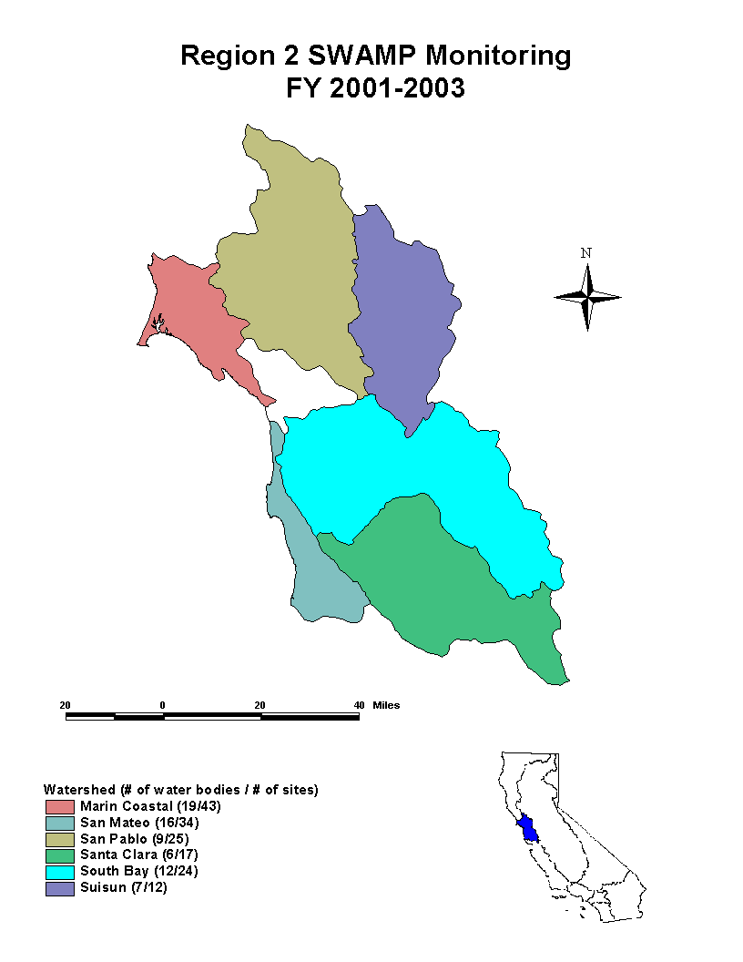
Region 3: Central Coast Region

SWAMP activities in this region are incorporated in RWQCB’s Central Coast Ambient Monitoring Program. Primary issues to be addressed in this region are related to nonpoint source pollution associated with row crop agriculture, vineyards, rangeland, and timber harvest. Urban runoff problems are increasing in some parts of the region. Nutrients, sedimentation, pesticides, and pathogens are the primary causes for 303(d) listings in the region. The goal of SWAMP monitoring in this region is to provide a screening level assessment of water quality based on a variety of indicators. The plan to carry out this goal includes several components: Coastal Confluences, Nearshore Assessment, and Watershed Characterization.

Coastal Confluences monitoring establishes ongoing monitoring sites at the lower ends of thirty major creeks and rivers right above tidal influence. This component provides trend data across the entire region, giving information on the nature of inputs to the ocean, which helps to prioritize problem watersheds. Nearshore Assessment focuses on how inputs from river mouths impact the nearshore environment and is being closely tied to Coastal Confluences data. The Watershed Characterization component is conducted in a five-year rotational cycle. Additional “focused” monitoring sites are placed at other locations of interest in the watershed, such as above and below specific land uses, point sources, BMPs, or other areas in need of characterization.

The data collected as a result of SWAMP monitoring will be used in some cases to determine whether water bodies warranted listing on the 303(d) list. At sites along the mainstem and at the lower ends of major tributaries of streams and rivers, some of the monitoring will provide indications of water quality degradation for anadromous fish species, using fish toxicity testing, benthic community analysis, habitat condition, and physical and chemical water condition.
Figure 3

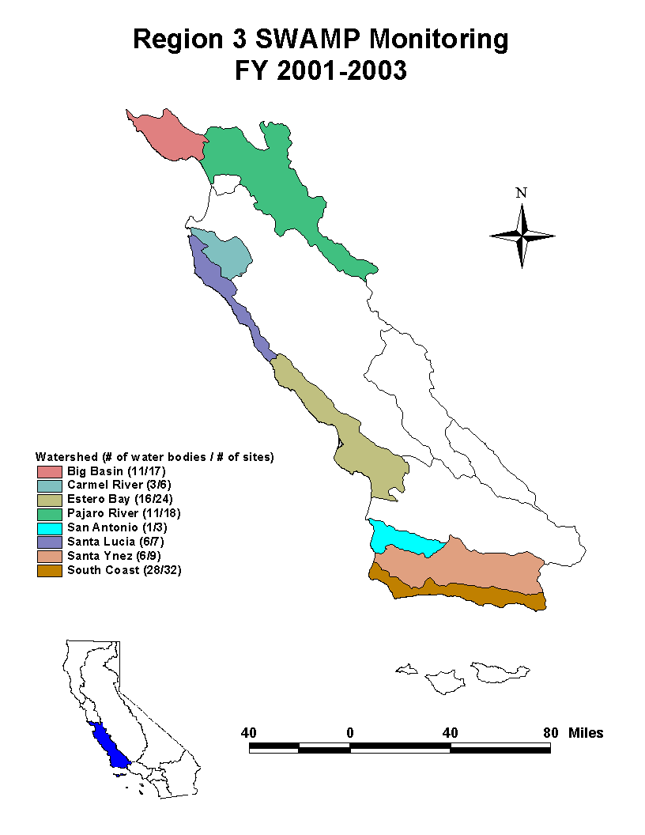
Region 4: Los Angeles Region

SWAMP sampling and analysis in the Los Angeles region will be used to assess the ambient conditions of the watersheds in Los Angeles and Ventura counties and will further delineate the nature, extent, and sources of toxic pollutants which have been detected or are suspected to be problematic for this region and its individual watersheds. Where applicable, a triad approach (benthic community analysis, water chemistry, and toxicity testing) is being used. The monitoring will also help to identify pristine conditions where no pollutants or contaminants are found.

Although the overall goal of SWAMP is to assess the ambient conditions of the watersheds, each watershed in the region is unique, and the design of the monitoring program and goals reflect this individuality. For example, the primary objective of monitoring in the Santa Clara watershed is to provide a broad baseline of the overall health of the watershed. Additional sub-objectives include determination of beneficial use attainment, filling in data gaps where data are either inconsistent or incomplete, and identification of potential reference sites for this watershed. A broad suite of parameters will be tested at the various stations to meet the needs of each unique watershed. In addition to the assessment of the ambient conditions of targeted watersheds, data collected by SWAMP will be used to develop the 305(b) report, 303(d) list and TMDLs, and for NPDES permit renewals. The information gathered will also be used in trend analysis, identification of impaired beneficial uses, as well as potentially in the development of an index of biological integrity.

SWAMP funds were focused in FY 2000-01 on monitoring in the Santa Clara-Calleguas hydrologic unit, and in FY 2001-02 on approximately 30 coastal sub-watersheds of the Malibu and Los Angeles-San Gabriel hydrologic units. Many of these sub-watersheds had not been sampled at all and others had been sampled modestly at best. In FY 2002-03, SWAMP resources are focusing on the Dominguez Channel and Los Angeles and Long Beach harbors. The focus of sampling is on basic and conventional water column chemistry, bacteriology, and bioassessment at most stations, with a major focus on bioassessment which historically has been overlooked.

Figure 4

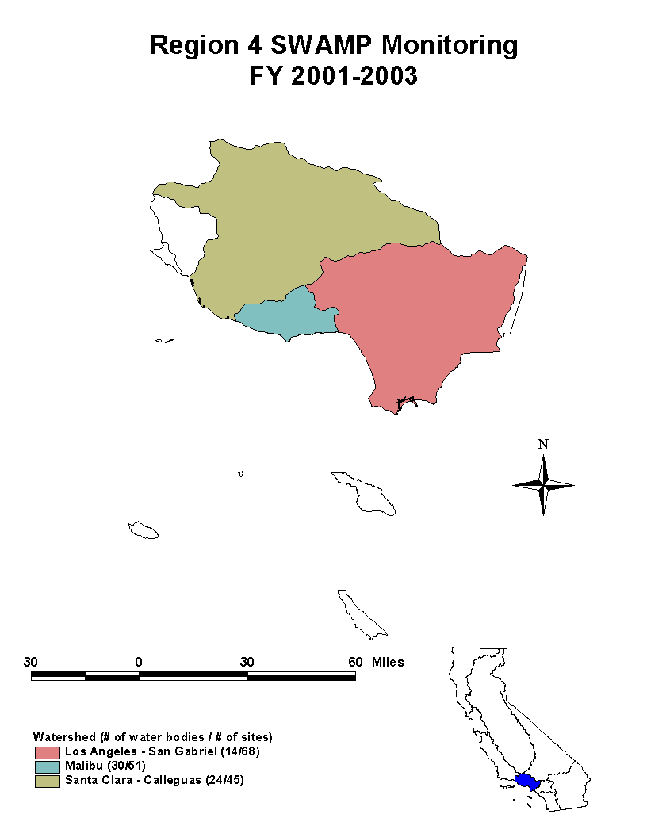
Region 5: Central Valley Region

Three major watersheds—Sacramento River, San Joaquin River, and Tulare Lake Basin—have been delineated within the Central Valley region, which stretches from the Oregon border to the northern tip of Los Angeles County. Since each watershed has both a unique set of stakeholders and unique water quality concerns that must be addressed, the management process and the accompanying monitoring program are watershed specific.

In the upper Sacramento River watershed, water quality issues principally relate to nonpoint source pollution resulting from past and current land management practices. These practices include livestock grazing, irrigated and non-irrigated agriculture, road and building construction, timber harvest, urban runoff, abandoned and inactive mines, and hydro-modification (i.e., dams, diversions, and stream channel disturbances). The overall SWAMP objective for this watershed is to evaluate the extent of water quality and beneficial use impairment.

The lower Sacramento River watershed contains over 5,700 miles of agriculturally dominated water bodies (ADWs). An ADW is a water body receiving greater than 50 percent of the flow from agricultural discharges during a significant portion of the irrigation season. Baseline aquatic community composition in these ADWs is largely unknown. In the fall of 2000, the Central Valley RWQCB undertook a SWAMP biological monitoring project in ADWs and effluent dominated water bodies (EDWs) of the Sacramento River watershed. This two-year project was intended to identify baseline aquatic community composition and assess the habitat condition at 45 sites, and to move towards identification of biological indicators of water quality in wadeable ADWs and EDWs of the lower Sacramento River watershed.

In the San Joaquin River watershed, SWAMP builds upon a monitoring framework developed as part of the agricultural subsurface drainage management program that has evolved since 1985. In addition, the watershed has been divided into five sub-basins to facilitate expanded monitoring within each sub-basin on a five-year rotational basis. SWAMP resources are being utilized for targeted sampling activities to better characterize the extent and source of known and suspected water quality impairments. Findings will be used to focus future control efforts and evaluate potential listing and delisting of 303(d) water bodies.

Point and nonpoint sources of pollution resulting from historical and current land use dominate water quality concerns in the Tulare Lake Basin. These uses include industrial processes, livestock grazing, dams, recreation, irrigated agriculture, confined animal facilities, and foothill and urban development. To date, there has been no comprehensive monitoring or assessment initiated for surface waters in this watershed. The overall objective of SWAMP for the Tulare Lake Basin is to identify reference and baseline surface water conditions, assess water quality and beneficial use impairment/support, provide data for impaired water body listings, and determine if there is an association between land use and water quality impacts.
Figure 5

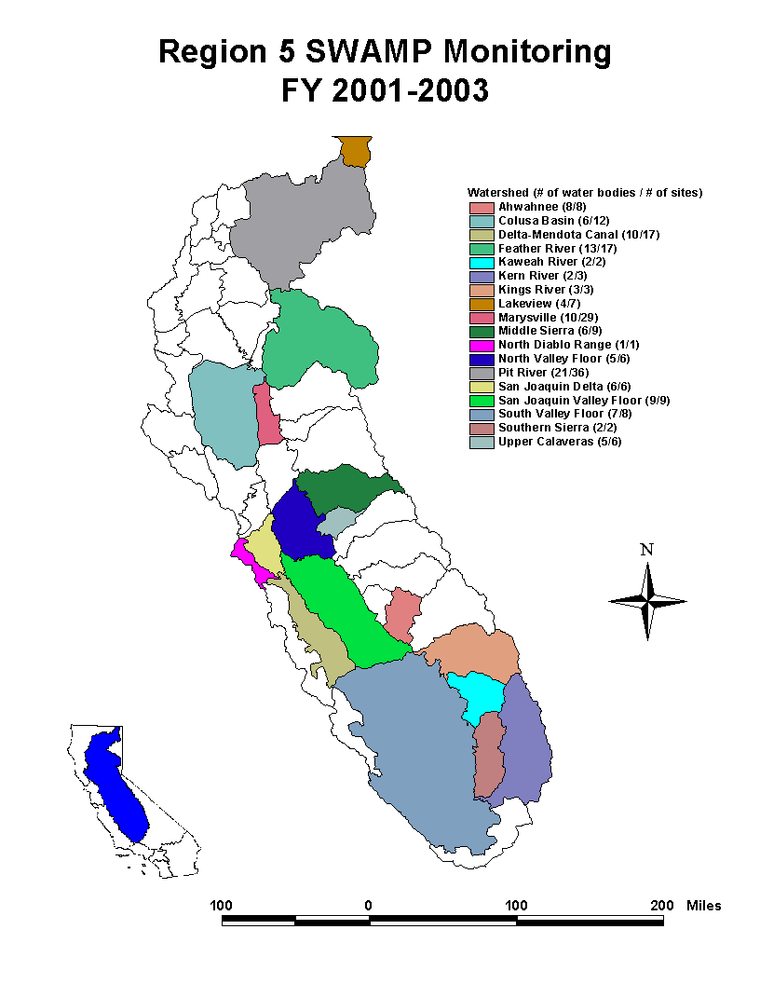
Region 6: Lahontan Region

The Lahontan region spans eastern California from the Oregon border in the north to the Mojave Desert in the south. SWAMP is the only significant source of ambient monitoring funds currently available to this region, as there are few regulated industrial or municipal dischargers to provide substantial monitoring information. The Lahontan RWQCB is using its SWAMP funds to establish a core network of long-term water monitoring stations throughout the region, primarily at locations where discrete numeric water quality objectives have long been established but little or no monitoring has occurred. This approach will allow the RWQCB to make more rapid and definitive assessments of the extent to which water quality standards are met or violated.

The objectives of SWAMP at this region are twofold. The first objective is to determine, using a broadly dispersed, region-wide network of sampling stations, whether ambient water quality for the monitored sites achieves the chemical and physical water quality objectives stipulated in the Basin Plan. The second objective is to continue an effort begun in 1999 to establish “reference conditions,” and eventually develop indices of biological integrity, for streams in the eastern Sierra Nevada based on instream benthic macroinvertebrate and algae assemblages. Bioassessment monitoring is focused on the hydrological units in the center of the region in an effort to develop biological reference conditions for streams in the eastern Sierra ecoregion.
Figure 6

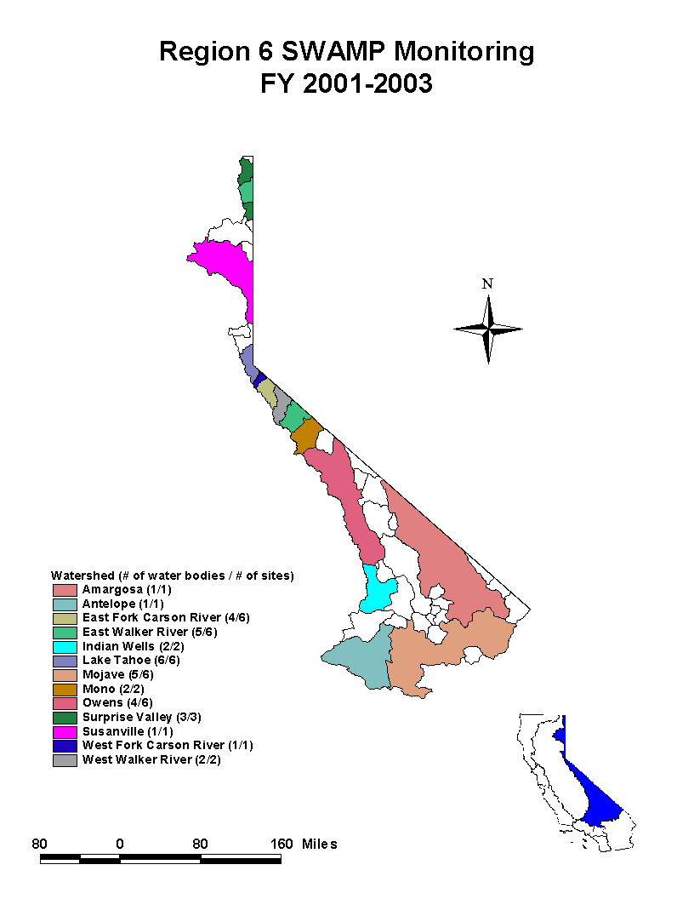
Region 7: Colorado River Basin Region

Most surface waters in the Colorado River Basin region are located in the Imperial Valley and East Colorado River Valley, with a few in the Coachella Valley, Lucerne Valley, and Hayfield planning areas. Therefore, SWAMP implementation in the region is focusing on the Imperial Valley and East Colorado River Valley.

SWAMP is implemented in each hydrologic area of the region over a five-year period. The site-specific goal is to monitor and assess the physical, chemical, and biological quality of the region’s surface waters. Efforts will concentrate on the Alamo River, given that the Alamo River Sedimentation/Siltation TMDL is the first TMDL that will be implemented in Imperial Valley. The use of BMPs to control silt runoff will take place within the next five years. Ambient monitoring information collected now and during implementation will be used to measure the effectiveness of BMPs. Furthermore, several constituents of concern that are transported with silt may be affected by BMPs. Monitoring will determine if implemented BMPs are reducing the amount of silt and the loading of other contaminants.

RWQCB staff selected monitoring sites based on protecting beneficial uses, taking into consideration the factors such as historical information, site location, information currently being collected, and future plans for implementation of BMPs. Locations that exhibited high concentrations of contaminants (e.g., selenium, pesticides, bacteria) were selected to monitor the progression of these pollutants. Similarly, sites in critical areas with regional significance (e.g., international boundary, diversion points, state borders, source waters) were also included.

SWAMP will provide a comprehensive view of changes that occur with BMP implementation and help develop a bioassessment program specific to the region. The information collected through SWAMP will also be used to prepare the 305(b) report and 303(d) list and to support RWQCB’s Basin Planning activities and complement other programs and studies conducted in the region.

Figure 7

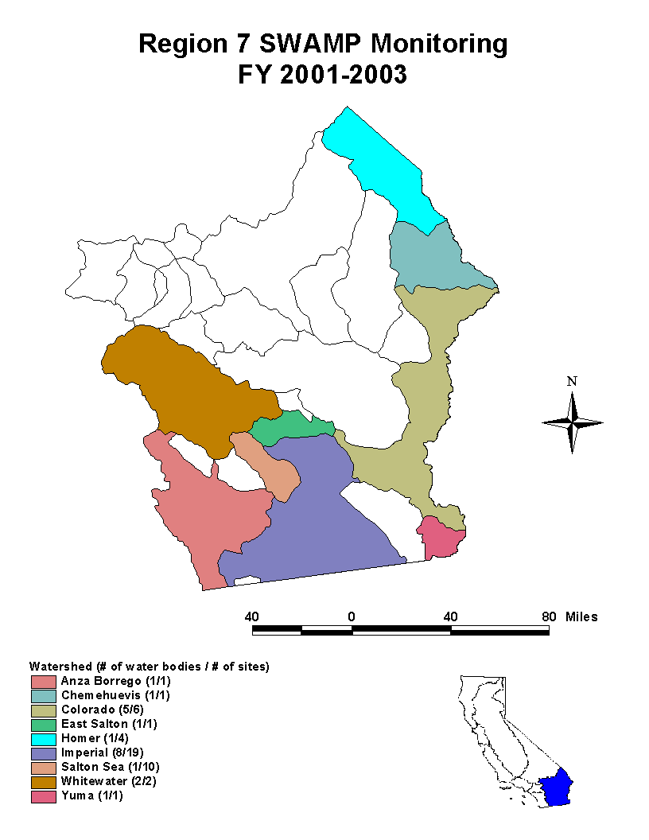
Region 8: Santa Ana Region

A comprehensive monitoring program is needed in the Santa Ana region to determine if the water quality objectives and/or beneficial uses are being attained in the receiving water bodies in this region. SWAMP activities in the region for FY 2000-01 through FY 2002-03 involve sampling in Anaheim Bay, Huntington Harbor, Lake Elsinore, and Canyon Lake. Sampling at Big Bear Lake is planned for FY 2004-05.

The general monitoring approach in this region involves applying a random sampling design to each water body being studied. Sampling activities include collecting surficial sediment samples for toxicity, benthic community and sediment chemistry analyses; and water column samples for toxicity and bacteria analyses. Furthermore, the water quality indicators are specific for each water body type and relate to the specific beneficial use being studied. This design, along with consistent sampling and analytical protocols, will not only allow RWQCB staff to determine whether each water body is attaining the beneficial uses but also allow for comparison among the different water bodies being studied in the region.

The data gathered by these activities will be used to prepare the region’s 305(b) report, update the 303(d) list, support other regulatory programs at the RWQCB, and determine the need to do focused studies in the future.

Figure 8

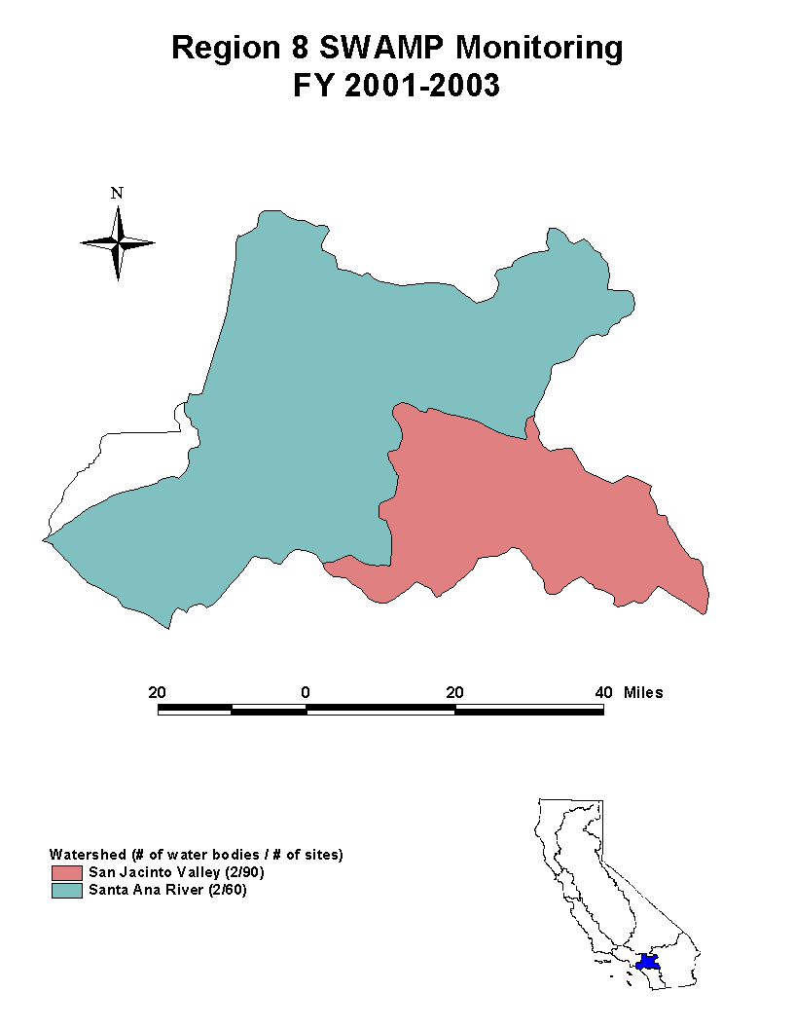
Region 9: San Diego Region

The creation of SWAMP has allowed the San Diego RWQCB to begin ambient monitoring on a five-year rotational basis in the region. This approach ensures that at the end of a five-year period there will have been monitoring activities in each of the watersheds in the region.

The primary objectives for SWAMP monitoring in this region include identifying the spatial extent of degraded sediment locations in rivers, lakes, nearshore waters, enclosed bays, and estuaries. Other objectives include monitoring sites influenced by point sources (e.g., storm drains, publicly owned treatment works, etc.) and those influenced by nonpoint sources of pollutants. In order to accomplish the objectives, the RWQCB plans to use the following indicators: biological response (sediment and water toxicity); pollutant exposure (fish tissue chemistry, nutrients, inorganic and organic water chemistry); and habitat (sediment grain size and gradations, hydrogen sulfide, and ammonia).

SWAMP monitoring in the San Diego region is intended to provide reliable, high quality information necessary to produce the 305(b) report and 303(d) list that are more comprehensive and more defensible than those of past years.

Figure 9

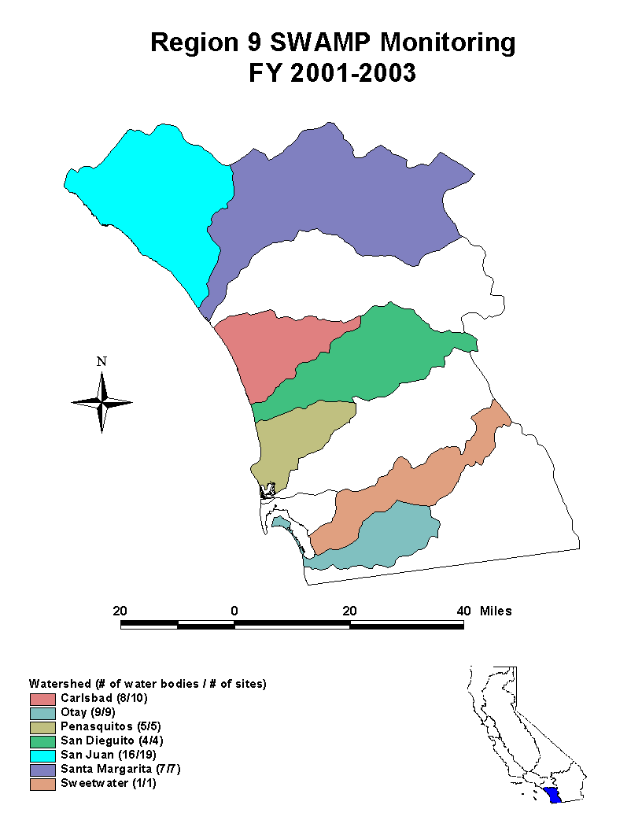

B. CWA SECTION 303(d)

1. Background

The State of California is required under Clean Water Act (CWA) section 303(d) and federal regulations (40 CFR 130) to prepare a list of and set priorities for water quality limited segments still requiring Total Maximum Daily Loads (TMDLs). The section 303(d) list was last revised in 1998. Federal regulations require the section 303(d) list to be updated every two years.

CWA section 303(d) requires states to identify waters that do not meet applicable water quality standards after the application of certain technology-based controls. As defined in the CWA and federal regulations, water quality standards include the designated uses of a water body, the adopted water quality criteria, and the State’s antidegradation policy. As defined in the Porter-Cologne Water Quality Control Act, water quality standards are beneficial uses to be made of a water body, the established water quality objectives (both narrative and numeric), and the State’s nondegradation policy (SWRCB Resolution No. 68-16).

The section 303(d) list must include a description of the pollutants causing the violation of water quality standards (40 CFR 130.7(b)(iii)(4)) and a priority ranking of the water quality limited segments taking into account the severity of the pollution and the uses to be made of the waters. A TMDL is the sum of the individual wasteload allocations for point sources and load allocations for nonpoint sources and natural background, tributaries, or adjacent segments. Federal regulation defines a “water quality limited segment” as “any segment [of a water body] where it is known that water quality does not meet applicable water quality standards, and/or is not expected to meet applicable water quality standards, even after application of technology-based effluent limitations required by CWA Sections 301(b) or 306.”

The states are required to review in even-numbered years the section 303(d) list, make changes as necessary, and submit the list to U.S. EPA for approval. Federal regulation exempted the requirement for the list to be submitted in 2000, and extended the date for submission of the next section 303(d) list to October 1, 2002.

The SWRCB is in the process of developing a Water Quality Control Policy for guidance on the development of the CWA section 303(d) list of water quality limited segments. The Policy will address the solicitation of all readily available data and information, evaluation of the data and information, an approach for considering the weight of evidence for identifying water quality limited segments, listing and de-listing factors for determining attainment of standards or beneficial uses, priority setting, and other topics. This policy, once developed, will be used to develop all future lists.

2. Development of the 2002 CWA Section 303(d) of Water Quality Limited Segments

Beginning March 14, 2001, the RWQCBs solicited other State agencies, Federal agencies, and the public for all readily available data and information to support the update of the section 303(d) list. The solicitation was first closed on May 15, 2001. On May 15, 2002, the SWRCB extended the solicitation of data and information until June 15, 2002.

Each of the nine RWQCBs assembled and evaluated all existing and readily available water quality-related data and information to develop the list and provided an assessment and documentation of decisions to list or not to list a state’s waters. RWQCB staff prepared draft staff reports, fact sheets (in many cases), and summaries of the additions, deletions and changes to the section 1998 303(d) list

Each RWQCB held public Workshops and/or Board meetings to consider the recommendations for revising the section 303(d) list. Many of the RWQCBs received substantial public comments (including comments from U.S. EPA), responded to the comments, and revised their reports/lists based on public comments or submitted data.

Each of the RWQCBs submitted staff reports and lists to SWRCB. The SWRCB staff reviewed the RWQCB recommendations and either concurred with the recommendation or identified the reasons for not concurring. SWRCB staff developed fact sheets for each proposal to add water bodies, delete water bodies, and change the section 303(d) list.

The SWRCB held public hearings to receive comment on the proposed section 303(d) list. The first hearing was held in northern California (on May 23 and 24, 2002) and the second hearing was held in southern California (May 30, 2002). The SWRCB heard additional comments on the revised submittal at its November 2002 Workshop. The SWRCB received written submittals and testimony from 425 individuals and organizations. SWRCB staff has responded in writing to all comments received by December 6, 2002 (Volume IV). Changes were made to the staff report and recommendations as a result of the comments.

The SWRCB approved the 303(d) list for submittal to U.S. EPA on February 4, 2003. U.S. EPA approved the Section 303(d) list in June 2003. On July 25, 2003, U.S. EPA added 5 waters and 15 pollutants to waters already listed.

Information on the California 303(d) listing process can be found on the SWRCB website at: http://www.swrcb.ca.gov/tmdl/303d_lists.html

3. 2002 CWA Section 303(d) List of Water Quality Limited Segments

The SWRCB approved 2002 CWA Section 303(d) List of Water Quality Limited Segments contains the following information for each listed segment:

- RWQCB
- Water body type
- Watershed
- Pollutant/stressor,
- Potential sources of pollutants
- A preliminary estimate of the size (area or length) of water body affected
- TMDL priority
- Estimated TMDL completion dates for high priority TMDLs

The 2002 U.S. EPA approved 303(d) list has a total of 685 water quality limited segments and 1,883 segment-pollutant combinations. The 2002 U.S. EPA approved 303(d) list is Appendix B of this document and can be found on the SWRCB website at this address: http://www.swrcb.ca.gov/tmdl/docs/2002cwa303d_listof_wqls072003.pdf

4. Monitoring List, Enforceable Program List, and TMDL Completed List for 2003

The SWRCB used portions of the U.S. EPA 2002 Integrated Water Quality Monitoring and Assessment Report Guidance (Office of Wetlands, Oceans and Watersheds) as follows:

If there is insufficient available data and information to list, water bodies were placed on a “Monitoring List.”

If water quality standards are not met but the problem can be addressed now by another enforceable program, water bodies were placed on a “Enforceable Programs List.”

If water quality standards are not met and a TMDL and implementation plan has been approved for the water body-pollutant combination, the water body-pollutant combination was placed on the “TMDLs Completed List.”

Monitoring List 2002

Many of the RWQCBs identified waters where minimal, contradictory, or anecdotal information suggests standards are not met but the available data or information is inadequate to draw a conclusion. In many cases, the data or information is not of adequate quality and quantity to support a listing and subsequent TMDL regulatory process. In these cases, a finding is warranted that more information must be collected to resolve whether objectives and beneficial uses are attained. However, allocations of resources for monitoring should not be based solely on the Monitoring List because of the multiple functions of SWAMP.
The Monitoring List contains 312 water bodies. It should not be considered part of the section 303(d) list; however, the list will be submitted to USEPA. The 2002 Monitoring List is presented in Appendix C and can be found on the SWRCB website at:
http://www.swrcb.ca.gov/tmdl/docs/2002_mon_list_020403.pdf

Enforceable Programs List 2002

Consistent with 40 CFR 130.7(b)(i), (ii), and (iii), several water bodies are listed where the Consolidated Toxic Hot Spots Cleanup Plan and enforcement of existing permits or other legal required authorities are stringent enough to attain water quality standards. These requirements and programs are specifically applicable to the identified water quality problem. SWRCB staff developed a 2002 Enforceable Programs List that contains 14 segment-pollutant combinations.

The 2002 Enforceable Programs List is not part of the section 303(d) list but it will be sent to U.S. EPA. The 2002 Enforceable Programs List is presented in Appendix D and can be found on the SWRCB website at: http://www.swrcb.ca.gov/tmdl/docs/2002_enf_prog_list_020403.pdf

TMDL Completed List 2002

A number of TMDLs have been completed. To show progress in developing TMDLs, the SWRCB staff developed a list of TMDLs completed. For the purposes of this list, a completed TMDL includes a technical TMDL report; implementation plan; adoption by the RWQCBs; and approval by SWRCB, the Office of Administrative Law (OAL) and U.S. EPA. Several TMDLs are in various stages of the approval process. The TMDLs Completed List contains those water quality limited segments that have TMDLs with an approved implementation plans.

At present, it is assumed that even though the TMDL has been completed that water quality standards or beneficial uses are not yet attained. Once it has been shown that standards are achieved and/or beneficial uses are attained the water bodies will be removed from this list.

The 2002 TMDLs Completed List should not be considered part of the section 303(d) list. However, the TMDLs Completed List will be submitted to U.S. EPA. The 2002 TMDL Completed List is presented in Appendix E and can be found on the SWRCB website at: http://www.swrcb.ca.gov/tmdl/docs/2002_tmdl_comp_list_020403.pdf
C. DESIGNATED USE SUPPORT SUMMARY

In previous 305(b) Reports, overall use support tables were presented for each water body type. These tables are no longer a reporting requirement of CWA Section 305(b) because the presentation of overall use could mask the specific number of uses impaired. The overall use tables have been replaced by the Tables 4A-4I summarizing the extent of impairment in terms of the number of beneficial uses affected.

A determination of degree of use support likely presents a worst-case scenario of the state's water quality because a substantial portion of the state's monitoring data are collected in response to suspected problems (i.e., healthy environments are less likely than troubled ones to be targeted for monitoring).

The two assessment categories "evaluated" and "monitored" used in the following Tables 4A-4I are defined in the U.S. EPA Guidelines for Preparation of the 1998 State Water Quality Assessments [305(b) Report] as follows:

"Evaluated waters" are those water bodies for which the use support decision is based on information other than current site-specific ambient data, such as data on land use, location of sources, predictive modeling using estimated input variables, and some surveys of fish and game biologists. As a general guide, if an assessment is based on older ambient data (e.g., older than five years), it would be considered "evaluated."

"Monitored waters" are those water bodies for which the use support decision is principally based on current site-specific ambient data believed to accurately portray water quality conditions. Waters with data from biosurveys would be included in this category along with waters monitored by fixed-station chemical/physical monitoring. To be considered "monitored" based on fixed-station chemical/physical monitoring, waters should be sampled quarterly or more frequently.

TABLE 4A. SUMMARY OF DESIGNATED USE SUPPORT: BAYS AND HARBORS (Acres)

DEGREE OF USE SUPPORT | ASSESSMENT CATEGORY |  | TOTAL ASSESSED
 | EVALUATED | MONITORED
Size Fully Supporting All Assessed Uses | 454 | 235 | 689
Size Fully Supporting All Assessed Uses but Threatened for at Least One Use | 350 | 10,899 | 11,249
Size Impaired for One or More Uses¹ | 2,439 | 457,442 | 459,881
TOTAL ASSESSED | 3,243 | 468,576 | 471,819

¹ Impaired = Partially or Not Supporting a Designated Use

TABLE 4B. SUMMARY OF DESIGNATED USE SUPPORT: COASTAL SHORELINE (Miles)

DEGREE OF USE SUPPORT | ASSESSMENT CATEGORY |  | TOTAL ASSESSED
 | EVALUATED | MONITORED
Size Fully Supporting All Assessed Uses | 535 | 74 | 609
Size Fully Supporting All Assessed Uses but Threatened for at Least One Use | 0 | 0 | 0
Size Impaired for One or More Uses¹ | 16 | 144 | 160
TOTAL ASSESSED | 551 | 218 | 769

¹ Impaired = Partially or Not Supporting a Designated Use
TABLE 4C. SUMMARY OF DESIGNATED USE SUPPORT: ESTUARIES (Acres)

DEGREE OF USE SUPPORT | ASSESSMENT CATEGORY |  | TOTAL ASSESSED
 | EVALUATED | MONITORED
Size Fully Supporting All Assessed Uses | 2,721 | 1,009 | 3,730
Size Fully Supporting All Assessed Uses but Threatened for at Least One Use | 141 | 1,181 | 1,322
Size Impaired for One or More Uses¹ | 136 | 101,982 | 102,118
TOTAL ASSESSED | 2,998 | 104,172 | 107,170

- Impaired = Partially or Not Supporting a Designated Use

TABLE 4D. SUMMARY OF DESIGNATED USE SUPPORT: LAKES / RESERVOIRS (Acres)

DEGREE OF USE SUPPORT | ASSESSMENT CATEGORY |  | TOTAL ASSESSED
 | EVALUATED | MONITORED
Size Fully Supporting All Assessed Uses | 89,316 | 19,124 | 108,440
Size Fully Supporting All Assessed Uses but Threatened for at Least One Use | 26,041 | 80,404 | 106,445
Size Impaired for One or More Uses¹ | 66,596 | 294,532 | 361,128
TOTAL ASSESSED | 181,953 | 394,060 | 576,013

¹ Impaired = Partially or Not Supporting a Designated Use
TABLE 4E. SUMMARY OF DESIGNATED USE SUPPORT: OCEAN and OPEN BAYS (Acres)

DEGREE OF USE SUPPORT | ASSESSMENT CATEGORY |  | TOTAL ASSESSED
 | EVALUATED | MONITORED
Size Fully Supporting All Assessed Uses | 313,494 | 0 | 313,494
Size Fully Supporting All Assessed Uses but Threatened for at Least One Use | 0 | 0 | 0
Size Impaired for One or More Uses¹ | 0 | 0 | 0
TOTAL ASSESSED | 313,494 | 0 | 313,494

¹ Impaired = Partially or Not Supporting a Designated Use

TABLE 4F. SUMMARY OF DESIGNATED USE SUPPORT: RIVERS / STREAMS (Miles)

DEGREE OF USE SUPPORT | ASSESSMENT CATEGORY |  | TOTAL ASSESSED
 | EVALUATED | MONITORED
Size Fully Supporting All Assessed Uses | 1,156 | 329 | 1,485
Size Fully Supporting All Assessed Uses but Threatened for at Least One Use | 1,746 | 1,856 | 3,602
Size Impaired for One or More Uses¹ | 5,670 | 21,779 | 27,449
TOTAL ASSESSED | 8,572 | 23,964 | 32,536

¹ Impaired = Partially or Not Supporting a Designated Use
TABLE 4G. SUMMARY OF DESIGNATED USE SUPPORT: SALINE LAKES (Acres)

DEGREE OF USE SUPPORT | ASSESSMENT CATEGORY |  | TOTAL ASSESSED
 | EVALUATED | MONITORED
Size Fully Supporting All Assessed Uses | 0 | 0 | 0
Size Fully Supporting All Assessed Uses but Threatened for at Least One Use | 0 | 0 | 0
Size Impaired for One or More Uses¹ | 665 | 479,920 | 480,585
TOTAL ASSESSED | 665 | 479,920 | 480,585

¹ Impaired = Partially or Not Supporting a Designated Use

TABLE 4H. SUMMARY OF DESIGNATED USE SUPPORT: WETLANDS, FRESHWATER (Acres)

DEGREE OF USE SUPPORT | ASSESSMENT CATEGORY |  | TOTAL ASSESSED
 | EVALUATED | MONITORED
Size Fully Supporting All Assessed Uses | 11,740 | 0 | 11,740
Size Fully Supporting All Assessed Uses but Threatened for at Least One Use | 502 | 494 | 996
Size Impaired for One or More Uses¹ | 92,513 | 11,597 | 104,110
TOTAL ASSESSED | 104,755 | 12,091 | 116,846

¹ Impaired = Partially or Not Supporting a Designated Use
TABLE 4I. SUMMARY OF DESIGNATED USE SUPPORT: WETLANDS, TIDAL (Acres)

DEGREE OF USE SUPPORT | ASSESSMENT CATEGORY |  | TOTAL ASSESSED
 | EVALUATED | MONITORED
Size Fully Supporting All Assessed Uses | 0 | 0 | 0
Size Fully Supporting All Assessed Uses but Threatened for at Least One Use | 0 | 3 | 3
Size Impaired for One or More Uses¹ | 13,920 | 66,672 | 80,592
TOTAL ASSESSED | 13,920 | 66,675 | 80,595

¹ Impaired = Partially or Not Supporting a Designated Use

D. INDIVIDUAL USE SUMMARY

Use Support Classifications

U.S. EPA categories of Fully Supporting, Fully Supporting But Threatened, Partially Supporting, and Not Supporting, are described below:

Fully Supporting refers to waters of good quality in the GeoWBS database, excluding the Fully Supporting But Threatened category which is treated separately. "Good" waters support and enhance all designated beneficial uses.

Fully Supporting But Threatened refers to those portions of good quality waters in the GeoWBS database which specifically identify at least one beneficial use as threatened.

Partially Supporting refers to all intermediate and less severely impaired waters in the GeoWBS database. "Intermediate" waters support beneficial uses with an occasional degradation of water quality. The term "intermediate" usually indicates suspected impacts to beneficial uses, i.e., a problem is indicated but inadequate data are available. "Impaired" water bodies cannot reasonably be expected to attain or maintain applicable water quality standards, and at least one beneficial use shows some degree of impairment.

Not Supporting refers to those water bodies in which a beneficial use is severely impaired and which staff judges to merit serious attention.

Tables 5A-5I show the level of support for each of the eight U.S. EPA designated beneficial uses in different types of water bodies. These include Fish Consumption, Shellfishing, Aquatic Life Support, Swimming, Secondary Contact, Drinking Water Supply, and Agriculture. California has more beneficial use categories than U.S. EPA 's designated use categories (See Appendix A). For Tables 5A-5I, California beneficial use designations have been grouped into the seven basic U.S. EPA beneficial use categories as outlined below:

U.S. EPA DESIGNATED EQUIVALENT CALIFORNIA
USE CATEGORIES BENEFICIAL USE CATEGORY*

Fish Consumption Ocean Commercial and Sport Fishing

Shellfishing Shellfish Harvesting

Aquatic Life Support Warm Freshwater Habitat
Cold Freshwater Habitat
Freshwater Replacement
Preservation of Biological Habitats of Special
Significance
Estuarine Habitat
Marine Habitat
Fish Spawning
Fish Migration
Rare and Endangered Species
Wildlife Habitat
Saline Water Habitat
Aquaculture

Swimming Water Contact Recreation

Secondary Contact Non-Contact Water Recreation

Drinking Water Supply Municipal and Domestic Supply

Agriculture Agricultural Supply

* A description of these California beneficial uses is included in Appendix A.

Beneficial use support status is determined for entire water bodies or portions of water bodies based on the length or areal extent represented by monitoring data or other evaluation criteria. In many cases, different portions of a water body have a different use support status. In certain cases where information is not available to determine the limits of impaired areas, the entire water body is considered impaired.
TABLE 5A. INDIVIDUAL USE SUPPORT SUMMARY: BAYS AND HARBORS (Acres)

GOALS | USE | SIZE FULLY SUPPORTING | SIZE SUPPORTING BUT THREATENED | SIZE PARTIALLY SUPPORTING | SIZE NOT SUPPORTING | SIZE NOT ATTAINABLE | SIZE NOT ASSESSED
Protect & Enhance Ecosystems | Aquatic Life Support | 868 | 961 | 284,380 | 158,228 | - | 27,382
Protect and Enhance Public Health | Fish Consumption | 1,492 | 10,424 | 301,222 | 154,577 | - | 4,005
 | Shellfishing | 8,235 | 10,022 | 256,727 | 147,983 | - | 20,293
 | Swimming | 425,376 | 402 | 6,095 | 4,067 | - | 35,324
 | Secondary Contact | 426,380 | 402 | 4,851 | 3,225 | - | 36,862
 | Drinking Water Supply | * | * | * | * | * | *
Social and Economic | Agriculture | 0 | 0 | 0 | 0 | - | 285,772
 | Cultural or Ceremonial | * | * | * | * | * | *

"*" = Category not applicable
"-" = Category applicable but no data available
"0" = Category applicable, but size of waters in the category is zero
TABLE 5B. INDIVIDUAL USE SUPPORT SUMMARY: COASTAL SHORELINE (Miles)

GOALS | USE | SIZE FULLY SUPPORTING | SIZE SUPPORTING BUT THREATENED | SIZE PARTIALLY SUPPORTING | SIZE NOT SUPPORTING | SIZE NOT ATTAINABLE | SIZE NOT ASSESSED
Protect & Enhance Ecosystems | Aquatic Life Support | 595 | 0 | 28 | 20 | - | 90
Protect and Enhance Public Health | Fish Consumption | 371 | 0 | 29 | 32 | - | 92
 | Shellfishing | 525 | 0 | 17 | 0.4 | - | 32
 | Swimming | 531 | 0 | 94 | 59 | - | 35
 | Secondary Contact | 596 | 0 | 35 | 52 | - | 36
 | Drinking Water Supply | * | * | * | * | * | *
Social and Economic | Agriculture | 0 | 0 | 0 | 0 | - | 43
 | Cultural or Ceremonial | * | * | * | * | * | *

"*" = Category not applicable
"-" = Category applicable but no data available
"0" = Category applicable, but size of waters in the category is zero
TABLE 5C. INDIVIDUAL USE SUPPORT SUMMARY: ESTUARIES (Acres)

GOALS | USE | SIZE FULLY SUPPORTING | SIZE SUPPORTING BUT THREATENED | SIZE PARTIALLY SUPPORTING | SIZE NOT SUPPORTING | SIZE NOT ATTAINABLE | SIZE NOT ASSESSED
Protect & Enhance Ecosystems | Aquatic Life Support | 3,498 | 1,181 | 97,319 | 4,023 | - | 2,829
Protect and Enhance Public Health | Fish Consumption | 2,440 | 55 | 94,273 | 2,945 | - | 4,486
 | Shellfishing | 2,425 | 0 | 1,053 | 675 | - | 97,791
 | Swimming | 8,141 | 329 | 88,847 | 2,902 | - | 4,648
 | Secondary Contact | 8,344 | 198 | 44,833 | 2,831 | - | 48,643
 | Drinking Water Supply | 0 | 0 | 44,060 | 0 |  | 55,093
Social and Economic | Agriculture | 0 | 0 | 465 | 0 | - | 96,218
 | Cultural or Ceremonial | * | * | * | * | * | *

"*" = Category not applicable
"-" = Category applicable but no data available
"0" = Category applicable, but size of waters in the category is zero

TABLE 5D. INDIVIDUAL USE SUPPORT SUMMARY: LAKES / RESERVOIRS (Acres)

GOALS | USE | SIZE FULLY SUPPORTING | SIZE SUPPORTING BUT THREATENED | SIZE PARTIALLY SUPPORTING | SIZE NOT SUPPORTING | SIZE NOT ATTAINABLE | SIZE NOT ASSESSED
Protect & Enhance Ecosystems | Aquatic Life Support | 142,995 | 90,571 | 286,390 | 4,043 | - | 69,625
Protect and Enhance Public Health | Fish Consumption | 92,825 | 179,284 | 89,316 | 6,049 | - | 199,782
 | Shellfishing | 20 | 0 | 0 | 0 | - | 208,690
 | Swimming | 149,196 | 75,570 | 181,598 | 2,651 | - | 155,302
 | Secondary Contact | 182,773 | 62,861 | 133,709 | 2,220 |  | 211,911
 | Drinking Water Supply | 172,304 | 125,877 | 40,294 | 1,546 | - | 151,339
Social and Economic | Agriculture | 192,945 | 38,238 | 11,303 | 2,246 |  | 331,452
 | Cultural or Ceremonial | 0 | 0 | 0 | 26,998 | * | 68,340

"*" = Category not applicable
"-" = Category applicable but no data available
"0" = Category applicable, but size of waters in the category is zero
TABLE 5E. INDIVIDUAL USE SUPPORT SUMMARY: OCEAN and OPEN BAYS (Acres)

GOALS | USE | SIZE FULLY SUPPORTING | SIZE SUPPORTING BUT THREATENED | SIZE PARTIALLY SUPPORTING | SIZE NOT SUPPORTING | SIZE NOT ATTAINABLE | SIZE NOT ASSESSED
Protect & Enhance Ecosystems | Aquatic Life Support | 311,305 | 0 | 0 | 0 | - | 2,916
Protect and Enhance Public Health | Fish Consumption | 311,305 | 0 | 0 | 0 | - | 2,916
 | Shellfishing | 311,305 | 0 | 0 | 0 | - | 405
 | Swimming | 311,305 | 0 | 0 | 0 | - | 2,916
 | Secondary Contact | 311,305 | 0 | 0 | 0 | - | 2,916
 | Drinking Water Supply | 98,448 | 0 | 0 | 0 | - | 488
Social and Economic | Agriculture | * | * | * | * | * | *
 | Cultural or Ceremonial | * | * | * | * | * | *

"*" = Category not applicable
"-" = Category applicable but no data available
"0" = Category applicable, but size of waters in the category is zero
TABLE 5F. INDIVIDUAL USE SUPPORT SUMMARY: RIVERS / STREAMS (Miles)

GOALS | USE | SIZE FULLY SUPPORTING | SIZE SUPPORTING BUT THREATENED | SIZE PARTIALLY SUPPORTING | SIZE NOT SUPPORTING | SIZE NOT ATTAINABLE | SIZE NOT ASSESSED
Protect & Enhance Ecosystems | Aquatic Life Support | 1,495 | 2,660 | 22,815 | 2,842 | - | 6,221
Protect and Enhance Public Health | Fish Consumption | 955 | 1,012 | 6,221 | 239 | - | 26,243
 | Shellfishing | 3 | 13 | 19 | 22 | - | 14,606
 | Swimming | 1,421 | 1,389 | 10,660 | 2,362 | - | 19,437
 | Secondary Contact | 2,054 | 1,136 | 6,668 | 2,106 | - | 24,044
 | Drinking Water Supply | 2,804 | 1,442 | 6,195 | 469 | - | 21,664
Social and Economic | Agriculture | 4,945 | 753 | 5,437 | 591 | - | 22,771
 | Cultural or Ceremonial | 0 | 677 | 612 | 0 | - | 10,960

"*" = Category not applicable
"-" = Category applicable but no data available
"0" = Category applicable, but size of waters in the category is zero
TABLE 5G. INDIVIDUAL USE SUPPORT SUMMARY: SALINE LAKES (Acres)

GOALS | USE | SIZE FULLY SUPPORTING | SIZE SUPPORTING BUT THREATENED | SIZE PARTIALLY SUPPORTING | SIZE NOT SUPPORTING | SIZE NOT ATTAINABLE | SIZE NOT ASSESSED
Protect & Enhance Ecosystems | Aquatic Life Support | 88,925 | 30,211 | 361,426 | 0 | - | 23
Protect and Enhance Public Health | Fish Consumption | 0 | 0 | 0 | 0 | - | 402,430
 | Shellfishing | 0 | 0 | 0 | 0 | - | 12,021
 | Swimming | 0 | 0 | 479,897 | 0 | - | 688
 | Secondary Contact | 79,534 | 0 | 400,363 | 0 | - | 688
 | Drinking Water Supply | 0 | 0 | 110,621 | 0 | - | 665
Social and Economic | Agriculture | 0 | 0 | 97,499 | 0 | - | 688
 | Cultural or Ceremonial | * | * | * | * | * | *

"*" = Category not applicable
"-" = Category applicable but no data available
"0" = Category applicable, but size of waters in the category is zero
TABLE 5H. INDIVIDUAL USE SUPPORT SUMMARY: WETLANDS, FRESHWATER (Acres)

GOALS | USE | SIZE FULLY SUPPORTING | SIZE SUPPORTING BUT THREATENED | SIZE PARTIALLY SUPPORTING | SIZE NOT SUPPORTING | SIZE NOT ATTAINABLE | SIZE NOT ASSESSED
Protect & Enhance Ecosystems | Aquatic Life Support | 11,737 | 688 | 74,417 | 0 | - | 45
Protect and Enhance Public Health | Fish Consumption | 173 | 0 | 49 | 0 | - | 81,801
 | Shellfishing | 0 | 0 | 0 | 0 | - | 10,374
 | Swimming | 11,831 | 688 | 8,174 | 0 | - | 66,169
 | Secondary Contact | 11,857 | 688 | 8,172 | 0 | - | 66,171
 | Drinking Water Supply | 176 | 195 | 62,793 | 0 | - | 18,830
Social and Economic | Agriculture | 0 | 194 | 11,081 | 0 | - | 70,543
 | Cultural or Ceremonial | * | * | * | * | * | *

"*" = Category not applicable
"-" = Category applicable but no data available
"0" = Category applicable, but size of waters in the category is zero
TABLE 5I. INDIVIDUAL USE SUPPORT SUMMARY: WETLANDS, TIDAL (Acres)

GOALS | USE | SIZE FULLY SUPPORTING | SIZE SUPPORTING BUT THREATENED | SIZE PARTIALLY SUPPORTING | SIZE NOT SUPPORTING | SIZE NOT ATTAINABLE | SIZE NOT ASSESSED
Protect & Enhance Ecosystems | Aquatic Life Support | 0 | 3 | 68,244 | 333 | - | 36,430
Protect and Enhance Public Health | Fish Consumption | 0 | - | 0 | 13 | - | 66,659
 | Shellfishing | - | - | - | - | - | 67,522
 | Swimming | 0 | 66,339 | 0 | 320 | - | 866
 | Secondary Contact | 0 | 66,339 | 0 | 320 | - | 866
 | Drinking Water Supply | * | * | * | * | * | *
Social and Economic | Agriculture | * | * | * | * | * | *
 | Cultural or Ceremonial | * | * | * | * | * | *

"*" = Category not applicable
"-" = Category applicable but no data available
"0" = Category applicable, but size of waters in the category is zero

E. TOTAL SIZES OF WATERS IMPAIRED BY VARIOUS CAUSE CATEGORIES

The GEOWBS database contains the portion (length or areal extent) of water bodies that are not fully supporting their designated uses (i.e., partially and not supporting uses) because of a specific pollutant or stressor. Causes are pollutants or stressors that contribute to the actual or threatened impairment of designated uses. Stressors are factors or conditions (other than specific pollutants) that cause impairment (e.g., flow and other habitat alterations, presence of exotic species).

Tables 6A-6I present, for each water body type, the length or areal extent of all impaired water bodies that are affected by one or more of 30 specific categories. The measurements in Tables 6A-6I are not additive because a water body may be affected by several pollutants or stressors, and its size is counted in each relevant cause category.

The types of contributions to impairment used in Tables 6A-6I are defined as follows:

A "major" contributor is a pollutant or stressor that is either the only one responsible for nonsupport of any designated use or it predominates over other pollutants or stressors.

A "moderate" contributor is a pollutant or stressor that is the only one responsible for partial support of any use, predominates over other causes of partial support, or is one of multiple causes of nonsupport that have a significant impact on designated use attainment.

A "minor" contributor is a pollutant or stressor that is one of multiple causes responsible for nonsupport or partial support and is judged to contribute relatively little to this nonattainment.
TABLE 6A.

TOTAL SIZES OF WATERS IMPAIRED BY VARIOUS CAUSE CATEGORIES

BAYS AND HARBORS (Acres)

SIZE OF WATERS BY
CONTRIBUTION TO IMPAIRMENT
CAUSE CATEGORY | MAJOR | MODERATE/MINOR
Cause/Stressor unknown | 6
Toxicity (Unknown toxicant) | 63 | 153,870
Pesticides | 342 | 440,040
Priority organic chemical | 63 | 452,265
Nonpriority organic chemical |  | 1,078
Metals | 21,670 | 359,479
Ammonia
Cyanide
Sulfates
Chlorine |  | 14
Other inorganics
Nutrients |  | 10,546
PH
Siltation |  | 26,621
Organic enrichment/low DO |  | 2,316
Salinity/TDS/chlorides
Thermal modifications |  | 14
Flow alterations |  | 141,665
Other habitat alterations | 10,192 | 140,545
Pathogen indicators | 689 | 26,854
Radiation
Oil and grease |  | 810
Taste and odor
Suspended solids
Noxious aquatic plants (macrophytes)
Turbidity |  | 14
Exotic species |  | 267,802
Excessive algal growth
Inappropriate littoral vegetation
TABLE 6B.

TOTAL SIZES OF WATERS IMPAIRED BY VARIOUS CAUSE CATEGORIES

COASTAL SHORELINE (Miles)

SIZE OF WATERS BY
CONTRIBUTION TO IMPAIRMENT
CAUSE CATEGORY | MAJOR | MODERATE/MINOR
Cause/Stressor unknown
Toxicity (Unknown toxicant)
Pesticides | 19 | 13
Priority organic chemical | 0.4 | 6
Nonpriority organic chemical
Metals |  | 31
Ammonia
Cyanide
Sulfates
Chlorine
Other inorganics
Nutrients
pH
Siltation
Organic enrichment/low DO
Salinity/TDS/chlorides
Thermal modifications
Flow alterations
Other habitat alterations
Pathogen indicators | 71 | 57
Radiation
Oil and grease
Taste and odor
Suspended solids
Noxious aquatic plants (macrophytes)
Turbidity
Exotic species
Excessive algal growth
Inappropriate littoral vegetation
TABLE 6C.

TOTAL SIZES OF WATERS IMPAIRED BY VARIOUS CAUSE CATEGORIES

ESTUARIES (Acres)

SIZE OF WATERS BY
CONTRIBUTION TO IMPAIRMENT
CAUSE CATEGORY | MAJOR | MODERATE/MINOR
Cause/Stressor unknown
Toxicity (Unknown toxicant) | 29 | 44,428
Pesticides | 6,781 | 90,829
Priority organic chemical |  | 93,942
Nonpriority organic chemical
Metals |  | 95,256
Ammonia |  | 208
Cyanide
Sulfates
Chlorine
Other inorganics
Nutrients | 207 | 3,591
pH |  | 15
Siltation |  | 5,210
Organic enrichment/low DO | 1,359 | 3,919
Salinity/TDS/chlorides |  | 22,948
Thermal modifications
Flow alterations |  | 49,875
Other habitat alterations | 29 | 662
Pathogen indicators | 241 | 5,129
Radiation
Oil and grease
Taste and odor
Suspended solids |  | 1,319
Noxious aquatic plants (macrophytes)
Turbidity |  | 8
Exotic species |  | 5,664
Excessive algal growth
Inappropriate littoral vegetation
TABLE 6D.

TOTAL SIZES OF WATERS IMPAIRED BY VARIOUS CAUSE CATEGORIES

LAKES / RESERVOIRS (Acres)

SIZE OF WATERS BY
CONTRIBUTION TO IMPAIRMENT
CAUSE CATEGORY | MAJOR | MODERATE/MINOR
Cause/Stressor unknown |  | 2,114
Toxicity (Unknown toxicant) |  | 2,451
Pesticides | 1,871 | 85,708
Priority organic chemical |  | 86,869
Nonpriority organic chemical |  | 85,864
Metals | 7,165 | 55,920
Ammonia |  | 27,915
Cyanide
Sulfates
Chlorine
Other inorganics
Nutrients | 114,300 | 79,514
pH | 26,998 | 884
Siltation | 86,384 | 9,545
Organic enrichment/low DO | 28,457 | 109,920
Salinity/TDS/chlorides | 950 | 925
Thermal modifications
Flow alterations | 26,998 | 89,859
Other habitat alterations | 26,998 | 163
Pathogen indicators | 4 | 31,680
Radiation
Oil and grease |  | 86,183
Taste and odor |  | 1,236
Suspended solids |  | 59
Noxious aquatic plants (macrophytes) | 310 | 7,218
Turbidity |  | 85,423
Exotic species |  | 85,404
Excessive algal growth | 85,455 | 26,503
Inappropriate littoral vegetation
TABLE 6E.

TOTAL SIZES OF WATERS IMPAIRED BY VARIOUS CAUSE CATEGORIES

OCEAN AND OPEN BAYS (Acres)

SIZE OF WATERS BY
CONTRIBUTION TO IMPAIRMENT
CAUSE CATEGORY | MAJOR | MODERATE/MINOR
Cause/Stressor unknown | 0 | 0
Toxicity (Unknown toxicant) | 0 | 0
Pesticides | 0 | 0
Priority organic chemical | 0 | 0
Nonpriority organic chemical | 0 | 0
Metals | 0 | 0
Ammonia | 0 | 0
Cyanide | 0 | 0
Sulfates | 0 | 0
Chlorine | 0 | 0
Other inorganics | 0 | 0
Nutrients | 0 | 0
pH | 0 | 0
Siltation | 0 | 0
Organic enrichment/low DO | 0 | 0
Salinity/TDS/chlorides | 0 | 0
Thermal modifications | 0 | 0
Flow alterations | 0 | 0
Other habitat alterations | 0 | 0
Pathogen indicators | 0 | 0
Radiation | 0 | 0
Oil and grease | 0 | 0
Taste and odor | 0 | 0
Suspended solids | 0 | 0
Noxious aquatic plants (macrophytes) | 0 | 0
Turbidity | 0 | 0
Exotic species | 0 | 0
Excessive algal growth | 0 | 0
Inappropriate littoral vegetation | 0 | 0

TABLE 6F.

TOTAL SIZES OF WATERS IMPAIRED BY VARIOUS CAUSE CATEGORIES

RIVERS / STREAMS (Miles)

SIZE OF WATERS BY
CONTRIBUTION TO IMPAIRMENT
CAUSE CATEGORY | MAJOR | MODERATE/MINOR
Cause/Stressor unknown |  | 29
Toxicity (Unknown toxicant) | 169 | 1,061
Pesticides | 563 | 2,671
Priority organic chemical | 25 | 322
Nonpriority organic chemical |  | 28
Metals | 293 | 2,281
Ammonia | 10 | 597
Cyanide
Sulfates
Chlorine |  | 29
Other inorganics |  | 173
Nutrients | 1,041 | 9,815
pH | 46 | 303
Siltation | 2,226 | 16,009
Organic enrichment/low DO | 1,846 | 4,353
Salinity/TDS/chlorides | 221 | 1,869
Thermal modifications | 1,790 | 14,612
Flow alterations | 3,795 | 4,588
Other habitat alterations | 3,375 | 7,907
Pathogen indicators | 597 | 4,546
Radiation
Oil and grease |  | 123
Taste and odor |  | 61
Suspended solids |  | 3,626
Noxious aquatic plants (macrophytes) | 9 | 183
Turbidity | 17 | 1,025
Exotic species | 18 | 170
Excessive algal growth | 34 | 103
Inappropriate littoral vegetation

TABLE 6G.

TOTAL SIZES OF WATERS IMPAIRED BY VARIOUS CAUSE CATEGORIES

SALINE LAKES (Acres)

SIZE OF WATERS BY
CONTRIBUTION TO IMPAIRMENT
CAUSE CATEGORY | MAJOR | MODERATE/MINOR
Cause/Stressor unknown
Toxicity (Unknown toxicant)
Pesticides
Priority organic chemical
Nonpriority organic chemical
Metals |  | 401,192
Ammonia
Cyanide
Sulfates
Chlorine
Other inorganics
Nutrients
pH | 57,756 | 69,954
Siltation |  | 57,756
Organic enrichment/low DO |  | 2,627
Salinity/TDS/chlorides | 158,845 | 273,748
Thermal modifications
Flow alterations | 187,386 | 665
Other habitat alterations |  | 40,933
Pathogen indicators |  | 233,340
Radiation
Oil and grease | 30,211
Taste and odor
Suspended solids
Noxious aquatic plants (macrophytes)
Turbidity
Exotic species
Excessive algal growth
Inappropriate littoral vegetation
TABLE 6H.

TOTAL SIZES OF WATERS IMPAIRED BY VARIOUS CAUSE CATEGORIES

WETLANDS, FRESHWATER (Acres)

SIZE OF WATERS BY
CONTRIBUTION TO IMPAIRMENT
CAUSE CATEGORY | MAJOR | MODERATE/MINOR
Cause/Stressor unknown
Toxicity (Unknown toxicant) |  | 615
Pesticides |  | 120
Priority organic chemical |  | 121
Nonpriority organic chemical
Metals | 33 | 1,011
Ammonia
Cyanide
Sulfates
Chlorine
Other inorganics | 44
Nutrients |  | 470
pH
Siltation |  | 469
Organic enrichment/low DO
Salinity/TDS/chlorides | 7,965 | 90,135
Thermal modifications
Flow alterations | 76 | 27,479
Other habitat alterations | 3 | 93,184
Pathogen indicators
Radiation | 2
Oil and grease |  | 468
Taste and odor
Suspended solids
Noxious aquatic plants (macrophytes)
Turbidity
Exotic species
Excessive algal growth
Inappropriate littoral vegetation
TABLE 6I.

TOTAL SIZES OF WATERS IMPAIRED BY VARIOUS CAUSE CATEGORIES

WETLANDS, TIDAL (Acres)

SIZE OF WATERS BY
CONTRIBUTION TO IMPAIRMENT
CAUSE CATEGORY | MAJOR | MODERATE/MINOR
Cause/Stressor unknown
Toxicity (Unknown toxicant) |  | 44
Pesticides | 13 | 34
Priority organic chemical
Nonpriority organic chemical |  | 13
Metals |  | 714,112
Ammonia |  | 31
Cyanide
Sulfates
Chlorine
Other inorganics
Nutrients |  | 714,068
pH |  | 31
Siltation
Organic enrichment/low DO |  | 714,068
Salinity/TDS/chlorides |  | 714,068
Thermal modifications
Flow alterations |  | 289
Other habitat alterations |  | 289
Pathogen indicators | 31
Radiation
Oil and grease
Taste and odor
Suspended solids
Noxious aquatic plants (macrophytes)
Turbidity
Exotic species |  | 289
Excessive algal growth
Inappropriate littoral vegetation

F. TOTAL SIZES OF WATERS IMPAIRED BY VARIOUS SOURCE CATEGORIES

The GEOWBS database contains the portion (length or areal extent) of water bodies that are not fully supporting their designated uses (i.e., partially and not supporting uses) that are affected by a specific source. Sources are the facilities or activities that contribute pollutants or stressors resulting in impairment of designated uses in a water body.

Tables 7A-7I present, for each water body type, the total length or areal extent of all impaired water bodies that are affected by each category of source. In Tables 7A-7I the measurements are not additive because a water body may be affected by several different sources of pollution and the appropriate size is counted in each relevant cause category.

The definitions for the types of contributions to impairment used in Tables 7A-7I are as follows:

A "major" contributor is a source that is either the only one responsible for nonsupport of any designated use or it predominates over other sources.

A "moderate" contributor is a source that is the only one responsible for partial support of any use, predominates over other sources of partial support, or is one of multiple sources of nonsupport that have a significant impact on designated use attainment.

A "minor" contributor is a source that is one of multiple sources responsible for nonsupport or partial support and is judged to contribute relatively little to this nonattainment.

TABLE 7A.

TOTAL SIZES OF WATERS IMPAIRED BY VARIOUS SOURCE CATEGORIES

BAYS AND HARBORS (Acres)

SIZE OF WATERS BY
CONTRIBUTION TO IMPAIRMENT
SOURCE CATEGORY | MAJOR | MODERATE/MINOR
Industrial Point Sources | 139,341 | 257,369
Municipal Point Sources |  | 419,005
Combined Sewer Overflows
Agriculture |  | 255,218
Crop-related sources | 79 | 2,001
Grazing-related sources |  | 11,338
Intensive animal feeding operations
Silviculture
Construction
Urban Runoff/Storm Sewers | 10,028 | 270,254
Resource Extraction | 242,743 | 38,041
Land Disposal |  | 391
Hydromodification | 139,341 | 155,399
Habitat Modification (non-hydromod)
Marinas and Recreational Boating |  | 2,219
Erosion from Derelict Land
Atmospheric Deposition |  | 416,926
Septage Disposal | 2,439 | 10,467
Leaking Underground Storage Tanks
Highway Maintenance and Runoff
Spills (Accidental) |  | 170,388
Contaminated Sediments | 153 | 171,619
Debris and Bottom Deposits |  | 16,075
Internal Nutrient Cycling (primarily lakes)
Sediment Resuspension
Natural Sources |  | 417,069
Recreational Activities |  | 119
Salt Storage Sites
Groundwater Loadings |  | 79,293
Groundwater Withdrawal |  | 21,670
Other | 10,022
Unknown Source | 15 | 266,104
Sources Outside State Jurisdiction/Borders
TABLE 7B.

TOTAL SIZES OF WATERS IMPAIRED BY VARIOUS SOURCE CATEGORIES

COASTAL SHORELINE (Miles)

SIZE OF WATERS BY
CONTRIBUTION TO IMPAIRMENT
SOURCE CATEGORY | MAJOR | MODERATE/MINOR
Industrial Point Sources |  | 0.3
Municipal Point Sources
Combined Sewer Overflows | 1.1 | 1.4
Agriculture |  | 16.6
Crop-related sources
Grazing-related sources | 3.3
Intensive animal feeding operations |  | 1.2
Silviculture
Construction |  | 3
Urban Runoff/Storm Sewers | 0.4 | 90
Resource Extraction |  | 12
Land Disposal |  | 1.2
Hydromodification
Habitat Modification (non-hydromod)
Marinas and Recreational Boating |  | 0.7
Erosion from Derelict Land
Atmospheric Deposition |  | 19.9
Septage Disposal |  | 24.6
Leaking Underground Storage Tanks
Highway Maintenance and Runoff
Spills (Accidental) |  | 56
Contaminated Sediments |  | 12
Debris and Bottom Deposits
Internal Nutrient Cycling (primarily lakes)
Sediment Resuspension
Natural Sources |  | 31.4
Recreational Activities |  | 19.9
Salt Storage Sites
Groundwater Loadings
Groundwater Withdrawal
Other
Unknown Source |  | 13.5
Sources Outside State Jurisdiction/Borders
TABLE 7C.

TOTAL SIZES OF WATERS IMPAIRED BY VARIOUS SOURCE CATEGORIES

ESTUARIES (Acres)

SIZE OF WATERS BY
CONTRIBUTION TO IMPAIRMENT
SOURCE CATEGORY | MAJOR | MODERATE/MINOR
Industrial Point Sources | 41,768 | 105,742
Municipal Point Sources |  | 103,647
Combined Sewer Overflows |  | 55
Agriculture | 2,034 | 150,482
Crop-related sources | 62 | 2,043
Grazing-related sources |  | 344
Intensive animal feeding operations |  | 15
Silviculture
Construction |  | 1,444
Urban Runoff/Storm Sewers | 1,488 | 150,078
Resource Extraction | 102,631 | 43,991
Land Disposal |  | 1,319
Hydromodification | 104,665 | 44,205
Habitat Modification (non-hydromod) |  | 1,515
Marinas and Recreational Boating | 141
Erosion from Derelict Land
Atmospheric Deposition |  | 102,631
Septage Disposal |  | 21
Leaking Underground Storage Tanks
Highway Maintenance and Runoff
Spills (Accidental) |  | 49
Contaminated Sediments | 2367 | 414
Debris and Bottom Deposits
Internal Nutrient Cycling (primarily lakes)
Sediment Resuspension
Natural Sources |  | 105,132
Recreational Activities |  | 15
Salt Storage Sites
Groundwater Loadings
Groundwater Withdrawal
Other
Unknown Source | 1,319 | 147,458
Sources Outside State Jurisdiction/Borders
TABLE 7D.

TOTAL SIZES OF WATERS IMPAIRED BY VARIOUS SOURCE CATEGORIES

LAKES / RESERVOIRS (Acres)

SIZE OF WATERS BY
CONTRIBUTION TO IMPAIRMENT
SOURCE CATEGORY | MAJOR | MODERATE/MINOR
Industrial Point Sources
Municipal Point Sources |  | 257
Combined Sewer Overflows
Agriculture | 27,175 | 73,209
Crop-related sources | 56 | 59
Grazing-related sources | 2,735 | 43,352
Intensive animal feeding operations
Silviculture | 85,364 | 20,704
Construction | 85,364 | 24,804
Urban Runoff/Storm Sewers | 85,506 | 69,867
Resource Extraction | 40,925 | 98,480
Land Disposal | 85,364 | 21,421
Hydromodification | 114,065 | 16,214
Habitat Modification (non-hydromod) | 114,335 | 1,436
Marinas and Recreational Boating | 86,183 | 49,341
Erosion from Derelict Land
Atmospheric Deposition | 85,364 | 25,879
Septage Disposal |  | 191
Leaking Underground Storage Tanks
Highway Maintenance and Runoff | 85,364 | 21,523
Spills (Accidental) |  | 839
Contaminated Sediments |  | 154
Debris and Bottom Deposits
Internal Nutrient Cycling (primarily lakes) | 164 | 2,188
Sediment Resuspension | 164
Natural Sources | 7,873 | 45,640
Recreational Activities |  | 6,320
Salt Storage Sites
Groundwater Loadings |  | 385
Groundwater Withdrawal
Other | 2,687 | 391
Unknown Source | 85,364 | 85,507
Sources Outside State Jurisdiction/Borders
TABLE 7E.

TOTAL SIZES OF WATERS IMPAIRED BY VARIOUS SOURCE CATEGORIES

OCEAN AND OPEN BAYS (Acres)

SIZE OF WATERS BY
CONTRIBUTION TO IMPAIRMENT
SOURCE CATEGORY | MAJOR | MODERATE/MINOR
Industrial Point Sources | 0 | 0
Municipal Point Sources | 0 | 0
Combined Sewer Overflows | 0 | 0
Agriculture | 0 | 0
Crop-related sources | 0 | 0
Grazing-related sources | 0 | 0
Intensive animal feeding operations | 0 | 0
Silviculture | 0 | 0
Construction | 0 | 0
Urban Runoff/Storm Sewers | 0 | 0
Resource Extraction | 0 | 0
Land Disposal | 0 | 0
Hydromodification | 0 | 0
Habitat Modification (non-hydromod) | 0 | 0
Marinas and Recreational Boating | 0 | 0
Erosion from Derelict Land | 0 | 0
Atmospheric Deposition | 0 | 0
Septage Disposal | 0 | 0
Leaking Underground Storage Tanks | 0 | 0
Highway Maintenance and Runoff | 0 | 0
Spills (Accidental) | 0 | 0
Contaminated Sediments | 0 | 0
Debris and Bottom Deposits | 0 | 0
Internal Nutrient Cycling (primarily lakes) | 0 | 0
Sediment Resuspension | 0 | 0
Natural Sources | 0 | 0
Recreational Activities | 0 | 0
Salt Storage Sites | 0 | 0
Groundwater Loadings | 0 | 0
Groundwater Withdrawal | 0 | 0
Other | 0 | 0
Unknown Source | 0 | 0
Sources Outside State Jurisdiction/Borders | 0 | 0

TABLE 7F.

TOTAL SIZES OF WATERS IMPAIRED BY VARIOUS SOURCE CATEGORIES

RIVERS / STREAMS (Miles)

SIZE OF WATERS BY
CONTRIBUTION TO IMPAIRMENT
SOURCE CATEGORY | MAJOR | MODERATE/MINOR
Industrial Point Sources | 16 | 2,293
Municipal Point Sources |  | 3,433
Combined Sewer Overflows |  | 1,413
Agriculture | 1,314 | 11,646
Crop-related sources | 148 | 3,640
Grazing-related sources | 191 | 3,277
Intensive animal feeding operations | 71 | 767
Silviculture | 846 | 13,089
Construction | 94 | 5,405
Urban Runoff/Storm Sewers | 143 | 2,601
Resource Extraction | 3,371 | 2,297
Land Disposal | 25 | 1,707
Hydromodification | 4,005 | 10,911
Habitat Modification (non-hydromod) | 2,938 | 16,106
Marinas and Recreational Boating
Erosion from Derelict Land |  | 96
Atmospheric Deposition | 6 | 248
Septage Disposal |  | 204
Leaking Underground Storage Tanks
Highway Maintenance and Runoff |  | 2,248
Spills (Accidental) |  | 204
Contaminated Sediments | 105 | 122
Debris and Bottom Deposits
Internal Nutrient Cycling (primarily lakes) | 4 | 109
Sediment Resuspension |  | 32
Natural Sources | 442 | 6,232
Recreational Activities | 20 | 318
Salt Storage Sites
Groundwater Loadings |  | 25
Groundwater Withdrawal |  | 52
Other |  | 959
Unknown Source | 56 | 1,862
Sources Outside State Jurisdiction/Borders | 675 | 2,066

TABLE 7G.

TOTAL SIZES OF WATERS IMPAIRED BY VARIOUS SOURCE CATEGORIES

SALINE LAKES (Acres)

SIZE OF WATERS BY
CONTRIBUTION TO IMPAIRMENT
SOURCE CATEGORY | MAJOR | MODERATE/MINOR
Industrial Point Sources | 30,211
Municipal Point Sources
Combined Sewer Overflows
Agriculture |  | 292,951
Crop-related sources |  | 233,340
Grazing-related sources |  | 1,190
Intensive animal feeding operations
Silviculture
Construction
Urban Runoff/Storm Sewers
Resource Extraction
Land Disposal
Hydromodification | 167,164 | 47,992
Habitat Modification (non-hydromod)
Marinas and Recreational Boating
Erosion from Derelict Land
Atmospheric Deposition
Septage Disposal
Leaking Underground Storage Tanks
Highway Maintenance and Runoff
Spills (Accidental)
Contaminated Sediments
Debris and Bottom Deposits
Internal Nutrient Cycling (primarily lakes)
Sediment Resuspension
Natural Sources | 246,580 | 665
Recreational Activities
Salt Storage Sites
Groundwater Loadings
Groundwater Withdrawal |  | 97,547
Other
Unknown Source |  | 39,743
Sources Outside State Jurisdiction/Borders

TABLE 7H.

TOTAL SIZES OF WATERS IMPAIRED BY VARIOUS SOURCE CATEGORIES

WETLANDS, FRESHWATER (Acres)

SIZE OF WATERS BY
CONTRIBUTION TO IMPAIRMENT
SOURCE CATEGORY | MAJOR | MODERATE/MINOR
Industrial Point Sources
Municipal Point Sources
Combined Sewer Overflows
Agriculture | 7,964 | 96,367
Crop-related sources |  | 120
Grazing-related sources | 492 | 29,617
Intensive animal feeding operations
Silviculture |  | 1
Construction | 1 | 62,590
Urban Runoff/Storm Sewers | 1 | 469
Resource Extraction |  | 2
Land Disposal |  | 496
Hydromodification | 75 | 27,481
Habitat Modification (non-hydromod) | 31 | 479
Marinas and Recreational Boating
Erosion from Derelict Land
Atmospheric Deposition
Septage Disposal
Leaking Underground Storage Tanks |  | 1
Highway Maintenance and Runoff |  | 470
Spills (Accidental) |  | 1
Contaminated Sediments
Debris and Bottom Deposits
Internal Nutrient Cycling (primarily lakes)
Sediment Resuspension
Natural Sources | 62,625 | 27,547
Recreational Activities |  | 3
Salt Storage Sites
Groundwater Loadings
Groundwater Withdrawal |  | 3,045
Other |  | 65,636
Unknown Source |  | 1
Sources Outside State Jurisdiction/Borders

TABLE 7I.

TOTAL SIZES OF WATERS IMPAIRED BY VARIOUS SOURCE CATEGORIES

WETLANDS, TIDAL (Acres)

SIZE OF WATERS BY
CONTRIBUTION TO IMPAIRMENT
SOURCE CATEGORY | MAJOR | MODERATE/MINOR
Industrial Point Sources |  | 31
Municipal Point Sources
Combined Sewer Overflows
Agriculture |  | 714,068
Crop-related sources
Grazing-related sources
Intensive animal feeding operations
Silviculture
Construction
Urban Runoff/Storm Sewers |  | 714,404
Resource Extraction
Land Disposal
Hydromodification |  | 714,357
Habitat Modification (non-hydromod) |  | 289
Marinas
Erosion from Derelict Land
Atmospheric Deposition
Septage Disposal
Leaking Underground Storage Tanks
Highway Maintenance and Runoff
Spills (Accidental) |  | 34
Contaminated Sediments
Debris and Bottom Deposits
Internal Nutrient Cycling (primarily lakes)
Sediment Resuspension
Natural Sources |  | 336
Recreational Activities |  | 289
Salt Storage Sites
Groundwater Loadings
Groundwater Withdrawal
Other
Unknown Source
Sources Outside State Jurisdiction/Borders

G. PUBLIC HEALTH CONCERNS

1. Health Warnings

OEHHA determines whether a public health hazard exists in eating fish or waterfowl from certain locations in California. These risk assessments are based on laboratory testing data and monitoring for toxic substances in fish tissue. Over the past several years, the health advisories listed in Table 8 have been issued by OEHHA and listed in the California Sport Fishing Regulations published by the Fish and Game commission and by the DFG. The percent area of rivers and lakes in California with fish consumption advisories is shown in Table 9.

TABLE 8.
FISH CONSUMPTION ADVISORIES FOR CALIFORNIA WATERS

REGION | WATER BODY  TYPE | HYDROLOGICAL SUB UNIT AREA | COUNTY | WATER BODY NAME | SIZE OF AREA RESTRICTED | CONTAMINANT | FISH WITH RESTRICTED CONSUMPTION
1 | Lake | 111.630 | Lake | Lake Pillsbury | 1,975 acres | Mercury | Under Public Review
2 | Bay & Estuary | Several | Several | San Francisco Bay and Delta | NA* | Mercury, PCBs and other chemicals | Striped bass, Shark, Sturgeon, (Richmond Harbor Channel (in addition to the above): Croakers, Surfperches, Bullheads, Gobies, and Shellfish)
2 | Lake | 207.210 | Solano | Lake Herman | 108 acres | Mercury | Largemouth bass
2 | Reservoir | 205.400 | Santa Clara | Guadalupe Reservoir | 63 acres | Mercury | Any type of fish
2 | Reservoir | 205.400 | Santa Clara | Calero Reservoir | 334 acres | Mercury | Any type of fish
2 | Reservoir | 205.400 | Santa Clara | Almaden Reservoir | 62 acres | Mercury | Any type of fish
2 | River | 205.400 | Santa Clara | Guadlupe River and associated percolation ponds | 18 miles | Mercury | Any type of fish
2 | Creek | 205.400 | Santa Clara | Guadlupe Creek and associated percolation ponds | 8 miles | Mercury | Any type of fish
2 | Creek | 205.400 | Santa Clara | Alamitos Creek and associated percolation ponds | 7 miles | Mercury | Any type of fish
3 | Lake | 309.820 | San Luis Obispo | Lake Nacimiento | 5,735 acres | Mercury | Largemouth bass
4 | Bay | 404.356 | Los Angeles | Point Dume, Malibu (Malibu Bay) | NA* | PCBs and DDT | White croaker
4 | Bay | 404.210 | Los Angeles | Malibu Pier (Malibu Bay) | NA* | PCBs and DDT | Queen fish
4 | Bay | 413.000 | Los Angeles | Short Bank (Malibu Bay) | NA* | PCBs and DDT | White croaker
4 | Bay | 405.120 | Los Angeles | Redondo Pier (Malibu Bay) | NA* | PCBs and DDT | Corbina
4 | Bay | 405.110 | Los Angeles | Point Vicente Palos Verde-Northwest (Malibu Bay) | NA* | PCBs and DDT | White croaker
4 | Bay | 405.110 | Los Angeles | White’s Point (Malibu Bay) | NA* | PCBs and DDT | White croaker, Sculpin, Rockfishes, Kelp bass
4 | Bay | 405.120 | Los Angeles | Los Angeles/Long Beach Harbor (esp. Cabrillo Pier) (San Pedro Bay) | NA* | PCBs and DDT | White croaker, Queenfish, Black croaker, Surfperches
4 | Bay | 405.120 | Los Angeles | Los Angeles/Long Beach Breakwater (Ocean side) (Long Beach Harbor) | NA* | PCBs and DDT | White croaker, Queenfish, Black croaker, Surfperches
4 | Bay | 405.120 | Los Angeles | Belmont Pier, Pier J (Long Beach Harbor) | NA* | PCBs and DDT | Surfperches
4 | Ocean | 413.000 | Los Angeles | Horseshoe | NA* | PCBs and DDT | Sculpin
4 | Ocean | 413.000 | Los Angeles | Kelp | NA* | PCBs and DDT | White Croaker
4 | Lake | 405.120 | Los Angeles | Machado Lake (Harbor Park Lake) | 45 acres | Chlordane and DDT | Goldfish, Carp
5 | Lake | 513,520 | Lake | Clear Lake | 40,070 acres | Mercury | Largemouth bass, White catfish, Channel catfish, Brown bullhead, Blackfish, Crappie, and Hitch
5 | Lake | 512.210 | Napa | Lake Berryessa | 19,083 | Mercury | Largemouth bass, Smallmouth bass, White catfish, Channel catfish, Rainbow trout
5 | Rivers | 541.200 | Merced | Grasslands Area | NA* | Selenium | Any type of fish
7 | Lake | 728.000 | Imperial and Riverside | Salton Sea | 233,340 acres | Selenium | Croaker, Orangemouth corvina, Sargo, and Tilapia
7 | River |  | Imperial | New River | 63 miles | Not specified | Any type of fish
8 | Bay | 801.110 | Orange | Newport Pier (Newport Bay) | NA* | PCBs and DDT | Corbina
NA = size of restricted area is unclear
TABLE 9.
PERCENT AREA OF LAKES AND RIVERS WITH FISH CONSUMPTION RESTRICTIONS

WATER BODY TYPE | TOTAL AREA IN CALIFORNIA | TOTAL AREA WITH RESTRICTIONS | PERCENT AREA WITH RESTRICTIONS
Lakes | 1,672,684 acres | 300,815 acres | 18
Rivers | 211,513 miles | 96 miles | 0.05

2. Ocean Beaches Affected By Bathing Area Closures

The following discussion was taken from the draft CALIFORNIA BEACH CLOSURE REPORT- 2001, produced by SWRCB (not yet available to the public).

California Health and Safety Code section 115910 requires local health officers to submit to the State Water Resources Control Board (SWRCB) by the 15th of each month a survey documenting all beach postings and closures that occurred during the preceding month due to threats to the public health. The law also requires SWRCB to (1) make available this information to the public by the 30th of each month, (2) publish a statewide annual report documenting the beach posting and closure data provided by health officers for the preceding calendar year by July 30, and (3) distribute this report to the Governor, Legislature, major media organizations, and public within 30 days of publication of the annual report.

SWRCB publishes the monthly beach posting and closure reports produced from the data provided by the local health officers on its Web site (http://www.swrcb.ca.gov/beach/index.html) for easy public access. The coastal Regional Water Quality Control Boards (RWQCBs) also post this information on their Web sites or link to SWRCB’s Web site.

This annual beach closure report summarizes the beach posting and closure information submitted by local health officers for the year 2001. It also includes a brief description of SWRCB and RWQCBs activities that are targeted to keep the beaches clean and healthy. Detailed beach posting/closure data received from local health officers will be provided in Appendix A of the California Beach Closure Report – 2001. Calendar year 2001 saw an increase in the number of beach closures, while the number of beach postings remained approximately the same. However, it is important to note that calendar year 2000 was the first year that full-year beach monitoring data were reported by local health officers and compiled by SWRCB. Also, monitoring efforts have been improved to detect problems, which could have resulted in a higher number of closures in 2001. Therefore, it is difficult to draw conclusions at this time regarding the beach closure trends in California.

Many projects aimed at improving coastal water quality are currently underway as part of the Governor’s Clean Beaches Initiative (CBI). These projects are being funded with Proposition 13 bond funds, totaling $32 million for FY 2001-02. Additionally, the FY 2002-03 budget includes $46 million in Proposition 40 funds to continue the funding for CBI projects. It is expected that these, as well as future projects, will have a positive effect on the state’s coastal water quality and reduce the health risk to the public wishing to use one of the state’s most valuable resources.

Economic Impact of California Beaches

California’s coastline is one of its most important natural features. It extends over 1,000 miles from the rocky cliffs of the north coast to the sandy, sun-drenched beaches in the south. The coastal areas represent a desirable place to live. Approximately 80 percent of California’s 33 million residents live within a 30-mile drive of its coastline. Millions of visitors come to see its beauty and play on the shores and in its waters. In 1999, Americans made a total of 33 million trips to California’s beaches. California’s beaches generate $17 billion per year in direct revenue. When indirect benefits are added, California’s beaches contribute $73 billion to the national economy and generate 883,000 jobs nationwide.

Increasingly, the public is becoming concerned about beach closures, swimmers’ illnesses, and the lack of public confidence due to the up and down nature of posted warning signs. When a beach is closed due to contamination, the economic effect can be devastating to local business owners.

Causes of Beach Closures

Beach closures that are included in this report are caused by water contamination by pathogens, which can potentially impact the health of the beachgoers when they are exposed to the contaminated water through skin contact (swimming or surfing) or ingestion. Fever, flu-like symptoms, ear infection, respiratory illness, gastroenteritis, cryptosporidiosis, hepatitis, and other illnesses have been associated with waterborne pathogens. Table 1 lists a number of pathogenic bacteria, protozoa, and viruses; their observed effects on exposed population; and the diseases commonly associated with them.

A 1996 epidemiological study sponsored by the Santa Monica Bay Restoration Project and partially funded by SWRCB validated the cause and effect relationship between elevated levels of bacteria in beach water and health problems observed in exposed beachgoers. Beach closures can also result from other events, such as a leaking sewage pipe or an oil spill.

Sources of Beach Pollution

The ocean is the final deposition site for most land-based pollutants entering California’s coastal watersheds. Nearshore impairments can result from discharges of industrial waste, dredge spoils, agricultural and urban runoff, and municipal sewer discharges. Although this impairment has been controlled to a great extent in recent years, the increases in population and development offer a constant challenge to those federal, state, and local agencies responsible for water quality control. As California’s coastal population increases, the number and volume of discharges from industrial and municipal facilities into our coastal waters also increase.

Table 10. Waterborne Pathogens, Diseases They Cause, and the Effects on Exposed Populations.

PATHOGEN |  | DISEASE | EFFECTS
BACTERIA | Escherichia coli  (enteropathogenic) | Gastroenteritis | Vomiting, diarrhea, death in susceptible populations
BACTERIA | Legionella pneumophila | Legionellosis | Acute respiratory illness
BACTERIA | Leptospira | Leptospirosis | Jaundice, fever (Weil’s disease)
BACTERIA | Salmonella typhi | Typhoid fever | High fever, diarrhea, ulceration of the small intestine
BACTERIA | Salmonella | Salmonellosis | Diarrhea, dehydration
BACTERIA | Shigella | Shigellosis | Bacillary dysentery
BACTERIA | Vibrio cholerae | Cholera | Extremely heavy diarrhea, dehydration
BACTERIA | Yersinia enterolitica | Yersinosis | Diarrhea
PROTOZOANS | Balantidium coli | Balantidiasis | Diarrhea, dysentery
PROTOZOANS | Crytosporidium | Cryptosporidiosis | Diarrhea
PROTOZOANS | Entamoeba histolytica | Amedbiasis (amoebic dysentery) | Prolonged diarrhea with bleeding, abscesses of the liver and small intestine
PROTOZOANS | Giardia lamblia | Giardiasis | Mild to severe diarrhea, nausea, indigestion
PROTOZOANS | Naegleria fowleri | Amoebic meningoencephalitis | Fatal disease; inflammation of the brain
VIRUSES | Adenovirus (31 types) | Respiratory disease
VIRUSES | Enterovirus (67 types, e.g., polio, echo, and Coxsackie viruses) | Gastroenteritis | Heart anomalies, meningitis
VIRUSES | Hepatitis A | Infectious hepatitis | Jaundice, fever
VIRUSES | Norwalk agent | Gastroenteritis | Vomiting, diarrhea
VIRUSES | Reovirus | Gastroenteritis | Vomiting, diarrhea
VIRUSES | Rotavirus | Gastroenteritis | Vomiting, diarrhea

Another primary source of coastal water impairment comes from the runoff flowing from the land through storm drains and hundreds of natural stream courses. Runoff from creeks, rivers, and storm drains is a significant source of impairment to California’s beaches. This runoff may come from rooftops, streets, yards, gardens, open spaces, parking lots, animal yards, construction sites, logging roads, and any other surface exposed to rain or snow. It collects human and animal waste, oil and rubber residue from cars, asbestos and metals from brake linings, pesticides, silt, and various types of vegetable matter. It may contain high bacterial counts and viruses, may be toxic to marine life, and may carry tons of garbage and silt that litter the ocean and beaches and kill or injure marine life. Since this runoff does not come from a discrete source, such as a pipe, it is regarded as “nonpoint source pollution.” Some of these types of wastes are collected in urban storm drains. Storm drain discharges are considered “point source” under the federal Clean Water Act’s (CWA) Storm Water Program and require National Pollutant Discharge Elimination System (NPDES) permits for discharges to surface waters.

SWRCB Projects to Improve Coastal Water Quality

Clean Beaches Initiative

In January 2001, Governor Gray Davis proposed a CBI to combat the problem of contaminated ocean water and beach postings/closures. The Governor’s CBI enables state and local agencies to address this contamination, making California beaches safer and ensuring the economic vitality of coastal areas. The proposed CBI activities include assistance to local agencies in areas that have chronic beach contamination problems and high beach usage. CBI also provided funding for research to develop rapid, inexpensive methods for detecting and analyzing bacteria and pathogens. Fifty projects were funded by Proposition 13 in FY 2001-02, totaling $32 million, as part of CBI. A list of these projects is provided in Appendix B of the California Beach Closure Report – 2001. In addition, FY 2002-03 budget includes $46 million in Proposition 40 funds to continue the funding for CBI projects. It is expected that these, as well as future projects, will have a positive effect on the state’s coastal water quality and reduce the health risk to the public wishing to use one of the state’s most valuable resources.

Development of Rapid Indicators and Sources Tracking Methods

The 2001 Budget Act provides $1.5 million in General Fund contract support for the development of rapid indicators. Subsequently, the Legislature passed Assembly Bill 639 (Chapter 502, Statutes of 2001) requiring SWRCB, in conjunction with the California Department of Health Services (DHS), to develop reliable, rapid, and affordable diagnostic tests for indicator organisms on or before July 1, 2003. SWRCB is currently developing a contract with the Southern California Coastal Water Research Project (SCCWRP), with the goal of developing analytical methods that can be completed within one day, ideally within several hours. The development of rapid indicators will reduce the lag time between the time when a sample is taken and analyzed and the time when warning signs are posted at a contaminated beach. The reduction in lag time will better protect the public by keeping them out of the water when conditions are known to be a threat to human health, rather than allowing the public to swim in possibly contaminated water while health officials wait several days for lab results before they post or close a beach.

In addition to the Clean Beaches Initiative projects listed in Appendix B, SWRCB also has entered into a contract with SCCWRP using Proposition 13 funds to study the technologies that can be used to implement the requirements of the coliform TMDL for the Santa Monica Bay beaches. The goal of this project is to identify the best techniques and the most rapid technologies for determining the sources of fecal contamination.

Responsibilities of SWRCB and RWQCBs

One of the primary responsibilities of SWRCB is to protect California’s valuable coastal waters by controlling discharges. The six RWQCBs bordering the coastline have prime responsibility for protecting coastal waters. Anyone wishing to discharge waste to the ocean from a pipe or waste facility (a “point source”) must obtain an NPDES permit from the appropriate RWQCB. RWQCBs establish monitoring programs to be conducted by the discharger as a way of measuring compliance with permit provisions. RWQCBs currently issue NPDES permits for discharges from municipal storm sewer systems serving a population of 100,000 or more. RWQCBs and SWRCB will soon implement storm water programs for smaller municipalities and construction projects to further control storm water discharges. SWRCB has also adopted two statewide general storm water permits for industrial and construction activities and a statewide permit to address all road construction activities of the California Department of Transportation. These permits require the storm water dischargers to implement programs to reduce and/or eliminate storm water pollution to the maximum extent possible. If nonpoint source discharges cause serious pollution, RWQCBs work with the dischargers to require the application of measures to control the waste (known as management practices or MPs) and prevent pollution. If those measures are not carried out effectively, RWQCBs may issue waste discharge requirements or take enforcement action. When necessary, RWQCBs also establish Total Maximum Daily Loads (TMDLs) to control discharges into impaired beach waters.

Responsibilities of Local Health Officers

California law (Health and Safety Code section 115880 et. seq.) requires local health officers to conduct weekly bacterial testing between April 1 and October 31 of waters adjacent to public beaches which have more than 50,000 visitors annually and are near storm drains which flow in the summer. Local health officers are required to test for three indicator organisms: total coliform, fecal coliform, and enterococci. If any one of these indicator organisms exceeds the standards (Table 2) established by DHS, the county health officer is required to post warning signs at the beach and make a determination whether to close that beach in the case of extended exceedances.

In the event of a known discharge of untreated sewage, the health officer is required to immediately test the waters adjacent to the public beach and take the appropriate action. If the discharge of untreated sewage is known to have reached recreational waters, then the health officer is required to close the beach until the waters meet the established bacterial standards. The law also requires the county health officer to establish a telephone hotline to inform the public of all beaches that are closed, posted, or otherwise restricted.

Ten coastal counties (Sonoma, San Mateo, Santa Cruz, Monterey, San Luis Obispo, Santa Barbara, Ventura, Orange, Los Angeles, and San Diego) and one city (Long Beach) have reported that they have beaches that are near storm drains and are visited by more than 50,000 people annually. Those beaches have been tested regularly for bacterial contamination as required by law, and each month the counties submit the information of beach postings and closures to SWRCB for publication on its Web site.

Table 11. California Department of Health Services’ Bacteriological Standards for Water-Contact Sports.

SAMPLE TYPE | INDICATOR | STANDARD1
Single | Total Coliform2 | 1,000
Single | Total Coliform | 10,000
Single | Fecal Coliform | 400
Single | Enterococci | 104
30-day Log Mean | Total Coliform | 1,000
30-day Log Mean | Fecal Coliform | 200
30-day Log Mean | Enterococci | 35
Number of organisms or colonies forming per 100ml of water.
2 If the ratio of Fecal to Total Coliform exceeds 0.1.

Indicator Organisms

Since identification and enumeration of pathogens (such as viruses in water) are difficult, time consuming, and expensive, laboratory methods have been developed to measure the presence and density of “indicator” organisms. The indicator organisms may not cause human health impacts, but their presence indicates the potential for water contamination with other pathogens that are harmful, such as bacteria, viruses, and protozoa. Indicator bacteria are carried to coastal waters in a variety of ways. Bacteria typically enter coastal waters from sewage spills, such as overflows of sanitary sewers and storm water runoff from urban, suburban, and rural areas. An ideal indicator would indicate when disease-causing agents were present at densities that could cause problems. As the coliform bacteria group (total, fecal, E. coli, and enterococci) is found in the intestines and feces of warm-blooded animals, its presence indicates that pathogens from untreated or partially treated sewage or contaminated runoff may be present in water. Other advantages of using the coliform bacteria group as indicator organisms include: (1) it is easily detected by simple laboratory methods; (2) it is not usually present in unpolluted waters; (3) its concentration in water can be correlated with the extent of contamination; and (4) it is safe to work with in the laboratory.

The drawback of using this “indicator” is that it may not accurately represent the actual health risk to swimmers. Even though the indicator group is present in the intestines and feces of many warm-blooded animals, the specific pathogens that are hazardous to human health may not be present. For example, large flocks of birds or migrating whales may contribute high levels of indicator bacteria to the waters adjacent to a public beach, but these animals may not be carrying any pathogens that are a threat to humans. At the present time, the potential health risk to humans from pathogens carried by animals is unknown. Additionally, the technology is not available to positively distinguish between animal and human-borne indicator bacteria. More research is needed on both of these topics.

Beach Closure, Beach Posting (Warning Sign), and Rain Advisory

County health officers may take three discrete actions based on beach water quality monitoring data, sewage spills, and storm events. Beaches or, more precisely, the ocean waters adjacent to the beaches are posted with warning signs or are closed when water samples that are collected in the surf zone have indicator levels which exceed DHS standards. The beach is reopened to the public once further sampling confirms that bacteria levels no longer exceed health standards.

A “Beach Closure” occurs as a result of a sewage spill or repeated incidences of exceedances of bacterial standards from an unknown source. A closure is a notice to the public that the water is unsafe for contact and that there is a high risk of getting ill from swimming in the water. Closures are mandatory in the event of a known untreated sewage discharge reaching recreational waters; otherwise, the decision to close the beach is at the discretion of the local health officer. A beach closure does not necessarily result in the closure of the entire beach for recreational activities. In most cases, the ocean is closed to swimming and other water contact recreation while the beach area is open for sunbathing, volleyball, and other activities that do not involve water contact.

A “Beach Warning” sign means that at least one bacterial standard has been exceeded, but there is no known source of human sewage. The posting of warning signs alerts the public of a possible risk of illness associated with water contact. The placement of signs may be short term when a single bacterial indicator standard is exceeded, or more permanent where monitoring indicates repeated contamination (e.g., from a storm drain). Warnings may also be posted where sources of contamination are identifiable and can be explained as not of human origin (e.g., resident marine mammals or seabirds).

A “Rain Advisory” is issued during and for a period of 72 hours after a storm event. Past experience has shown that indicator levels generally exceed state standards during and after storm events. The runoff generated by the storm event brings with it pollution from the surrounding urban and rural areas and, with that pollution, comes high numbers of indicator bacteria. Rain advisories are typically issued to the public through various media outlets (television, radio, newspapers, etc.). These advisories are preemptive in nature and may not be based on actual water quality data. Since there is no consistency among counties of when and if they issue rain advisories, the discussions below do not include the numbers of advisories issued for each county. Rain advisory information reported by counties is included in Appendix A of the California Beach Closure Report – 2001.

Beach-Mile Days (BMDs)

BMD is used to express the magnitude of a beach closure or posting incident. It is the product of the number of days a beach was posted/closed and the length of impacted coastline (in miles). For example, if a particular beach was closed for five days and for a distance of 200 yards, the number of BMDs for this incident would be 0.57 (200 yards/1 mile X 5 days). BMD is a useful measure for comparing the health of beaches from year to year. It is a more meaningful measure of comparison than the number of incidences or the number of days of postings or closures.

BEACH POSTING AND CLOSURE INFORMATION FOR THE YEAR 2001

Calendar year 2001 saw an increase in the number of beach closures, while the number of beach postings remained approximately the same. However, it is important to note that calendar year 2000 was the first year that full-year beach monitoring data were reported by local health officers and compiled by SWRCB. Also, monitoring efforts have been improved to detect problems, which could have resulted in a higher number of closures in 2001. Therefore, it is difficult to draw conclusions at this time regarding the beach closure trends in California.

The information presented in this report is derived from SWRCB’s Beach Posting and Closure Database, which identifies the beach name, type of event (closure/posting/rain advisory), dates of the event, and length of affected coastline. The database calculates the number of BMDs associated with each posting or closure. Reports detailing the events that were reported in 2001 for each county can be found in Appendix A of the California Beach Closure Report – 2001. The reports are grouped by closures, postings, and rain advisories and then grouped in order beginning with the northernmost county and ending with the southernmost county. At the end of each individual county report, the total of the incidences of closures/postings/rain advisories, days (duration), and BMDs are specified.

Beach Closures

Table 12 shows a summary of the number of closures, duration, and BMDs for each county for both 2001 and 2000. The table clearly shows an increase in the total number of beach closures between 2000 and 2001, with the biggest percent increase in closures occurring in Ventura County. Figure 10 illustrates that the vast majority (greater than 88 percent) of beach closures statewide are due to sewage discharges resulting from system failures, line breaks, and overflows.

Table 12. Beach Closures for 2001 and 2000 by County.

COUNTY | NUMBER OF INCIDENCES |  | NUMBER OF DAYS |  | BEACH-MILE DAYS CLOSED
YEAR | 2001 | 2000 | 2001 | 2000 | 2001 | 2000
Del Norte | 0 | 0 | - | - | - | -
Humboldt | 0 | 0 | - | - | - | -
Mendocino | 1 | 1 | 12 | 15 | 2.7 | 2.6
Sonoma | 2 | 2 | 37 | 4 | 3.7 | 0.4
Marin | 0 | 0 | - | - | - | -
Contra Costa | 1 | 0 | 10 | - | 0.9 | -
Alameda | 0 | 0 | - | - | - | -
San Francisco | 0 | 0 | - | - | - | -
San Mateo | 6 | 9 | 38 | 217 | 21.2 | 41.9
Santa Cruz | 2 | 0 | 4 | - | 0.2 | -
Monterey | 6 | 6 | 39 | 16 | 6.8 | 3.9
San Luis Obispo | 0 | 1 | - | 1 | - | 0.1
Santa Barbara | 1 | 0 | 7 | - | 1.6 | -
Ventura | 16 | 4 | 78 | 12 | 37.7 | 0.7
Los Angeles | 6 | 7 | 12 | 45 | 34.1 | 33.6
Long Beach (City) | 1 | 0 | 9 | - | 0.5 | -
Orange | 51 | 40 | 182 | 152 | 53.1 | 53.4
San Diego | 59 | 47 | 362 | 310 | 362.4 | 187.0
TOTAL | 152 | 117 | 790 | 772 | 524.9 | 323.6

Figure 10. Sources of Contamination Resulting in 2001 Beach Closures Statewide (Based on Beach-Mile Days)

The large increase in the number of BMDs is partially due to two events that occurred in San Diego County. One occurred at OCE Imperial Beach City Beach (2/13/01-3/16/01) that resulted in 41.1 BMDs of closure. The other occurred at OCE Tijuana Slough National Wildlife Refuge Shoreline (1/9/01-5/10/01), which resulted in 119.17 BMDs of closure. These two events accounted for 80 percent of the increase in BMDs of closure reported by all counties between 2000 and 2001, and 44 percent of San Diego County’s BMDs of closure in 2001. Both of these events were the result of increased runoff (due to winter storm events) originating in Mexico, which overwhelmed dry weather diversions at the border and resulted in sewage and contaminated runoff being carried by the Tijuana River to the coast.

Beach Postings

Table 13 shows a summary of the number of postings, duration and BMDs for each county for both 2001 and 2000. In general, the statewide number of incidents, their duration, and BMDs for beach postings have not notably increased or decreased. However, some counties have had noticeable increases and decreases. For example, Sonoma County had the largest percent decrease (over 80 percent) in the number of postings, duration and BMDs, while San Francisco County had the largest percent increase (over 200 percent) in the number of postings, duration and BMDs. Many factors could have contributed to the increase or decrease of the number of beaches posted. A conclusion should not be drawn solely based on these numbers as to whether water quality is improving or declining in the water adjacent to those beaches.

There were 28 permanently posted beaches statewide in 2001. Some counties have chosen to post warning signs year-round (typically at storm drain outfalls or creek mouths) to warn the public about chronically poor water quality at a particular location. Counties have the option of whether or not to include their permanently posted beaches in the beach database. Of the 28 permanently posted beaches, 21 are included in the database and are in the individual county reports in Appendix A of the California Beach Closure Report – 2001 (one in San Mateo County and 20 in Orange County). Table 14 shows the remaining seven beaches that had permanent postings but were not included in the Beach Database for 2001. There is currently no established standard as to the circumstances under which a beach should be permanently posted; it is at the discretion of the local health officer.

Statewide, the majority of all beach postings (over 75 percent) are the result of unknown sources as illustrated by Figure 11. When postings and closures are combined, greater than 50 percent of all sources are unknown (Figure 12). This clearly indicates that there is a need for more research into methods that would help local health officials determine the source of coastal water contamination. If inexpensive and non labor-intensive methods were made available to county officials, many of the sources of poor coastal water quality could be diagnosed, and management steps could be taken to reduce contamination and the health risk to the public.

Table 13. Beach Postings for 2001 and 2000 by County.

COUNTY | NUMBER OF INCIDENCES |  | NUMBER OF DAYS |  | BEACH-MILE DAYS POSTED
YEAR | 2001 | 2000 | 2001 | 2000 | 2001 | 2000
Del Norte | 0 | 0 | - | - | - | -
Humboldt | 0 | 0 | - | - | - | -
Mendocino | 0 | 0 | - | - | - | -
Sonoma | 2 | 12 | 4 | 29 | 0.4 | 2.7
Marin | 0 | 0 | - | - | - | -
Contra Costa | 0 | 0 | - | - | - | -
Alameda | 0 | 0 | - | - | - | -
San Francisco | 34 | 13 | 70 | 31 | 104.2 | 49.0
San Mateo1 | 17 | 17 | 101 | 387 | 59.0 | 21.5
Santa Cruz | 14 | 7 | 47 | 44 | 6.1 | 19.8
Monterey | 15 | 16 | 81 | 42 | 31.5 | 13.8
San Luis Obispo | 20 | 6 | 68 | 16 | 11.1 | 2.2
Santa Barbara | 147 | 152 | 1,176 | 1,296 | 56.3 | 73.5
Ventura | 96 | 72 | 967 | 237 | 98.5 | 13.4
Los Angeles | 263 | 325 | 1,204 | 1,150 | 93.0 | 126.1
Long Beach (City) | 58 | 99 | 78 | 161 | 2.2 | 4.6
Orange1 | 325 | 290 | 3,235 | 2,055 | 646.5 | 595.8
San Diego | 187 | 274 | 855 | 2,450 | 51.5 | 168.9
TOTAL | 1,178 | 1,283 | 7,886 | 7,898 | 1,160.3 | 1,091.3
Numbers do not include permanent postings. The permanent postings for these counties are included in the beach database and in the reports in Appendix A of the SWRCB California Beach Closure Report—2001.

Table 14. Permanently Posted Beaches not Reported in 2001 Beach Database

County | Beaches
Santa Cruz | Neary Lagoon at Cowell Beach
 | San Lorenzo River at the mouth
 | Schwan Lake at Twin Lakes Beach1
 | Soquel Creek at the mouth at Capitola Beach1
 | Aptos Creek at the mouth between Rio del Mar Beach and Seacliff Beach1
Los Angeles | Santa Monica Canyon Creek2
San Diego | Casa Beach at Children’s Pool3
Due to birds.
2 Posted 25 yards on each side.
3 San Diego County Department of Environmental Health no longer considers this a recreational beach; however, the San Diego RWQCB has designated this beach as a recreational beach, and it is currently listed on the state’s CWA section 303(d) list of impaired water bodies.
Figure 11. Sources of Contamination Resulting in 2001Beach Postings Statewide (Based on Beach-Mile Days)

Figure 12. Sources of Contamination Resulting in 2001 Beach Closures and Postings Statewide (Based on Beach-Mile Days)

