Evaluation of

State Water Resources Control Board
Water Availability Analysis

June 2001

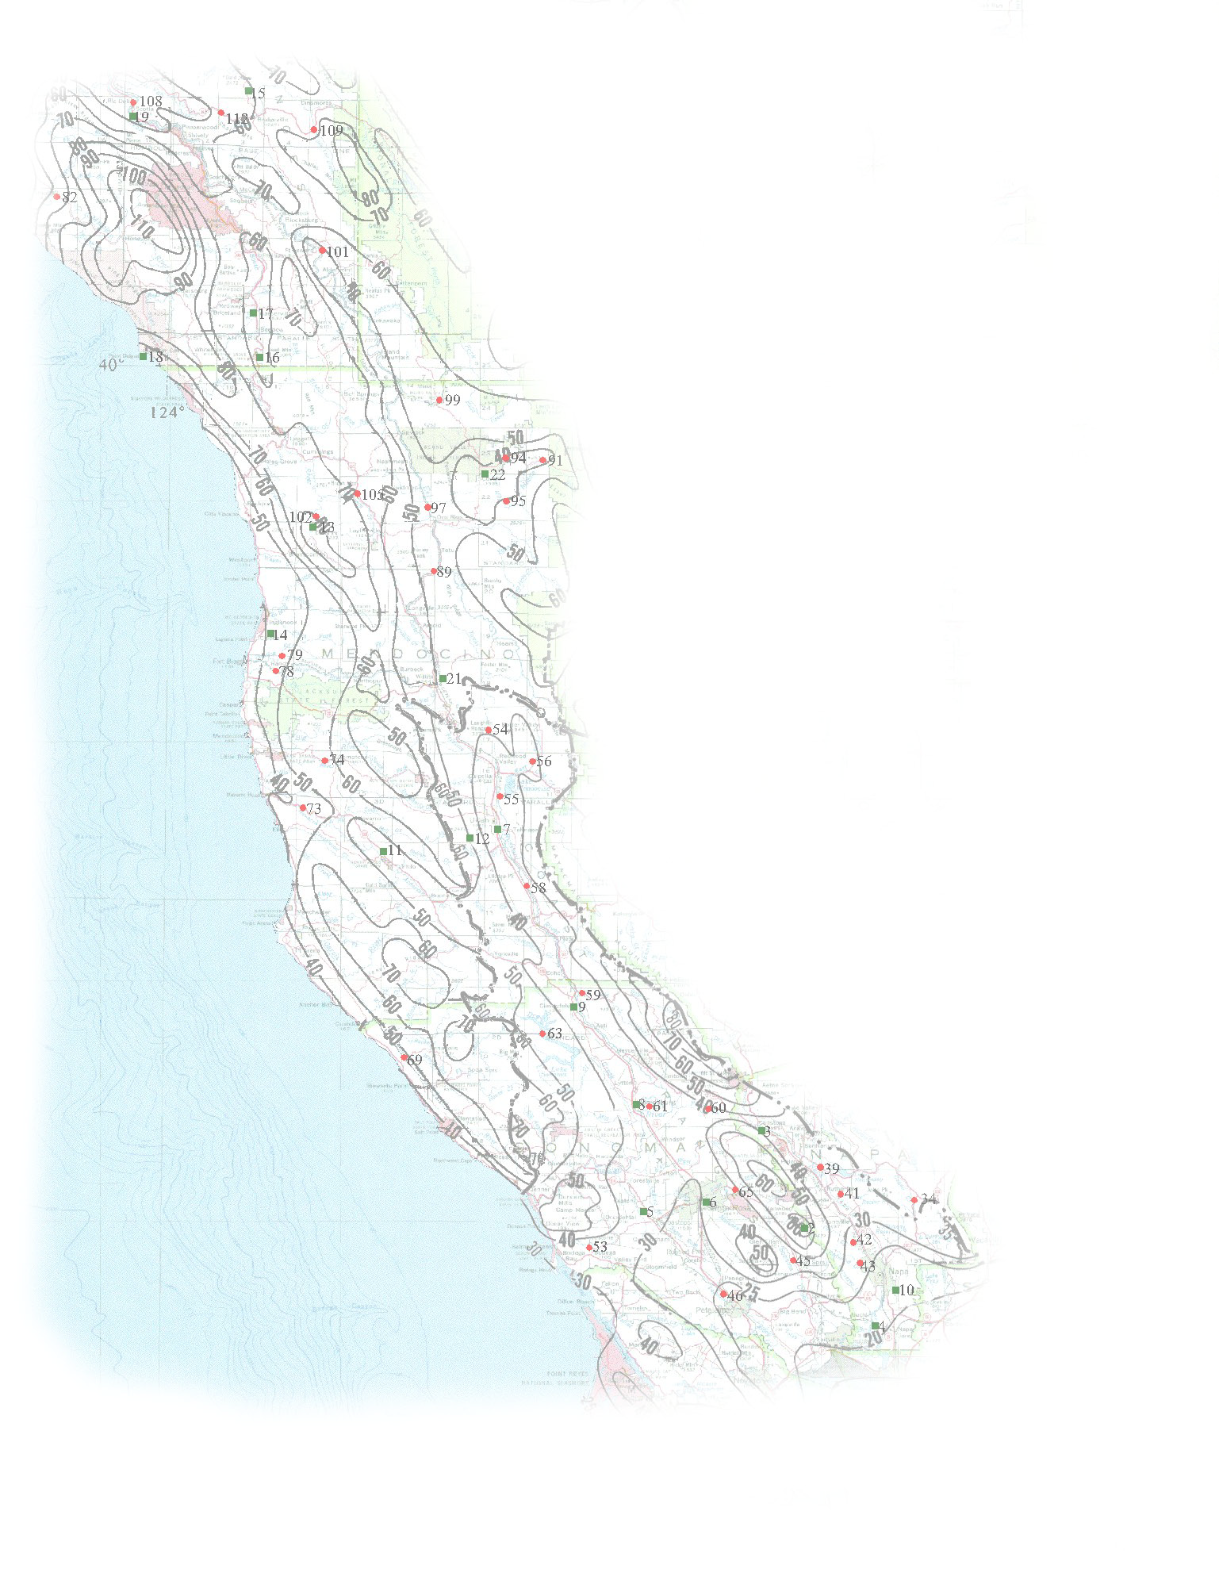


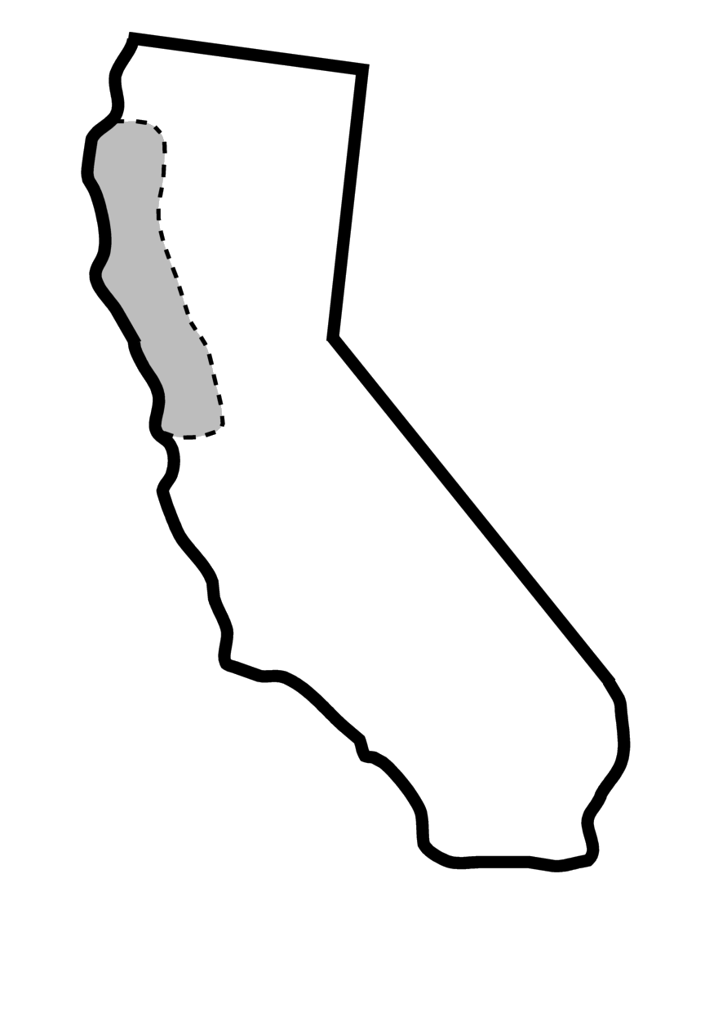

Evaluation of SWRCB Water Availability Analysis

INTRODUCTION

The purpose of this evaluation is to review the State Water Resources Control Board (SWRCB) Water Availability Analysis (WAA) for accuracy and defensibility. The SWRCB has performed numerous WAA to determine if an adequate quantity of water is available to issue water rights to applicants in the northern California coastal region. The SWRCB WAA is used to determine if water is available for diversion and to evaluate the potential environmental impacts due to additional appropriations in the north coast region.

In order for the SWRCB to issue a water right, there must be enough water available at an applicant’s point of diversion. This is accomplished by determining the natural water supply during the diversion season (usually December 15th to March 31st) then subtracting use by existing water rights and instream flow requirements.

To assess cumulative environmental impacts the SWRCB uses a “Cumulative Flow Impairment Index” (CFII), which is the ratio of water demand to water supply at the most upstream and downstream points of anadromy. The upstream and downstream points of anadromy are the most upstream and downstream points downstream of the point of diversion where anadromous fish are present and spawning. If less than 5 percent of the natural water supply occurring during the supply season (October 1st to March 31st) is allocated, then cumulative impacts are deemed to be insignificant. If more than 10 percent of the natural water supply occurring during the diversion season is allocated there are possible significant cumulative impacts. If the basin is between 5 percent and 10 percent allocated, then additional analysis may be required.

The secondary purpose of this evaluation is to suggest methods that may be either more accurate or be more defensible for performing WAA. There may be methods for determining water availability that are more defensible and increase the accuracy of the analysis. These possibilities have been explored and are discussed in this evaluation.

Description of SWRCB WAA method
In order to estimate water availability, stream runoff must be determined for both the diversion and water supply seasons, and bypass flow requirements must also be estimated. Since stream flow measurements are not made for most (if not all) streams where water availability must be calculated, stream flow must be estimated. Stream flow during the diversion and supply seasons is calculated by estimating the average annual unimpaired runoff and disaggregating it into seasonal volumes. Instream flow requirements are determined based on the February median flow for the drainage basin.

Estimation of Average Annual Unimpaired Runoff
The SWRCB employs a procedure similar to the Rational Runoff Method to estimate average annual runoff from drainage areas above diversion points for water right applications. The Rational Runoff Method is used to estimate peak flows for the design of storm drains. The California Department of Transportation (CALTRANS) often uses the Rational Runoff Method to estimate peak discharge rates. This empirical hydrologic method is documented in the CALTRANS Highway Design Manual. The Rational Formula is expressed as follows:

Q = CiA

Q = Discharge (cfs)
i = precipitation (inches per hour)
A = Drainage Area (acres)
C = Runoff Coefficient

Although CALTRANS restricts the use of the Rational Runoff Method to estimation of peak flows, the SWRCB has adopted a similar approach to estimate average annual runoff volume. To estimate the average annual runoff volume, Q is expressed as a runoff volume in acre feet (AF) per year, i is the average annual precipitation in feet per year, and A is the drainage area in acres.

Runoff Occurring During the Diversion Season
Water availability for pending water rights applications must be determined for the diversion season, which is typically December 15 through March 31. The SWRCB calculates the seasonal percentage of runoff for each of the special coastal watersheds (Navarro, Russian, Napa, etc) based on historical United States Geological Survey (USGS) stream gage data. The percentage is then applied to the average annual runoff estimated above the applicant’s point of the diversion. The following procedure is used to calculate the seasonal runoff volume:

- Sum the December 15 through March 31 daily flow for each year of record for the nearest USGS stream gage within the watershed;
- Average the seasonal flows found in step 1 to determine average annual seasonal runoff;
- Divide the average found in step 2 by the average annual flow volume for the gage data to determine the percent of flow occurring in the diversion season; and
- Multiply the percentage found in step 3 by the average annual runoff estimated at the project site using the Rational Method.

Runoff Occurring During the Supply Season
The CFII is calculated based on the average annual flow during the water supply season, which is October 1 through March 31. The runoff during the supply season is determined using almost the same procedure that is used for determining runoff during the diversion season. The only difference is that the sum calculated in Step 1 is based on the October 1 through March 31.

Calculating Bypass Flow Requirements
Bypass flows are determined using the February median flow criteria proposed by the National Marine Fisheries Service (NMFS). The February median flow is estimated using a procedure similar the one used to estimate the seasonal flow. The following procedure is used to determine the minimum bypass flow:

- The daily February median flow rate is determined for a gage within the watershed.
- Flow is prorated to drainage area being analyzed using ratio of areas and average annual precipitation.

EVALUATION OF SWRCB METHOD
The accuracy of the SWRCB method is evaluated by comparing its results to gaged basins. Rainfall/runoff relationships for gaged basins are compared to relationships estimated using the Rational Method to determine if estimated relationships are reasonable. When a WAA is needed in an ungaged basin, the SWRCB uses a WAA method based on rainfall rather than stream gages. Since the basins where gage data are available are different than those analyzed by the SWRCB, this study included many basins in the evaluation. Historical streamflow and precipitation data for 37 basins in the north coast region of California are used to calculate rainfall/runoff relationships based on gaged drainage basins. The relationships of the 37 gaged basins are compared to 55 relationships established by use of the SWRCB WAA method. The attached SWRCB WAA Evaluation Base Map contains the location of both the precipitation and stream flow gages used for this evaluation.

Description of Gage Data
The SWRCB usually uses average annual flow to determine water availability. Therefore, this study uses average annual flow and average annual precipitation to calculate relationships for gaged basins, so that the results could be directly compared. USGS streamflow records are used to calculate average annual drainage basin outflows. Average annual precipitation for the corresponding basins are estimated using data published by the USGS and historical records.

In 1969, the USGS published a report, Mean Annual Precipitation in the California Region. This report was prepared because national precipitation maps did not accurately portray the high spatial variability of precipitation occurring over the variety of terrain found in California. Additionally, the USGS performed a study in 1977, Magnitude and Frequency of Floods in California, in which basin-averaged precipitation was determined for approximately 700 drainage basins throughout California where outflow is gaged by the USGS. These USGS reports provide the basic information used in this study to evaluate the SWRCB WAA methodology. Many flow and precipitation records were extended beyond 1977 so that a longer period of record could be included in the calculations.

It was necessary to adjust the average annual precipitation estimated in the 1977 USGS report. Since many of the streamflow stations used in the analysis were in service for short periods of time, the streamflow data do not represent long-term average annual flow. Rainfall/runoff relationships derived from a short period of runoff to long-term average precipitation may be skewed. For example, if streamflow is measured for a short period during dryer years and then related to long-term average precipitation, the rainfall/runoff relationship will show that average annual runoff is less than it really is for the basin. For this reason averages for streamflow and precipitation are based only on years when both data are available.

The 1977 USGS report estimated long-term annual average precipitation for drainage basins based on drainage basin boundaries and isohyetal maps. To estimate average annual precipitation for years where streamflow data exists, average annual precipitation in the 1977 USGS report were indexed to gaged precipitation records. Precipitation gages used in the analysis are displayed in the attached SWRCB WAA Evaluation Base Map.

A summary of the historical USGS gage data used for the evaluation is contained in Table 1. Table 1 contains drainage area, average annual precipitation, runoff volume, and runoff/rainfall ratio, which are comparable to the values used in the Rational Runoff Method. Table 1 also includes information identifying the stream gages, precipitation gages, and number of annual data points used to calculate rainfall/runoff relationships. The names of the precipitation gages corresponding to the ID numbers contained in Table 1 are presented in Table 2. Drainage basin outflow, precipitation, drainage area, and runoff coefficient for the SWRCB WAA are contained in Table 3.

Comparison of Gage Data to SWRCB WAA
The SWRCB WAA values are compared to historical gaged values by plotting the total drainage area runoff volume against total precipitation volume. Precipitation volume is computed by multiplying basin precipitation by basin area. Chart 1 is a plot of runoff volume versus precipitation volume for historical gage data and data from the SWRCB WAA. The slope of the trend line indicates the runoff coefficient, or C in the Rational Formula. The historical gage data includes basins as large as 1,300,000 acres while the SWRCB WAA focuses on basins smaller than 12,000 acres. Although the gage data includes much larger basins, the runoff coefficients, or slope of the best fit lines, only differ by 4 percent. Chart 2 shows the same gage data but focuses on drainage basins smaller than 12,000 acres. The difference in the slopes of the best-fit lines shown in Chart 2 is 5percent. Because the maximum value in the SWRCB WAA data is significantly greater than all other values, it has a very large influence on the best-fit line. Removing the point with the maximum value in the SWRCB WAA data set (Chart 3) results in the best-fit lines becoming very close with less than 1 percent difference.

As shown on Chart 1 through Chart 3, the relationships between rainfall and runoff from the SWRCB WAA compare very well to those based on USGS gage data. The best-fit lines for both the SWRCB WAA data and the gage data have high regression coefficients (R²) showing they follow a linear trend. Since the slopes of the best-fit lines for both data sets are very close, the SWRCB WAA results are adequate for their intended purpose.

Limitations of Evaluation
Historical streamflow is altered by diversions and regulation, therefore, rainfall/runoff relationships developed based on historical stream gage data do not necessarily represent natural conditions. Since the SWRCB WAA estimate is intended to represent natural conditions, the comparison of SWRCB WAA and historical stream gage data should involve an adjustment for historical impairment of the stream gage data. In most cases historical diversion data does not exist or is difficult to estimate. Also, historical diversions in many basins are very small relative to stream flow. To estimate the effect of historical use, historical streamflow is adjusted by allowable water right diversions. Allowable diversions based on the maximum allowable under water rights are tabulated for two basins used in the evaluation. Flows for Dry Creek, tributary to the Napa River, and the Navarro River flows are adjusted by adding the maximum allowable diversion under existing water rights to estimate the effect of historical use for this evaluation. Chart 4 contains a plot of runoff versus precipitation for gage data and gage data adjusted for historical use. These two basins have relatively low use compared to the total basin outflow and the adjustment appears minor relative to the flow. An adjustment to historical gage data would result in the best-fit line describing the SWRCB WAA rainfall/runoff relationship being closer to gaged basins.

Estimation of Seasonal Runoff
Seasonal runoff is estimated based on stream flow that is generally downstream from the basin where WAA is applied. In some cases the downstream flow may be impaired by diversions and regulation that could change the portion of annual runoff that occurs during the diversion season. In addition, natural factors such as stream-ground water interaction can alter seasonal flows at downstream locations differently than basins located further upstream in a watershed. Use of downstream gages tends to decrease the accuracy of seasonal runoff estimations, however the decrease in accuracy may be insignificant if regulation within the watershed is minor. Although use of downstream gages tends to decrease to accuracy for the seasonal runoff estimated, the accuracy of this method commensurate with the accuracy of the annual runoff estimation. In general, the estimation of seasonal runoff using the SWRCB method should be adequate for a preliminary analysis, which is the intended purpose.

Estimation of February Median Flow
Similar issues exist when estimating February median flow as when estimating seasonal runoff; historical use and natural factors may influence the flows at the stream gage used for estimation. Peak flows tend to dampen as they move downstream through the watershed. The ratio of median flow to average flow for downstream gages may be different than the ratio for basins upstream within the same watershed. In some cases the February median flow may be influenced by factors that result in the ratio of February median flow to average flow to be higher than some smaller basins within a watershed.

Limitations and Accuracy of WAA Approach
Although results from the Rational Runoff Method compare well to historical gage data, the application of the Rational Runoff Method to determine annual flow volumes is difficult to defend. Typically the Rational Runoff Method, including the determination of the runoff coefficient, are intended to estimate peak flow for design purposes. However, the results of this evaluation demonstrate that use of this method produces reasonable results, which are acceptable for a preliminary analysis. It is recommended that a more defensible method be developed for future applications.

The SWRCB WAA may provide the required level of accuracy and detail when water use within watershed is very high; however, it may not be accurate enough when the use within a watershed is near the cutoff criteria (5 or 10 percent). Many factors, including the accuracy of precipitation estimated and basin characteristics such as stream-groundwater interaction and location of basin with the watershed, can easily cause the accuracy of this method to vary by more than 15%. For example, if the results of the WAA show that 20 percent of a basin is allocated the actual WAA may be as low as 5 percent and as large as 35 percent. Therefore, if the WAA results show a basin to be less than 20 percent allocated a more accurate analysis may be necessary.

Due to the fact that the accuracy of the WAA is limited, it is recommended that applicants be allowed to perform a more comprehensive water availability analysis.

DEVELOPMENT OF ALTERNATIVE METHOD

Because the Rational Runoff Method is intended to estimate peak flow for design purposes there may be inaccuracies when applied to estimating runoff volume. An alternative method may reduce uncertainty and increase the accuracy of runoff volume estimations. The following guidelines should be used for selection of alternative methods:

- Defensibility - Should be more defensible than Rational Method
- Accuracy - Should be accurate enough for screening based on 5% to 10% criteria
- Ease in application – Should be as easy to apply as the Rational Method
- Purpose - Screening level analysis
- Time step - Could be seasonal, but annual may be acceptable

One of the inherent difficulties in selecting a method is balancing defensibility and accuracy with ease in application and simplicity. Typically, more sophisticated methods for determining runoff are more accurate and defensible, but an inordinate amount of time is involved in acquiring data and performing analyses. Simplified methods tend to ignore important drainage basins characteristics that could cause results to become less accurate and defensible. The goal is to select a method that is defensible and accurate enough to serve as a screening tool without requiring a great level of detail and effort.

After considering several methods for estimating runoff (i.e. HEC1, NRCS, etc.) a procedure for developing runoff estimates developed by the USGS appeared to be the most appropriate for estimating water availability. The USGS performed an analysis in 1977, Magnitude and Frequency of Floods in California, where they related magnitude and frequency of floods to basin characteristics. The USGS related drainage area, precipitation, and altitude to floods using regression analysis. The possibility of applying the USGS approach to developing equations relating basin characteristics to runoff volume rather than peak flood flows may produce equations that are well suited for the SWRCB WAA. The USGS focused on basin characteristics that have the greatest influence on magnitude and frequency of flood events. The development of equations for estimating runoff volume could focus on factors that have the greatest influence on runoff volume.

The basic approach is to develop a method of estimating runoff that relates the rainfall/runoff relationship to basin characteristics. For example, drainage basins that have little forest cover and low evapotranspiration (ET) rates may have a high runoff coefficient relative to drainage basins that are heavily forested with high ET rates. The actual form of the equation depends on how various factors influence the rainfall/runoff flow volume relationship. Drainage basin characteristics that were considered by the USGS are as follows:

- Drainage area
- Mean annual precipitation
- Precipitation intensity
- Mean annual potential ET
- Main channel slope
- Main channel length
- Altitude index
- Surface-storage index
- Forest cover

There may be basin characteristics that better describe the relationship between rainfall and runoff volume, i.e. groundwater contribution to streamflow. For example, it is expected that runoff will increase as basin drainage area increases. Chart 5 is a plot of runoff versus drainage area for the same basins used in Chart 2. Although runoff increases as drainage area increases and the regression coefficient is relatively high, (0.908), the data points are still scattered around the best-fit line. By incorporating additional basin characteristics a better relationship can be developed. For example, multiplying drainage area by precipitation will improve the relationship (Chart 2) where the regression coefficient for the gage data is 0.917. This relationship can surely be improved by incorporating additional factors.

Conclusion and Suggestions
For an analysis such as the SWRCB WAA method, an infinite amount of refinement can be made to improve the results. The problem is determining the point of diminishing return, or the point where the analysis is “good enough”. The SWRCB WAA method appears to be adequate for a preliminary analysis; however, when water availability is close to the screening criteria it may not be “good enough” and additional refinements may be needed. Refinements that can produce more accurate results when water availability is near a threshold will help avoid additional analysis in the future.

Refinements could range from applying an entirely different analytical method to better estimation of drainage basin precipitation. The following list contains suggestions that could produce a more accurate water availability analysis:

- Develop an alternative method as previously suggested;
- Apply a method that performs the WAA on a monthly or seasonal basis;
- Determine a way to better estimate February median flow for small basins;
- Employ method to better estimate historical use with each basin; and
- Use more precipitation data to get better estimates for basin precipitation.

